VISOKA ŠKOLA STRUKOVNIH STUDIJA ZA INFORMACIONE I KOMUNIKACIONE TEHNOLOGIJE INTERNET TEHNOLOGIJE

DOKUMENTACIJA

Predmet: Web programiranje PHP 2 Student: Anica Radenković 57/20

Sadržaj

Uvod 5

Korišćeni jezici 5

Domen 5

Opis funkcionalnosti 6

Template 6

Organizacija 7

sitemap.xml 7

Organizacija stranica 9

**Izgled stranica i opis njihovih funkcionalnosti:** 9

main/login.blade.php 9

main/register.blade.php 10

**Izgled dela sajta za autorizovanog korisnika:** 10

main/home.blade.php 10

products/index.blade.php 12

cart/index.blade.php 13

orders/orderFrom.blade.php 14

orders/index.blade.php 14

main/contact.blade.php 15

main/author.blade.php 16

**Izgled dela sajta za administratora** 17

admin/home.blade.php 17

admin/orders/index.blade.php 18

admin/messages/index.blade.php 18

admin/users/index.blade.php 19

admin/products/index.blade.php 20

admin/products/update.blade.php 20

admin/products/insert.blade.php 21

Kodovi 22

Views 22

Components 23

Fixed 26

Layouts 30

Routes 78

web.php 78

Middleware 81

Admin.php 81

UserLoggedIn.php 82

User.php 82

Models 83

ActivitiesModel.php 84

Category.php 84

Color.php 85

Discount.php 85

Material.php 86

Message.php 86

MessageModel.php 87

Order.php 88

OrdersModel.php 88

Price.php 89

Product.php 90

ProductModel.php 91

Role.php 95

Users.php 96

UserModel.php 96

Providers 97

AppServiceProvider.php 97

Rules 99

Address.php 99

EmailUnique.php 100

Password.php 101

ProductName.php 102

ProductNameUnique.php 103

UserFullName.php 104

Requests 105

AddToCartRequest.php 106

MessageAdminRequest.php 106

OrderFormRequest.php 107

ProductInsertRequest.php 108

ProductUpdateReuqest.php 109

RegisterUserRequest.php 110

UserRequest.php 111

Helpers 112

ActivityLogger.php 112

Controllers 113

AdminController.php 113

AuthorController.php 117

CartController.php 118

ContactController.php 120

HomeController.php 121

LoginController.php 122

MainController.php 123

OrdersController.php 124

ProductsController.php 127

ProductsInsertController.php 128

ProductsUpdateController.php 130

RegisterController.php 135

Assets 136

css/style.css 137

js/main.js 145

Database 154

# 

# Uvod

## Korišćeni jezici

Markup jezici: HTML, XML

Stilski jezik: CSS

Skript jezick: JavaScript

Framework: Bootstrap, Laravel

Biblioteke: jQuery

## Domen

Aplikacija je namenja prodaji nameštaja. Autorizovani korisnici mogu da kupuju proizvode i imaju pregled narudžbina. Pored kupovine imaju mogućnost da kontaktiraju administratora ukoliko je to potrebno. Administratori imaju mogućnost da unesu nov proizvod, izmene ga i obrišu. Takodje administratori upravljaju korisnicima i njihovim narudžbinama. Na početnoj stranici admin panela nalazi se ispis svih aktivnosti korisnika. Korisnici se sami registruju. Neuatorizovani korisnici nemaju pristup sadržaju sajta.

## Opis funkcionalnosti

* Responsive sajt, Bootstrap
* Dodavanje naloga, logovanje na isti
* Upravljanje proizvodima kao administrator

(dodavanje proizvoda, njihovo brisanje i izmena)

* Upravljanje porudžbinama kao korisnik i kao administrator
* Upravljanje korisnicima kao administrator (izmena uloge, izmena statusa naloga i brisanje naloga)
* Dohvatanje proizvoda, narudžbina, aktivnosti, korisnika i poruka iz baze
* Aktivnosti korisnika (posećenost svake stranice, logovanje tog dana)
* Slanje poruka administratoru
* Ispis poruka administratoru
* Filter proizvoda, sortiranje i pretraga
* Dodavanje proizvoda u korpu
* Ispis porudžbina korisnicima
* Straničenje poruka, porudžbina, aktivnosti i korisnika
* Optimalna organizacija view-a
* Validacija grešaka
* Upotreba komponenata
* Middleware
* Upotreba ajax-a na određenim delovima sajta

## Template

Nije korišćen template, samostalno pisan kod

# Organizacija

## sitemap.xml

<?xml version="1.0" encoding="UTF-8"?>  
<urlset xmlns="http://www.sitemaps.org/schemas/sitemap/0.9">  
 <url>  
 <loc>http://127.0.0.1:8000/login</loc>  
 <lastmod>2023-01-25</lastmod>  
 <changefreq>never</changefreq>  
 <priority>0.4</priority>  
 </url>  
 <url>  
 <loc>http://127.0.0.1:8000/home-user</loc>  
 <lastmod>2023-01-25</lastmod>  
 <changefreq>yearly</changefreq>  
 <priority>0.2</priority>  
 </url>  
 <url>  
 <loc>http://127.0.0.1:8000/products</loc>  
 <lastmod>2023-01-25</lastmod>  
 <changefreq>daily</changefreq>  
 <priority>1</priority>  
 </url>  
 <url>  
 <loc>http://127.0.0.1:8000/cart</loc>  
 <lastmod>2023-01-25</lastmod>  
 <changefreq>daily</changefreq>  
 <priority>0.9</priority>  
 </url>  
 <url>  
 <loc>http://127.0.0.1:8000/orders</loc>  
 <lastmod>2023-01-25</lastmod>  
 <changefreq>weekly</changefreq>  
 <priority>0.7</priority>  
 </url>  
 <url>  
 <loc>http://127.0.0.1:8000/order-form</loc>  
 <lastmod>2023-01-25</lastmod>  
 <changefreq>never</changefreq>  
 <priority>0.1</priority>  
 </url>  
 <url>  
 <loc>http://127.0.0.1:8000/contact</loc>  
 <lastmod>2023-01-25</lastmod>  
 <changefreq>never</changefreq>  
 <priority>0.1</priority>  
 </url>  
 <url>  
 <loc>http://127.0.0.1:8000/author</loc>  
 <lastmod>2023-01-25</lastmod>  
 <changefreq>never</changefreq>  
 <priority>0.1</priority>  
 </url>  
 <url>  
 <loc>http://127.0.0.1:8000/register</loc>  
 <lastmod>2023-01-25</lastmod>  
 <changefreq>never</changefreq>  
 <priority>0.3</priority>  
 </url>  
 <url>  
 <loc>http://127.0.0.1:8000/home-admin</loc>  
 <lastmod>2023-01-25</lastmod>  
 <changefreq>daily</changefreq>  
 <priority>0.9</priority>  
 </url>  
 <url>  
 <loc>http://127.0.0.1:8000/products-admin</loc>  
 <lastmod>2023-01-25</lastmod>  
 <changefreq>weekly</changefreq>  
 <priority>0.7</priority>  
 </url>  
 <url>  
 <loc>http://127.0.0.1:8000/products-insert-form</loc>  
 <lastmod>2023-01-25</lastmod>  
 <changefreq>yearly</changefreq>  
 <priority>0.5</priority>  
 </url>  
 <url>  
 <loc>http://127.0.0.1:8000/products-update</loc>  
 <lastmod>2023-01-25</lastmod>  
 <changefreq>yearly</changefreq>  
 <priority>0.5</priority>  
 </url>  
 <url>  
 <loc>http://127.0.0.1:8000/orders-admin</loc>  
 <lastmod>2023-01-25</lastmod>  
 <changefreq>weekly</changefreq>  
 <priority>0.7</priority>  
 </url>  
 <url>  
 <loc>http://127.0.0.1:8000/messages</loc>  
 <lastmod>2023-01-25</lastmod>  
 <changefreq>daily</changefreq>  
 <priority>0.8</priority>  
 </url>  
 <url>  
 <loc>http://127.0.0.1:8000/users</loc>  
 <lastmod>2023-01-25</lastmod>  
 <changefreq>daily</changefreq>  
 <priority>0.8</priority>  
 </url>  
  
  
</urlset>

# Organizacija stranica

## **Izgled stranica i opis njihovih funkcionalnosti:**

### main/login.blade.php

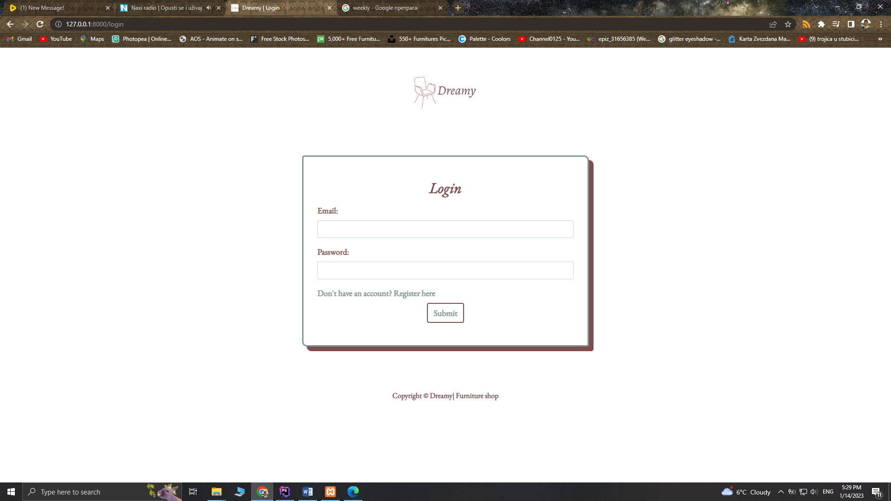

Stranica koja se inicijalno prikazuje korisniku. Prikazana je forma za logovanje, gde se unosi email i lozinka korisnika. Ukoliko korisnik nema nalog mora se registrovati. Nakon logovanja korisnik se preusmerava na početnu stranicu u odnosu na njegovu ulogu. Za logovanje je koriščena sesija.

### main/register.blade.php

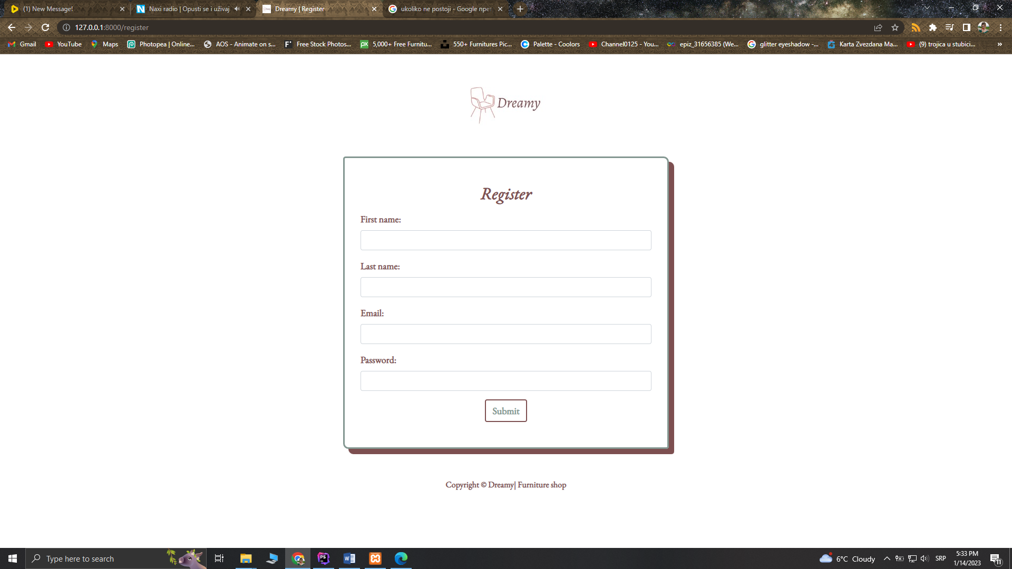

Stranica za registrovanje korisnika. Korisnik unosi podatke u formu (ime, prezime i parametre za logovanje: email, password). Ukoliko je uspešno registrovan preusmerava se na login formu.

## **Izgled dela sajta za autorizovanog korisnika:**

### main/home.blade.php

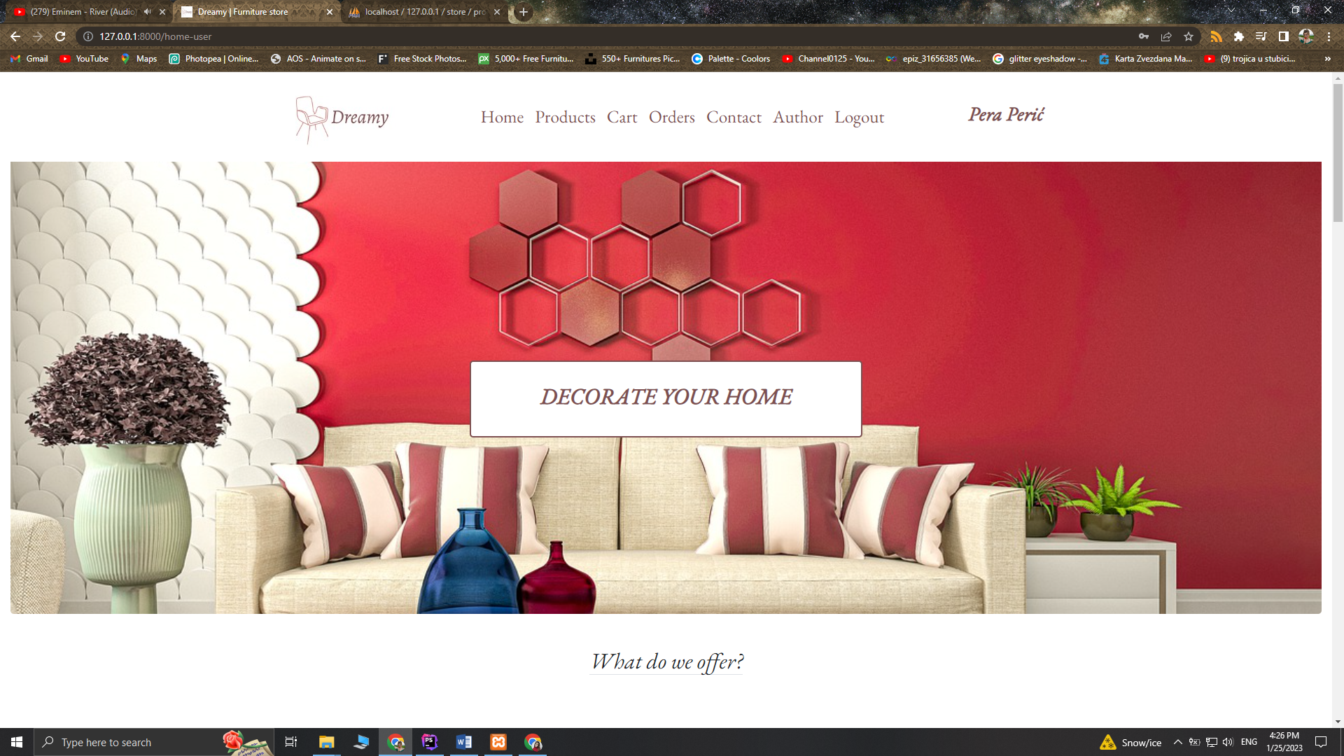

U odnosu koji je korisnik uzlogovan prikazuje se njegove ime i prezime u delu navigacije u desnom uglu.

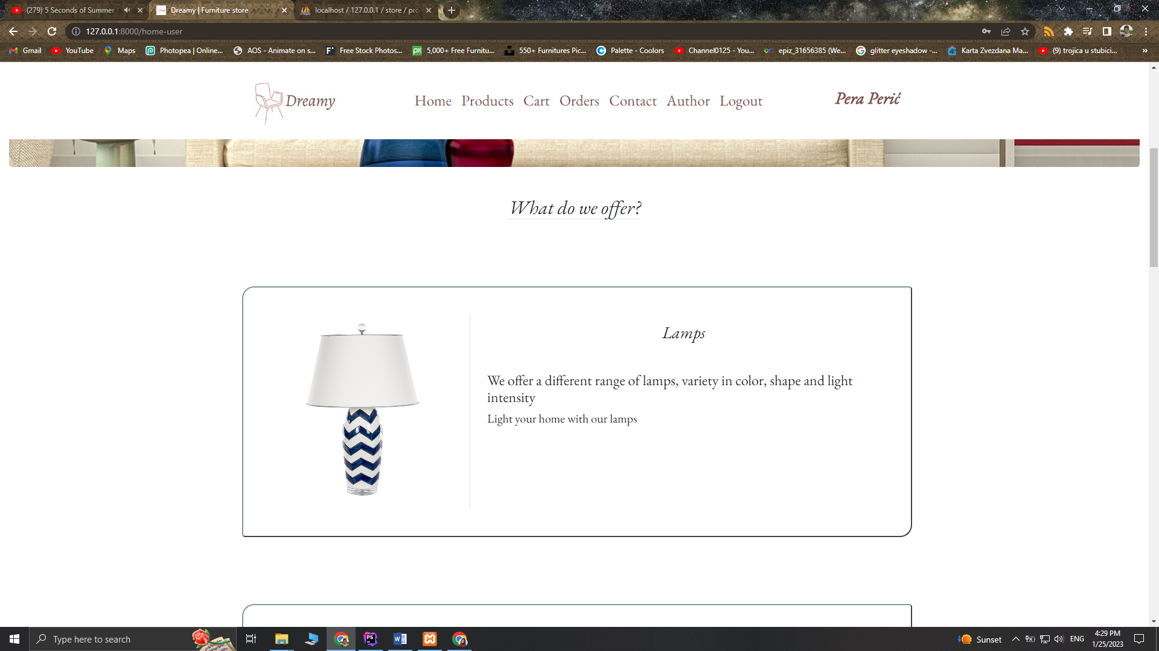

Blok gde su prikazen kategorije ispisan je kao komponenta koja se vrti u petlji. Podaci su izvučeni iz baze i smešteni u HomeController.

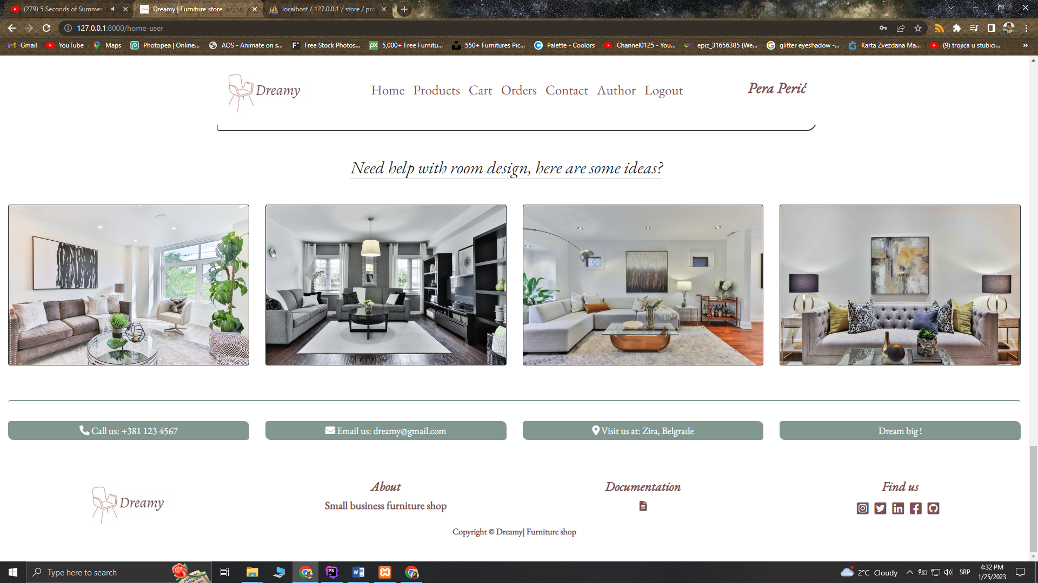

Svaki blok je zapravo jedna komponenta koja se vrti u petlji. Podaci u ovom bloku su dohvaćeni iz HomeController-a gde su napisani kao niz.

### products/index.blade.php

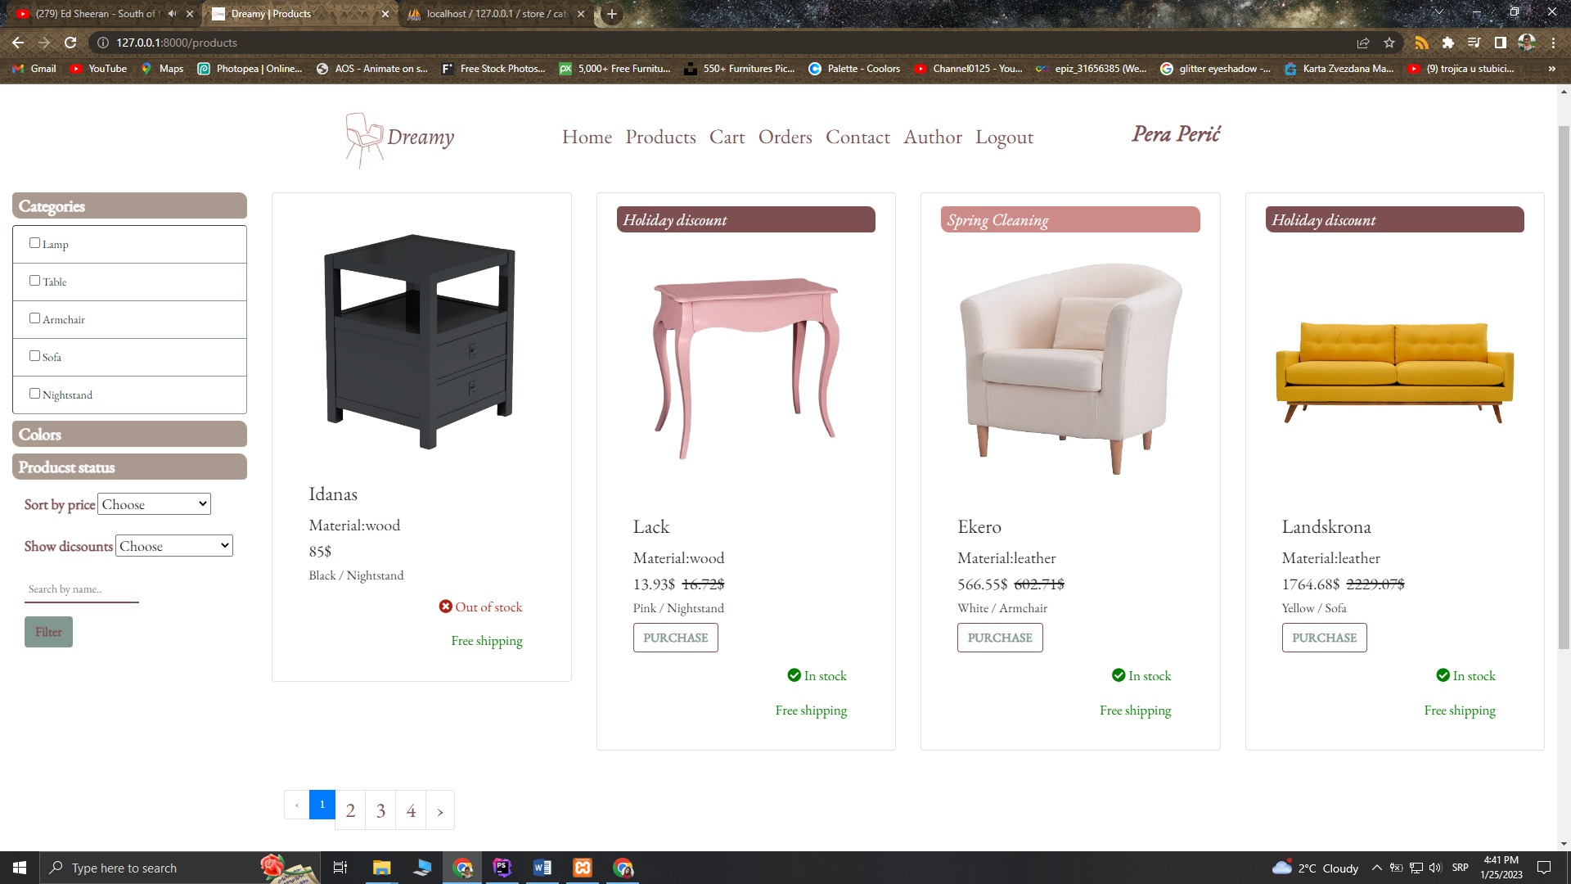

Stranica za prikaz proizvoda korisnicima. Sa leve strane se nalazi blok za filter i sortirtanje proizvoda. Proizvodi se mogu sortirati po ceni opadajuće i ratuće. Filter je moguć na osnovu kategorije, boje, materijala, statusa, akcije i naziva proizvoda. Svi filteri i paginacija su usklađeni. Ukoliko ne postoji proizvod za oređeni filter ispisuje se poruka.

Proizvodi su ispisani pomoću komponente i izvučeni iz baze. Klikom na dugme ***PURCHASE*** proizvod se dodaje u korpu i korisniku se ispisuje poruka da je proizvod dodat u korpu.

### cart/index.blade.php

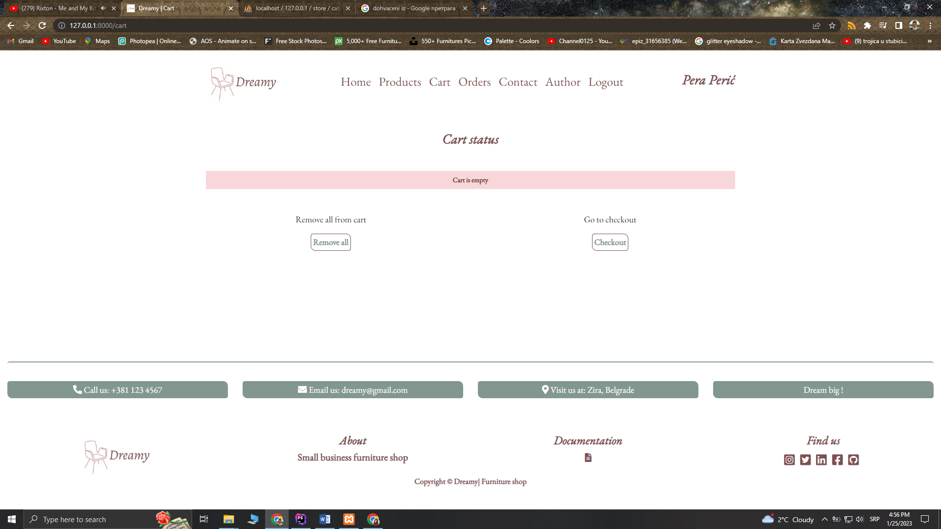

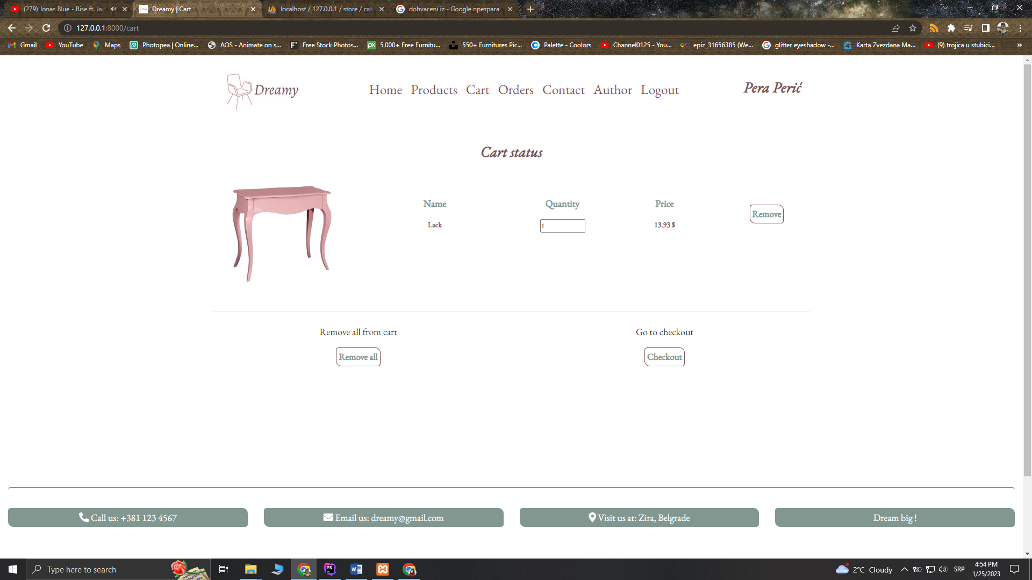Ukoliko korisnik nije dodao ništa u korpu ispisaće se poruka da je korpa prazna.

Ispis proizvoda iz korpe korisnika. Podaci iz korpe su smešteni u sesiju. Moguće je izmeniti kolučinu proizvoda ili ga izbaciti iz korpe klikom na dugme ***Remove***. Klikom na dugme ***Remove all*** briše se cela sesija. Dugme ***Checkout*** preusmerava korisnika na formu za napravljenu porudžbinu. Cela funkcionalsnot korpe je obavljena pomoću ajax-a.

### orders/orderFrom.blade.php

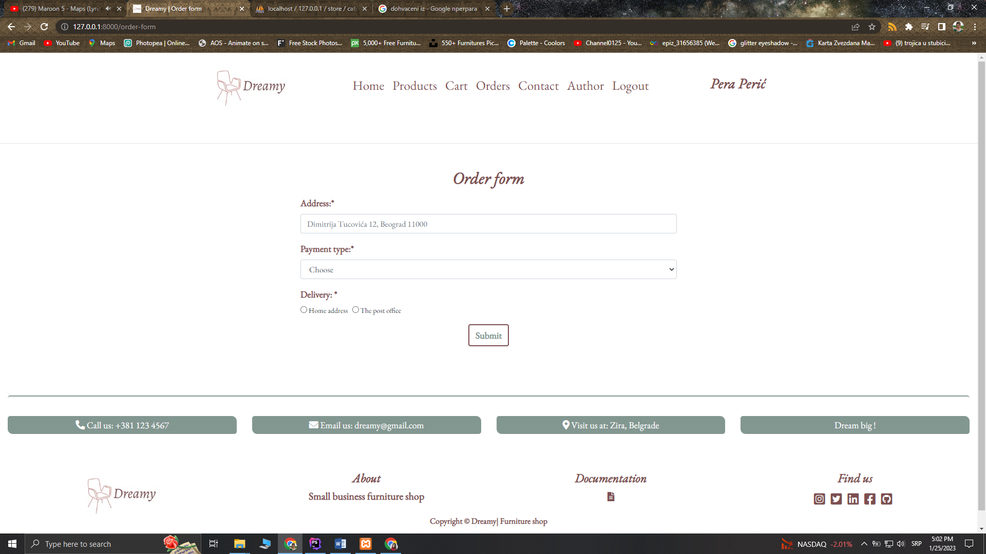

Nakon klika na dugme ***Checkout*** na stranici **Cart** korisnik se preusmerava na formu za porudžbinu. Potrebno je uneti adresu, način isporuke i način plaćanja. Klikom na dugme ***Submit*** korisnik se preusmerava na stranicu **Orders** i njegova porudžbina se upisuje u bazu. Sesija za korpu se tada briše.

### orders/index.blade.php

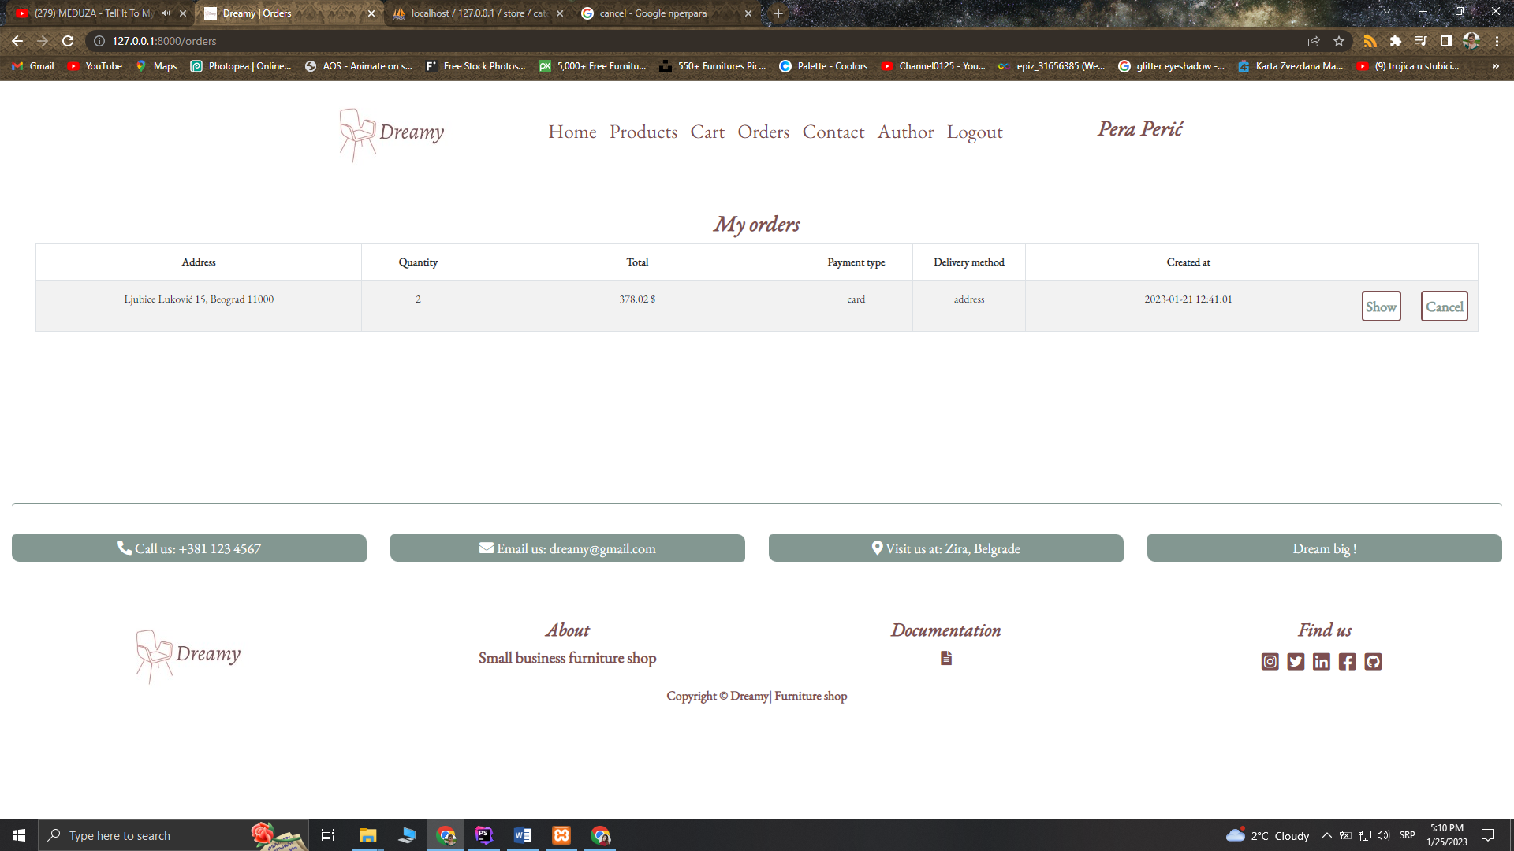

Ispis porudžbina korisnika koje su izvučene iz baze. Korisnik je u mogućnosti da otkaže porudžbnu klikom na dugme ***Cancel.*** Korišćen ajax za brisanje narudžbine. Paginacija je primenjena

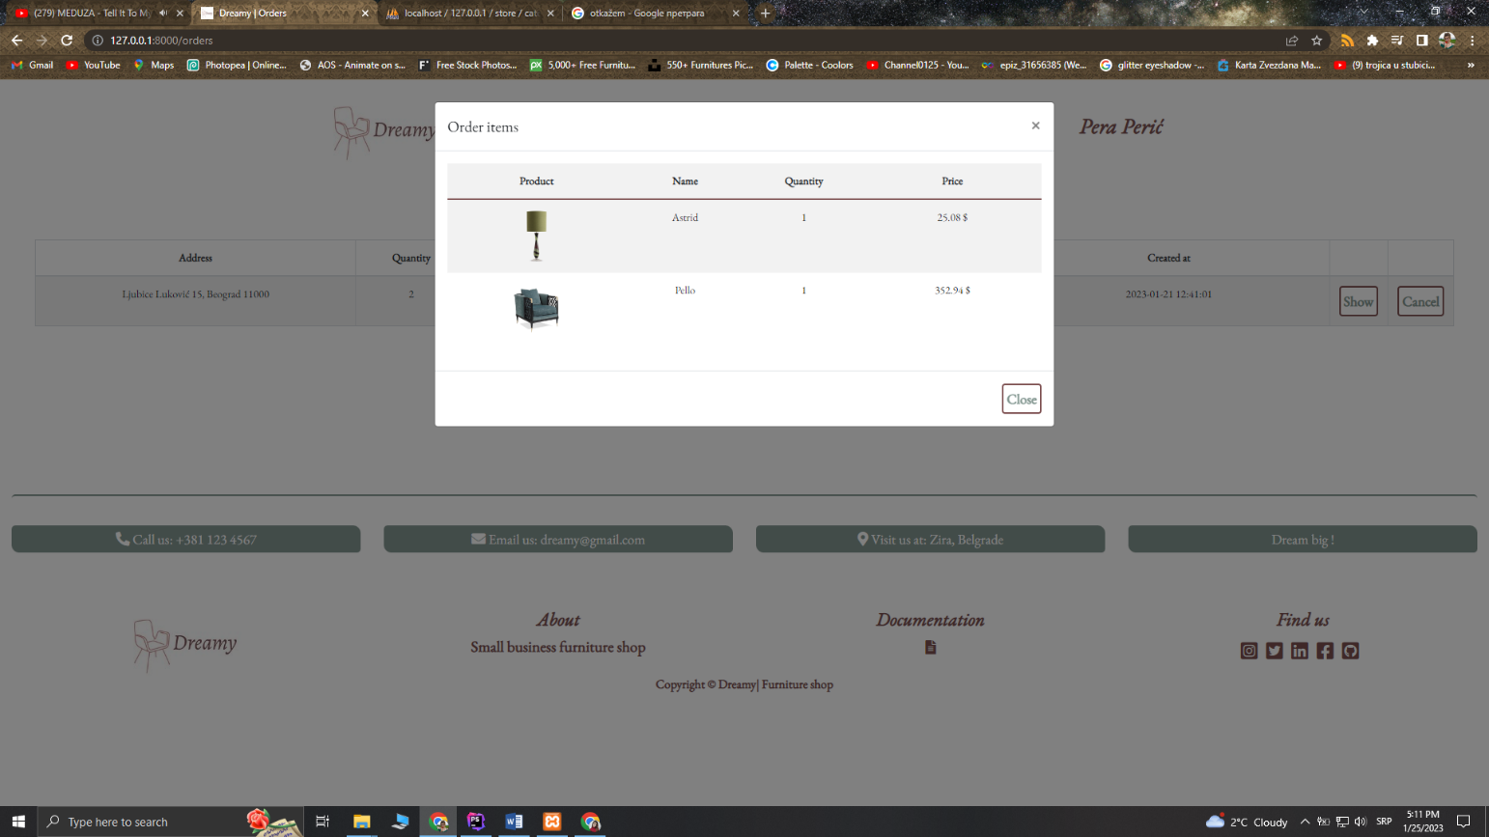

Klikom na dugme ***Show*** prikazuje se modal sa stavkama iz narudžbine. Korišćen ajax.

### main/contact.blade.php

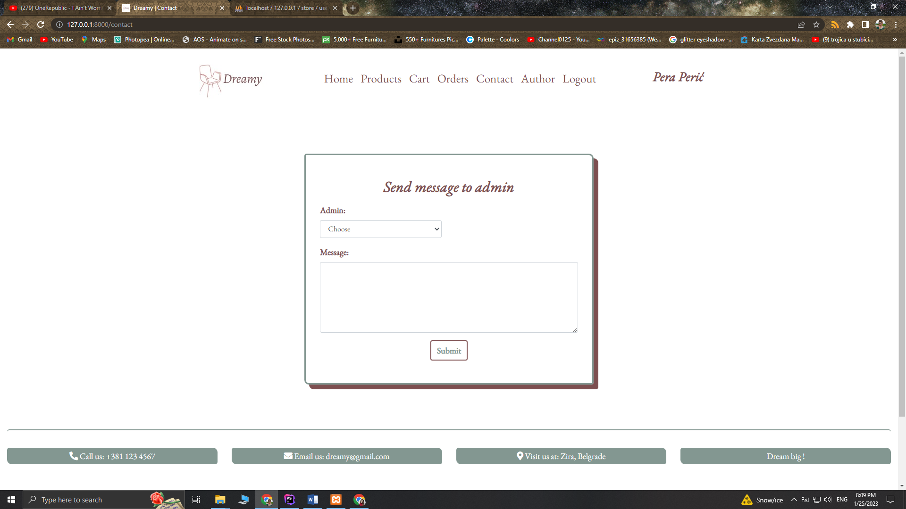

Na stranici **Contact** korisnik je u mogućnosti da pošalje poruku administratoru. Korisnik bira iz padajuće liste kom administratoru želi da se obrati. Poruka se upisuje u bazu i ispisuje na admin panelu.

### main/author.blade.php

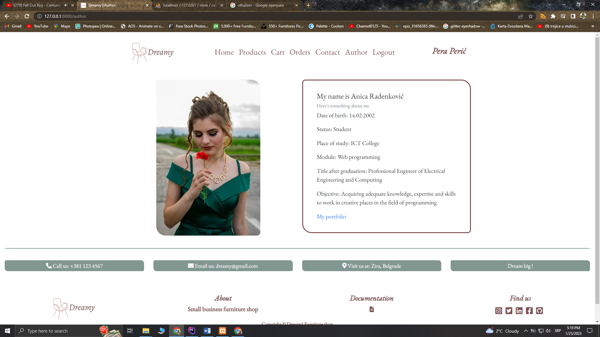

Stranica o autoru sajta.

## **Izgled dela sajta za administratora**

### admin/home.blade.php

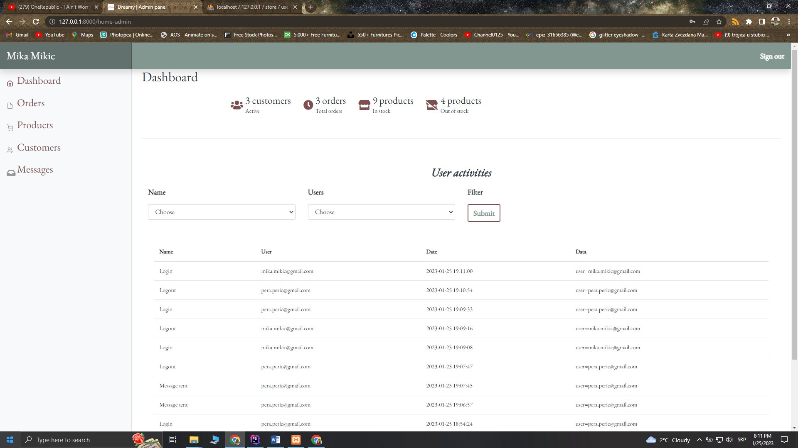

Na početnoj stranici admin panela izlistane su aktivnosti korisnika. Stavke koje se zabeleže su akcija koja se desila, korisnik koji je obavio tu akciju, datum kada je zabeležena i podaci vezani za akciju. Omogućeno je filtriranje aktivnosti po nazivu i korisniku. Filter i paginacija su usklađeni.

### admin/orders/index.blade.php

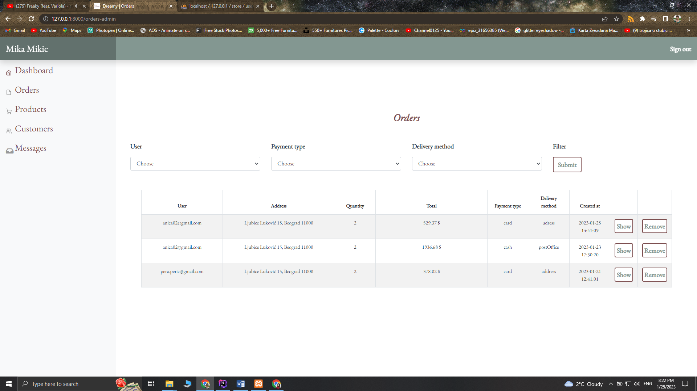

Prikaz svih narudžbina korisnika iz baze. Omogućeno je brisanje narudžbine i pregled pojedinih stavki. Filtriranje narudžbina po korisniku, načinu plaćanja i načinu dostave. Filter i paginacija su usklađeni.

### admin/messages/index.blade.php

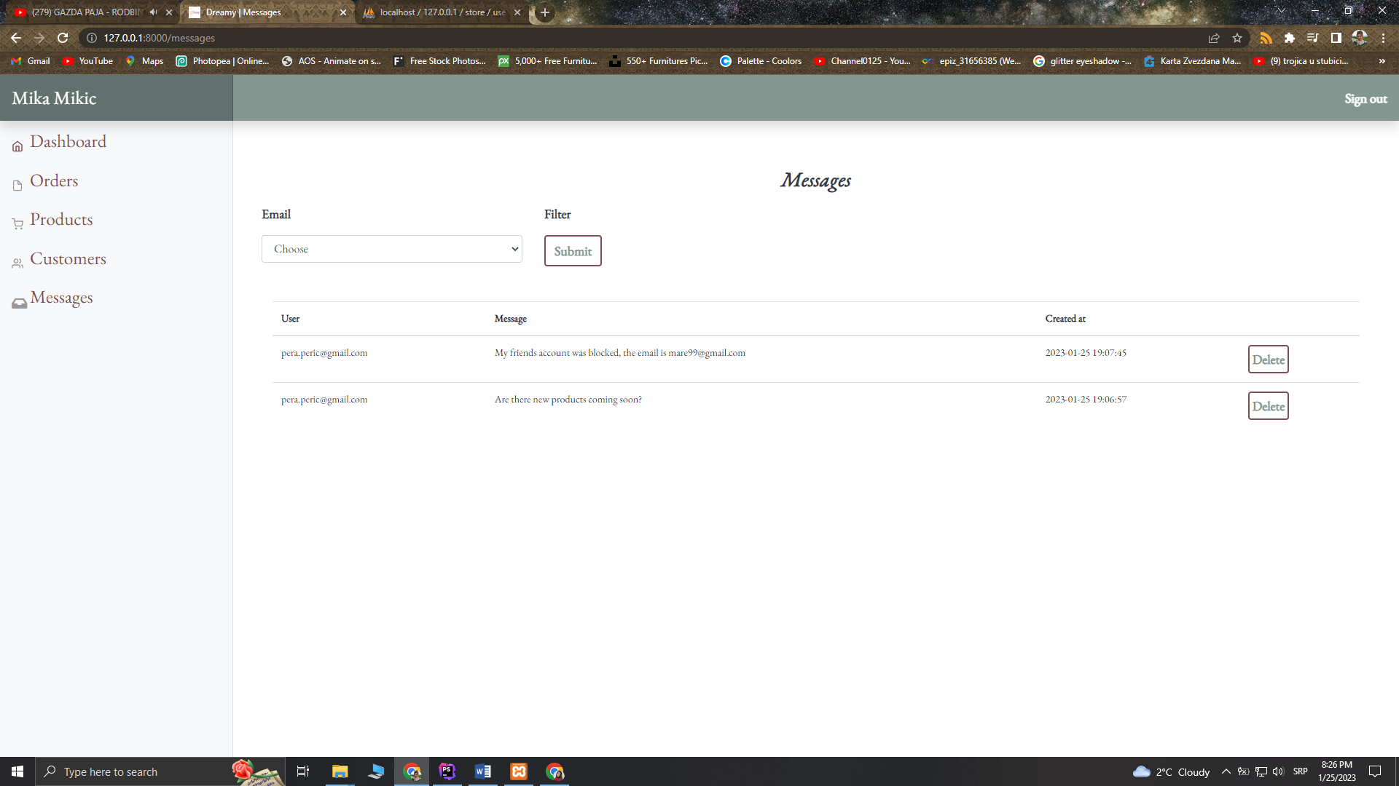

Ispis poruka namenjenim određenom administratoru. Omogućeno brisanje poruke. Filter po korisničkom email-u. Filter i paginacija usklađeni.

### admin/users/index.blade.php

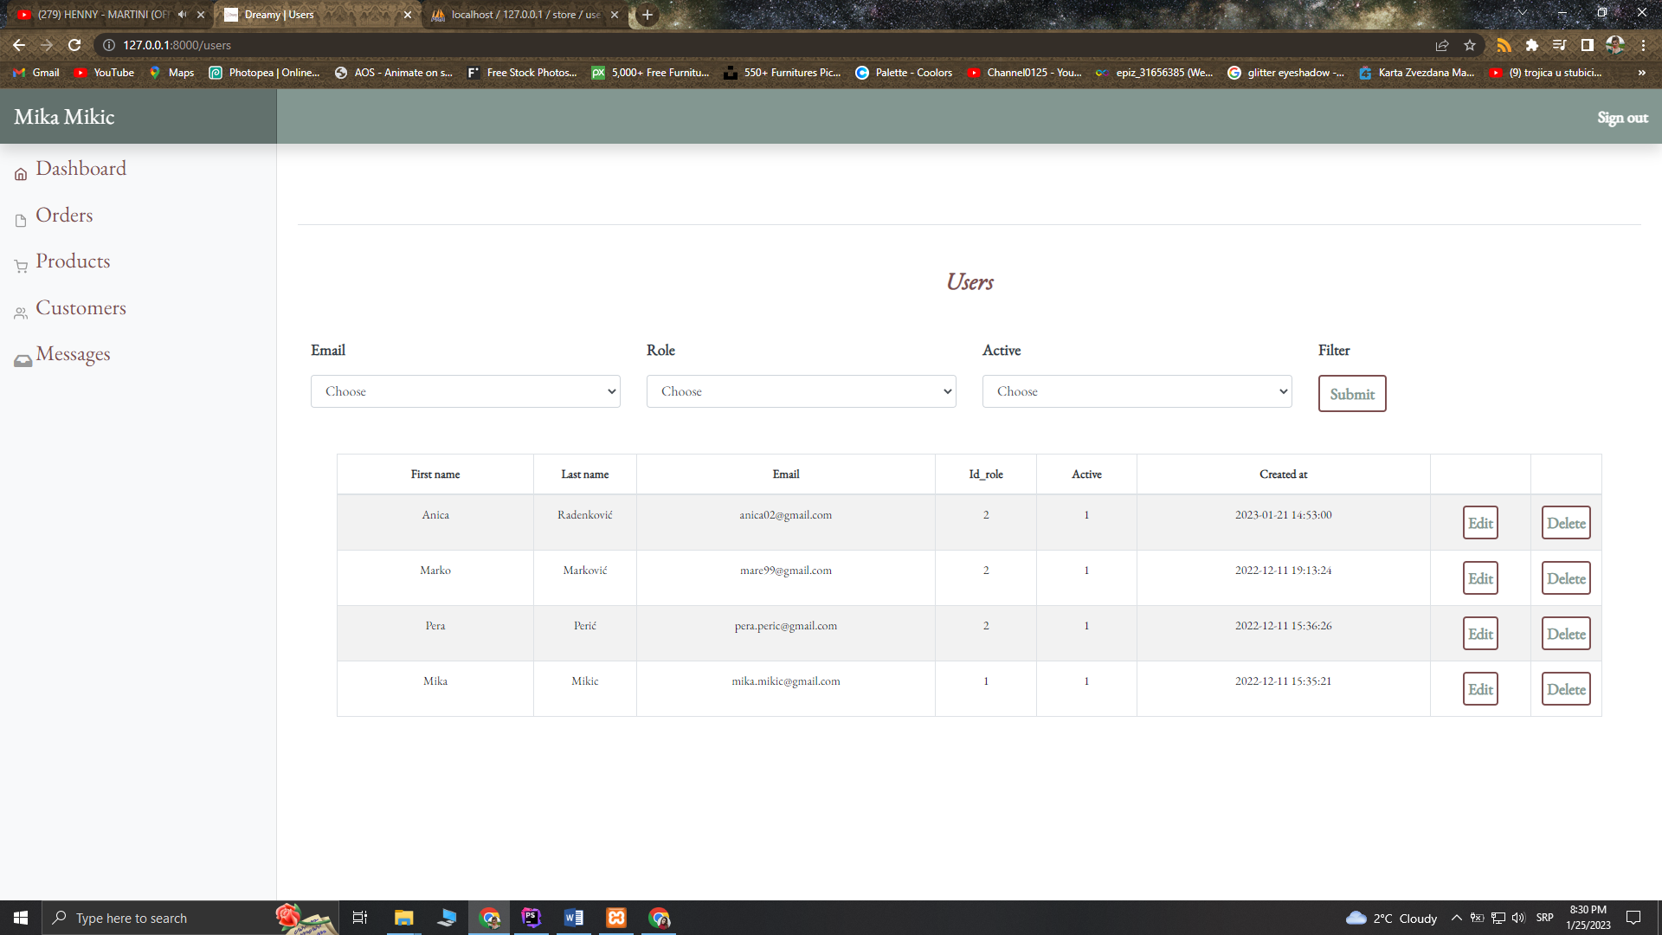

Stranica namenjena ispisu korisnika iz baze. Omogućeno je brisanje i izmena korisničkih naloga. Filter korisnika po email-u, ulozi i statusu naloga. Klikom na dugme ***Edit*** prikazuje se modal sa formom za izmenu naloga korisnika.

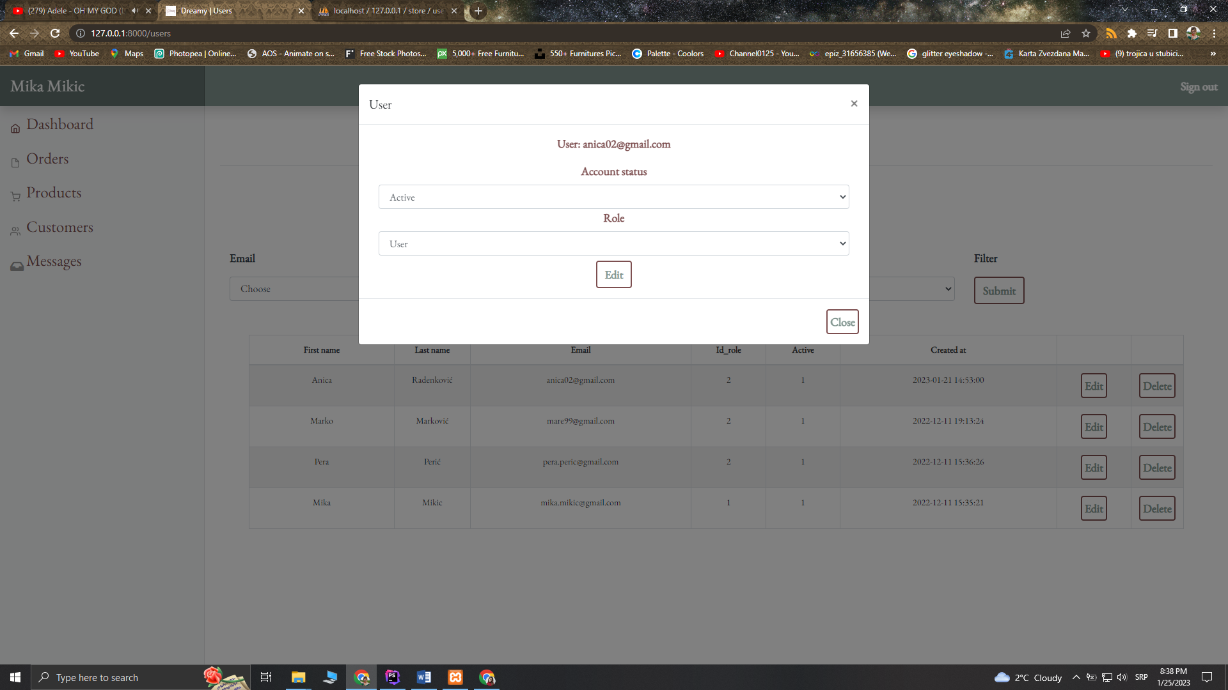

Moguća izmena statusa naloga i uloge. Prikaz podataka putem ajax-a.

### admin/products/index.blade.php

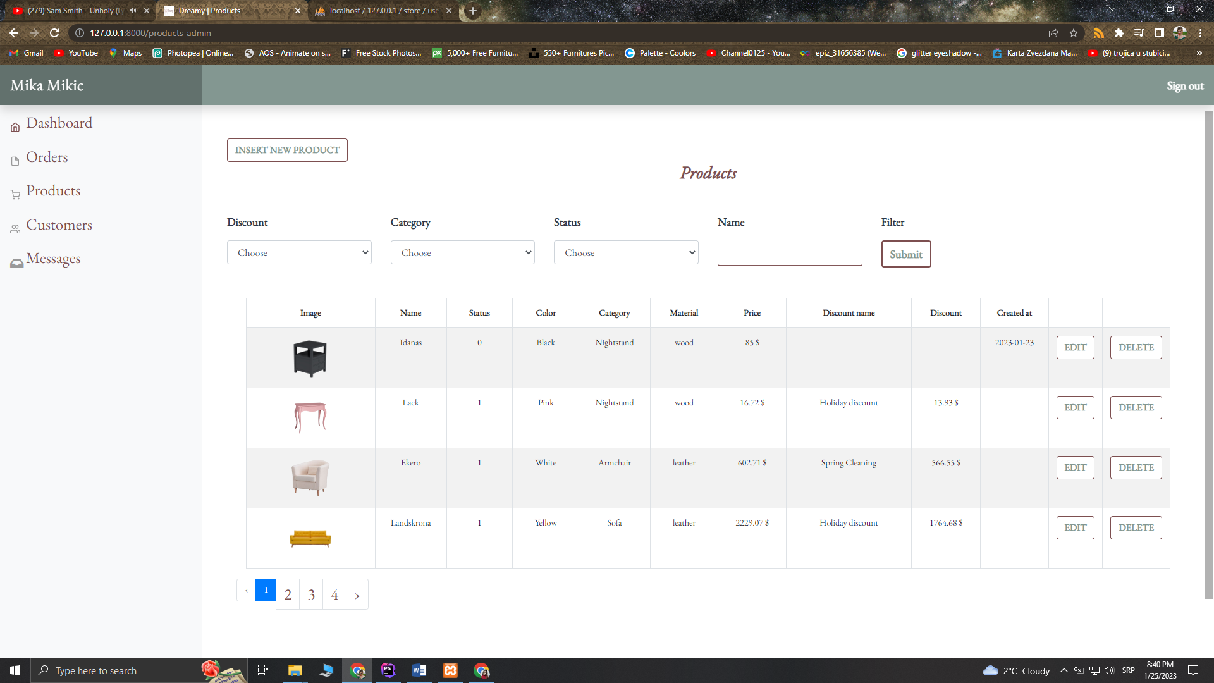

Stranica za upravljanje proizvodima. Proizvode je moguće izmeniti, obrisati i dodati nov. Filter proizvoda po tipu popustu, kategoriji, statusu i nazivu. Filter i paginacija su usklađeni. Klikom na dugme ***Edit*** učitava se stranica sa formom za izmenu proizvoda. Klikom na dugme ***INSERT NEW PRODUCT*** učitava se forma za unos novog proizvoda.

### admin/products/update.blade.php

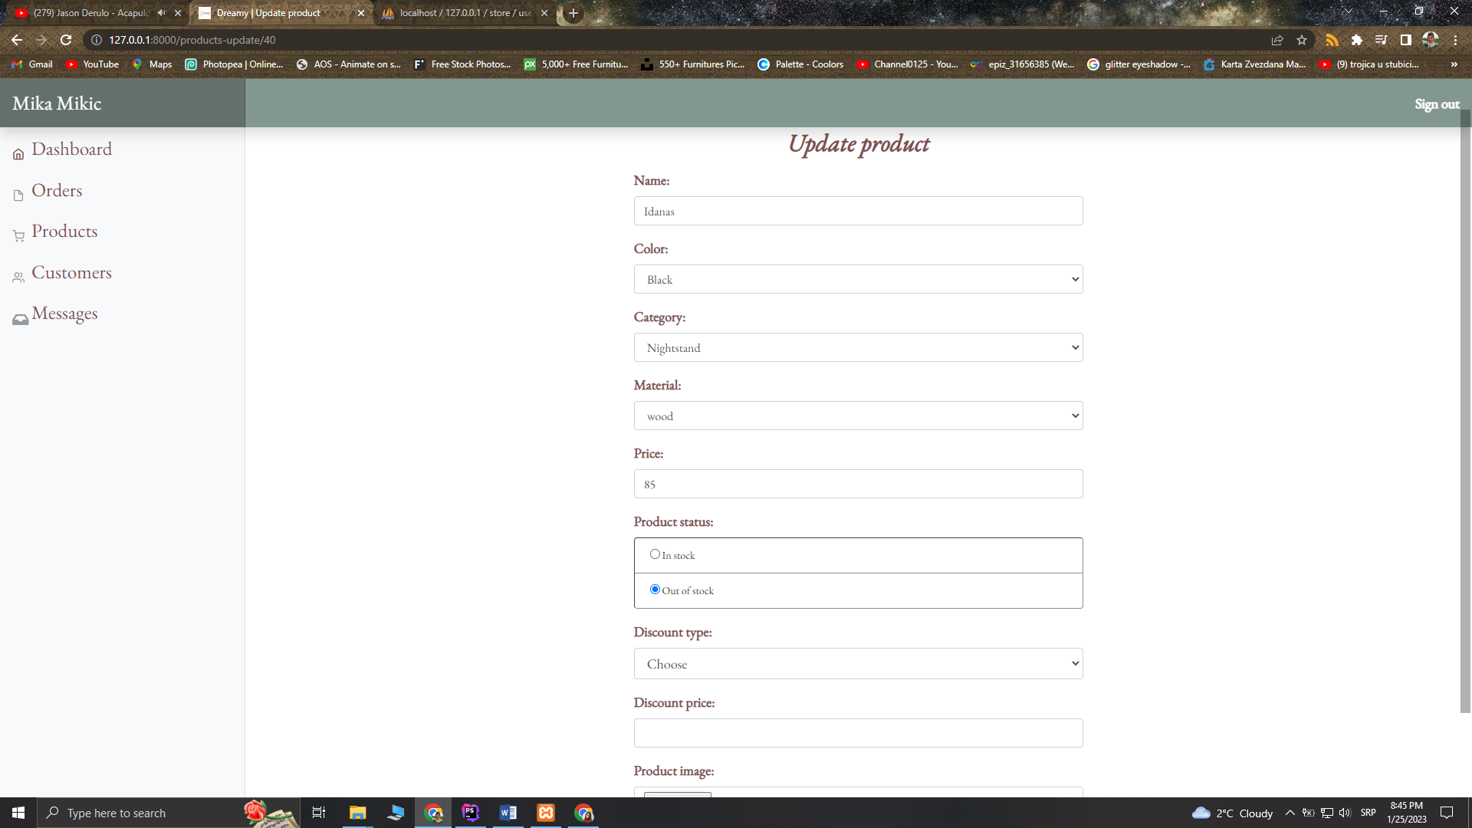

Moguća je izmena naziva, boje, kategorije, materijala, cene, statusa, tipa popusta, cene popusta i slike. Validacija unosa.

### admin/products/insert.blade.php

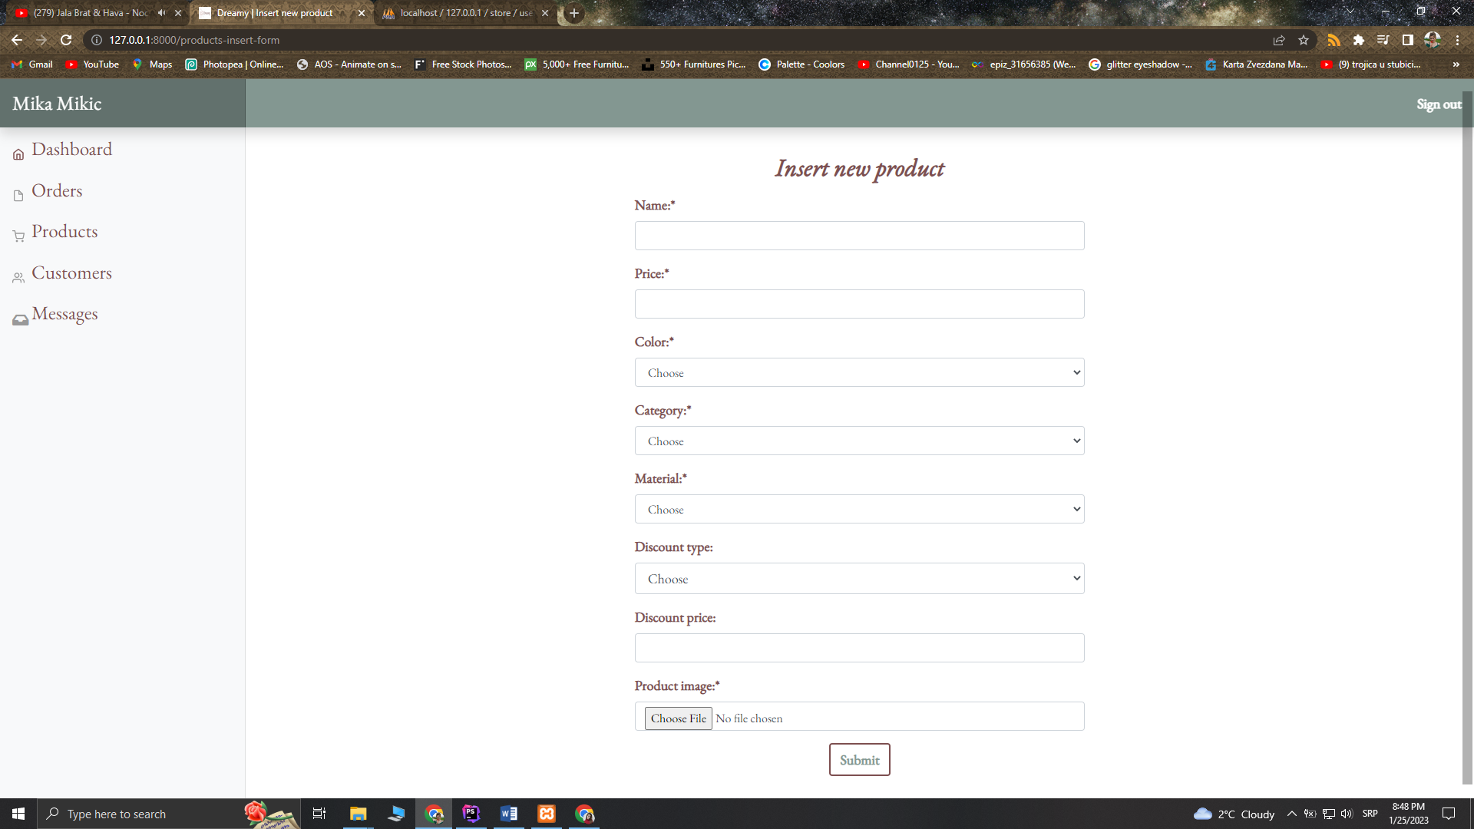

Stranica za unos novog proizvoda. Nakon validacije podaci se upisuju u bazu. Za proizvod se unose sledeći parametri: naziv, cena, boja, kategorija, materijal, tip popusta, cena popusta i slika proizvoda.

# Kodovi

## Views

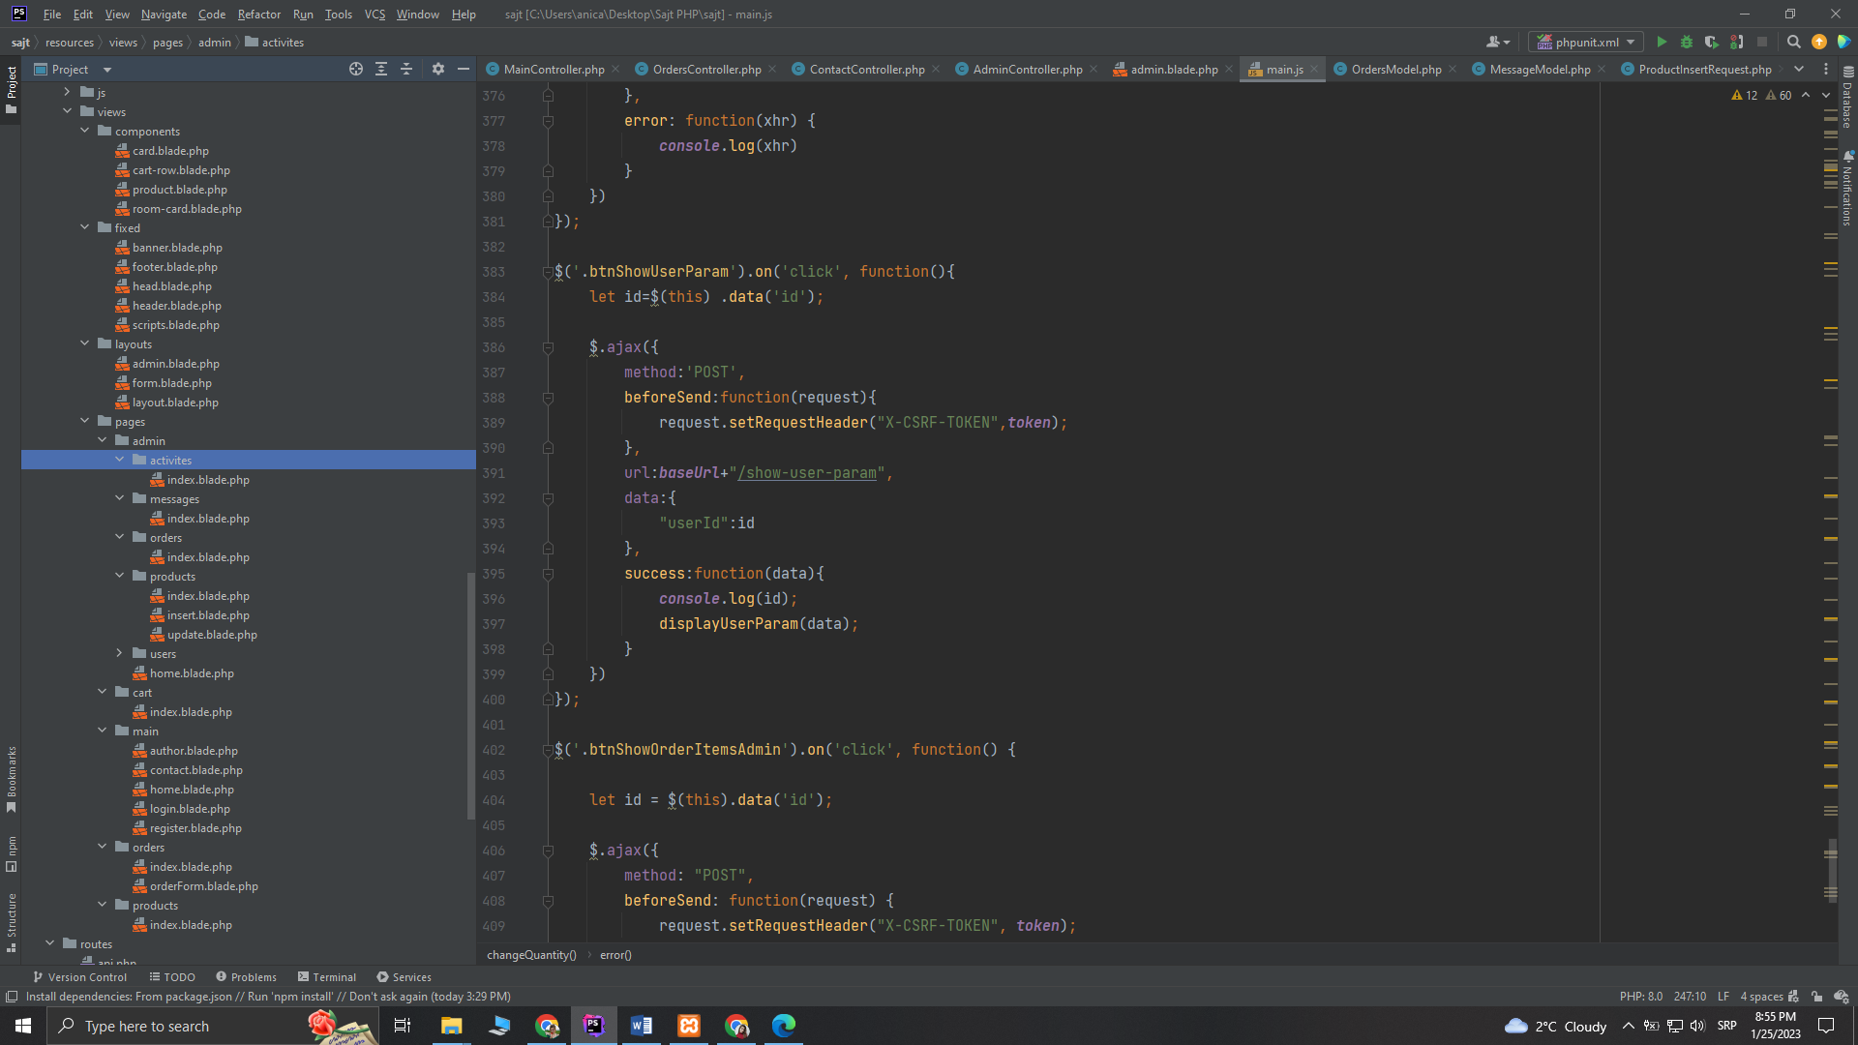

### Components

#### card.blade.php

<div class="row top-margin borderCards cardP col-12 ml-1">  
 <div class="col-sm-4 border-right">  
 <img src="{{asset('assets/img/'.$image)}}" alt="{{$imageAlt}}" class="w-100"/>  
 </div>  
 <div class="col-sm-8">  
 <div class="description text-left">  
 <h3 class="font-italic text-center">{{$title}}s</h3>  
 <h4 class="mt-5">{{$description1}}</h4>  
 <h5 class="">{{$description2}}</h5>  
  
 </div>  
 </div>  
</div>

#### cart-row.blade.php

<div class="row" class="cartItems" id="cartItem_{{$idProd}}">  
 <div class="col-12 col-sm-3 text-center">  
 <img src="{{asset('assets/img/'.$image)}}" class="w-100" alt="{{$alt}}">  
 </div>  
 <div class="col-12 col-sm-3 text-center rowItem font-weight-bold colorRottenCherry">  
 <div class="col text-center font-weight-bold colorMint font18">  
 <p>Name</p>  
 </div>  
 <p>{{$name}}</p>  
 </div>  
 <div class="col-12 col-sm-2 text-center rowItem font-weight-bold colorRottenCherry">  
 <div class="col text-center font-weight-bold colorMint font18">  
 <p>Quantity</p>  
 </div>  
 @if($discount)  
 <input type="number" onchange="changeQuantity(  
 {{$idProd}},{{$discount}},{{count(session()->get('cart'))}},this  
 )" value="{{ session()->get("cart")[$idProd] }}" style="width: 6em" />  
 @else  
 <input type="number" onchange="changeQuantity(  
 {{$idProd}}, {{$price}},{{count(session()->get('cart'))}},this  
 )" value="{{ session()->get("cart")[$idProd] }}" style="width: 6em" />  
 @endif  
  
 </div>  
  
 <div class="col-12 col-sm-2 text-center rowItem font-weight-bold colorRottenCherry">  
 <div class="col text-center font-weight-bold colorMint font18">  
 <p>Price</p>  
 </div>  
 @if($discount)  
 <p id="price_{{$idProd}}">{{ number_format((float)$discount * session()->get("cart")[$idProd], 2, '.', ''). " $" }}</p>  
  
 @else  
 <p id="price_{{$idProd}}">{{ number_format((float)$price * session()->get("cart")[$idProd], 2, '.', ''). " $" }}</p>  
 @endif  
  
  
 </div>  
 <div class="col-12 col-sm-2 text-center rowItem ">  
 <div class="col text-center font-weight-bold ">  
 <p></p>  
 </div>  
 <button onclick="removeFromCart({{$idProd}})" class="colorMint btn removeButton py-1 px-1">Remove</button>  
 </div>  
  
</div>

#### room-card.blade.php

<div class="col-12 col-sm-6 col-lg-3 mb-3">  
 <div class="card bg-dark text-white cardRoom">  
 <img src="{{asset('assets/img/'.$src)}}" class="card-img" alt="{{$alt}}">  
 </div>  
</div>

#### product.blade.php

<div class="col-12 col-sm-6 col-lg-4 col-xl-3 product">  
 <div class="card mb-5 py-3 px-4 text-center cardWidth">  
 <div>  
 @if(!empty($discountPrice))  
 <div class="text-left pl-2 {{$discountStyle}}">  
 <h5 class="py-1 font-italic">{{$discountName}}</h5>  
 </div>  
 @else  
 <div></div>  
 @endif  
  
 </div>  
  
 <img src="{{asset('assets/img/'.$imgSrc)}}" class="card-img-top " alt="{{$imgAlt}}">  
 <div class="card-body text-left">  
 <h4 class="card-title">{{ ucfirst(trans($name))}}</h4>  
 <h5 class="card-text">Material:{{$material}}</h5>  
 @if(!empty($discountPrice))  
 <h5 class="card-text"> {{$discountPrice}}$ &nbsp;<s>{{$price}}$</s></h5>  
 @else  
 <h5 class="card-text"> {{$price}}$</h5>  
 @endif  
  
 <h6 class="card-text">{{$color}} / {{$category}}</h6>  
  
  
 @if($status==1)  
 <div class="row text-right">  
  
 <div class="col-5 col-sm-6 col-xl-5 ">  
 <button type="button" onclick="addToCart({{$prodId}})" class="btn btnProduct colorMint font-weight-bold">  
 PURCHASE  
 </button>  
 </div>  
  
  
 </div>  
  
 <div class="col-12 mt-3">  
 <p class="card-text inStock text-right"><i class="fas fa-check-circle"></i> In stock</p>  
 </div>  
 <div class="col-12 mt-3">  
 <p class="card-text inStock text-right">Free shipping</p>  
 </div>  
  
 @elseif($status==0)  
  
 <div class="col-12 mt-3">  
 <p class="card-text outStock text-right"><i class="fas fa-times-circle"></i> Out of stock</p>  
 </div>  
 <div class="col-12 mt-3">  
 <p class="card-text inStock text-right">Free shipping</p>  
 </div>  
 @endif  
  
 </div>  
 </div>  
</div>

### Fixed

#### head.blade.php

<head>  
 <title>@yield("title")</title>  
 <meta charset="UTF-8"/>  
 @yield("csrf-token")  
 <meta name="viewport" content="width=device-width, initial-scale=1.0"/>  
 <meta name="keywords" content="@yield("keywords")"/>  
 <meta name="description" content="@yield("description")"/>  
 <link rel="shortcut icon" href="{{asset("assets/img/logo1.png")}}"/>  
  
 <script src="https://kit.fontawesome.com/ce9a3cdf18.js" crossorigin="anonymous"></script>  
 <script src="https://cdn.jsdelivr.net/npm/feather-icons@4.28.0/dist/feather.min.js"></script>  
 <script src="{{ asset("assets/js/jquery.js") }}"></script>  
 <link rel="stylesheet" href="https://cdn.jsdelivr.net/npm/bootstrap@4.6.1/dist/css/bootstrap.min.css" integrity="sha384-zCbKRCUGaJDkqS1kPbPd7TveP5iyJE0EjAuZQTgFLD2ylzuqKfdKlfG/eSrtxUkn" crossorigin="anonymous">  
 <link rel="canonical" href="https://getbootstrap.com/docs/4.6/examples/dashboard/">  
 <link href="{{asset('assets/css/dashboard.css')}}" rel="stylesheet">  
 <link type="text/css" rel="stylesheet" href="{{asset("assets/css/style.css")}}"/>  
  
 <link href="https://cdnjs.cloudflare.com/ajax/libs/toastr.js/2.0.1/css/toastr.css" rel="stylesheet" />  
</head>

#### header.blade.php

<header class="@yield('header_class')">  
 <div class="container">  
  
 <nav class="navbar navbar-expand-lg navbar-light">  
 <a class="navbar-brand2" href="{{route('home-user')}}"><img alt="logo" src="{{asset("assets/img/logo1.png")}}"/></a>  
  
 <button class="navbar-toggler" type="button" data-toggle="collapse" data-target="#navbarTogglerDemo02" aria-controls="navbarTogglerDemo02" aria-expanded="false" aria-label="Toggle navigation">  
 <span class="navbar-toggler-icon"></span>  
 </button>  
 <div class="collapse navbar-collapse" id="navbarTogglerDemo02">  
 <ul class="navbar-nav m-auto mt-lg-0 text-center colorRottenCherry" id="navigation">  
  
 @if(session()->has('user'))  
  
  
  
 <li class="nav-item"><a class="nav-link" href="{{route('home-user')}}">Home</a></li>  
 <li class="nav-item"><a class="nav-link" href="{{route('products')}}">Products</a></li>  
 <li class="nav-item"><a class="nav-link" href="{{route('cart')}}">Cart</a></li>  
 <li class="nav-item"><a class="nav-link" href="{{route('orders')}}">Orders</a></li>  
 <li class="nav-item"><a class="nav-link" href="{{route('contact')}}">Contact</a></li>  
 <li class="nav-item"><a class="nav-link" href="{{route('author')}}">Author</a></li>  
  
  
 <li class="nav-item"><a class="nav-link" href="{{route('logout')}}">Logout</a></li>  
 @endif  
 </ul>  
 <h3 class="font-weight-bold font-italic colorRottenCherry">{{session()->get('user')->first_name." " .session()->get('user')->last_name}}</h3>  
 </div>  
  
 </nav>  
  
 </div>  
 </header>

#### footer.blade.php

<footer>  
 <div class="container-fluid">  
 <div id="footer">  
 <div class="row mb-5 ">  
 <div class="col-12 col-sm-6 col-lg-3 mb-2 text-center">  
 <p class="footerCol py-1"><i class="fas fa-phone-alt "></i> Call us: +381 123 4567</p>  
 </div>  
 <div class="col-12 col-sm-6 col-lg-3 mb-2 text-center">  
 <p class="footerCol py-1"><i class="fas fa-envelope "></i> Email us: dreamy@gmail.com</p>  
 </div>  
 <div class="col-12 col-sm-6 col-lg-3 mb-2 text-center">  
 <p class="footerCol py-1"><i class="fas fa-map-marker-alt"></i> Visit us at: <a href="https://g.page/golden-tulip-zira-belgrade?share" target="_blank" class="text-decoration-none colorWhite"> Zira, Belgrade</a></p>  
 </div>  
 <div class="col-12 col-sm-6 col-lg-3 mb-2 text-center">  
 <p class="footerCol py-1"></i> Dream big !</p>  
 </div>  
 </div>  
 <div class="row">  
 <div class="col-12 col-sm-6 col-lg-3 text-center">  
 <img alt="logo" src="{{asset('assets/img/logo1.png')}}"/>  
 </div>  
 <div class="col-12 col-sm-6 col-lg-3 text-center colorRottenCherry">  
 <h4 class="font-italic font-weight-bold">About</h4>  
 <h5 class="font-weight-bold">Small business furniture shop</h5>  
 </div>  
 <div class="col-12 col-sm-6 col-lg-3 text-center colorRottenCherry">  
 <h4 class="font-italic font-weight-bold">Documentation</h4>  
 <a href="Documentation/Documentation.pdf" target="_blank" class=" colorRottenCherry font18"><i class="fas fa-file-alt"></i></a>  
 </div>  
 <div class="col-12 col-sm-6 col-lg-3 text-center colorRottenCherry">  
 <h4 class="font-italic font-weight-bold">Find us</h4>  
 <div id="socialN">  
 @foreach($links as $link)  
 <a href="{{$link['href']}}" target="_blank" class="colorRottenCherry fontSI mr-2"><i class="{{$link['icon']}}"></i></a>  
 @endforeach  
 </div>  
 </div>  
 </div>  
 <div class="row">  
 <div class="col-12 text-center colorRottenCherry">  
 <h6 class="font-weight-bold">Copyright &copy; Dreamy| Furniture shop</h6>  
 </div>  
 </div>  
  
  
 </div>  
 </div>  
</footer>

#### scripts.blade.php

<script>  
 const ***baseUrl*** = "{{url('/')}}";  
 const ***token***="{{csrf_token()}}";  
  
</script>  
  
<script src="https://cdn.jsdelivr.net/npm/bootstrap@4.6.1/dist/js/bootstrap.bundle.min.js" integrity="sha384-fQybjgWLrvvRgtW6bFlB7jaZrFsaBXjsOMm/tB9LTS58ONXgqbR9W8oWht/amnpF" crossorigin="anonymous"></script>  
  
<script>***window***.jQuery || document.write('<script src="{{asset('assets/js/jquery.slim.min.js')}}"><\/script>')</script><script src="{{asset('assets/js/bootstrap.bundle.min.js')}}" crossorigin="anonymous"></script>  
  
<script type="text/javascript" src="{{asset('assets/js/main.js')}}"></script>  
<script src="https://cdnjs.cloudflare.com/ajax/libs/toastr.js/2.0.1/js/toastr.js"></script>

#### banner.blade.php

<div class="container-fluid">  
 <div id="banner">  
 <div id="apperText">  
 <div class="row">  
 <div class="col-12">  
 <div id="motto" class="centering text-center colorRottenCherry">  
 <h2 class="font-weight-bold font-italic">DECORATE YOUR HOME</h2>  
  
 </div>  
 </div>  
  
 </div>  
  
 </div>  
 </div>  
</div>

### Layouts

#### layout.blade.php

<!DOCTYPE html>  
<html>  
@include('fixed.head')  
  
<body>  
@include('fixed.header')  
@yield('banner')  
@yield('content')  
  
@include('fixed.footer')  
@include('fixed.scripts')  
</body>  
</html>

#### form.blade.php

<!DOCTYPE html>  
<html>  
@include('fixed.head')  
  
<body>  
<div class="container-fluid text-center mt-5">  
 <img alt="logo" src="{{asset("assets/img/logo1.png")}}"/>  
</div>  
@yield('content')  
<footer>  
 <div class="container-fluid">  
 <div class="row">  
 <div class="col-12 text-center colorRottenCherry">  
 <h6 class="font-weight-bold">Copyright &copy; Dreamy| Furniture shop</h6>  
 </div>  
 </div>  
 </div>  
</footer>  
  
@include('fixed.scripts')  
</body>  
</html>

#### admin.blade.php

<!DOCTYPE html>  
<html>  
@include('fixed.head')  
  
<body>  
<nav class="navbar navbar-dark sticky-top backgroundNav flex-md-nowrap p-0 shadow">  
 <a class="navbar-brand col-md-3 col-lg-2 mr-0 px-3 font26">{{session()->get('user')->first_name." " .session()->get('user')->last_name}}</a>  
 <button class="navbar-toggler position-absolute d-md-none collapsed" type="button" data-toggle="collapse" data-target="#sidebarMenu" aria-controls="sidebarMenu" aria-expanded="false" aria-label="Toggle navigation">  
 <span class="navbar-toggler-icon"></span>  
 </button>  
  
 <ul class="navbar-nav px-3">  
 <li class="nav-item text-nowrap">  
 <a class="nav-link font-weight-bold colorWhite font18" href="{{route('logout')}}" >Sign out</a>  
 </li>  
 </ul>  
</nav>  
  
<div class="container-fluid">  
 <div class="row">  
 <nav id="sidebarMenu" class="col-md-3 col-lg-2 d-md-block bg-light sidebar collapse">  
 <div class="sidebar-sticky pt-3">  
 <ul class="nav flex-column">  
 <li class="nav-item">  
 <a class="nav-link active" href="{{route('home-admin')}}">  
 <svg xmlns="http://www.w3.org/2000/svg" width="24" height="24" viewBox="0 0 24 24" fill="none" stroke="currentColor" stroke-width="2" stroke-linecap="round" stroke-linejoin="round" class="feather feather-home"><path d="M3 9l9-7 9 7v11a2 2 0 0 1-2 2H5a2 2 0 0 1-2-2z"></path><polyline points="9 22 9 12 15 12 15 22"></polyline></svg>  
 Dashboard <span class="sr-only">(current)</span>  
 </a>  
 </li>  
 <li class="nav-item">  
 <a class="nav-link" href="{{route('orders-admin')}}">  
 <svg xmlns="http://www.w3.org/2000/svg" width="24" height="24" viewBox="0 0 24 24" fill="none" stroke="currentColor" stroke-width="2" stroke-linecap="round" stroke-linejoin="round" class="feather feather-file"><path d="M13 2H6a2 2 0 0 0-2 2v16a2 2 0 0 0 2 2h12a2 2 0 0 0 2-2V9z"></path><polyline points="13 2 13 9 20 9"></polyline></svg>  
 Orders  
 </a>  
 </li>  
 <li class="nav-item">  
 <a class="nav-link" href="{{route('products-admin')}}">  
 <svg xmlns="http://www.w3.org/2000/svg" width="24" height="24" viewBox="0 0 24 24" fill="none" stroke="currentColor" stroke-width="2" stroke-linecap="round" stroke-linejoin="round" class="feather feather-shopping-cart"><circle cx="9" cy="21" r="1"></circle><circle cx="20" cy="21" r="1"></circle><path d="M1 1h4l2.68 13.39a2 2 0 0 0 2 1.61h9.72a2 2 0 0 0 2-1.61L23 6H6"></path></svg>  
 Products  
 </a>  
 </li>  
 <li class="nav-item">  
 <a class="nav-link" href="{{route('users')}}">  
 <svg xmlns="http://www.w3.org/2000/svg" width="24" height="24" viewBox="0 0 24 24" fill="none" stroke="currentColor" stroke-width="2" stroke-linecap="round" stroke-linejoin="round" class="feather feather-users"><path d="M17 21v-2a4 4 0 0 0-4-4H5a4 4 0 0 0-4 4v2"></path><circle cx="9" cy="7" r="4"></circle><path d="M23 21v-2a4 4 0 0 0-3-3.87"></path><path d="M16 3.13a4 4 0 0 1 0 7.75"></path></svg>  
 Customers  
 </a>  
 </li>  
  
 <li class="nav-item">  
 <a class="nav-link" href="{{route('show-messages')}}">  
 <i class="fas fa-inbox feather feather-bar-chart-2"></i>  
 Messages  
 </a>  
 </li>  
 </ul>  
  
  
  
 </div>  
 </nav>  
 <main role="main" class="col-md-9 ml-sm-auto col-lg-10 px-md-4"><div class="chartjs-size-monitor"><div class="chartjs-size-monitor-expand"><div class=""></div></div><div class="chartjs-size-monitor-shrink"><div class=""></div></div></div>  
 @yield('content')  
 </main>  
 </div>  
</div>  
  
<div>  
 <div id="twoseven-ext-tab-media-modal" class="twoseven-ext-tab-media-modal" style="display: none;">  
 <!-- Modal content -->  
 <div class="twoseven-ext-tab-media-modal-content">  
 <div class="iframe-container" style="height: 100%; width: 100%;">  
 <span class="close">×</span>  
 </div>  
 </div>  
 </div></div>  
@include('fixed.scripts')  
</body>  
  
</html>

Pages

#### cart/index.blade.php

@extends('layouts.layout')  
@section('header_class')  
 fixed-top  
@endsection  
@section('csrf-token')  
 <meta name="csrf-token" content="{{ csrf_token() }}">  
@endsection  
@section('title')  
 Dreamy | Cart  
@endsection  
@section('keywords')  
 products, lamp, table, armchair, sofa, nightstand, sort, purchase, discount  
@endsection  
@section('description')  
 Dreamy furniture store, your cart  
@endsection  
@section('content')  
 <div class="container border-top marginTB2">  
 <div class="row">  
 <div class="col-12 py-5">  
 <h3 class="font-weight-bold font-italic text-center colorRottenCherry">Cart status</h3>  
 <div id="cartStatus">  
 @if(empty($cartItems))  
 <div class="col-12">  
 <p class="alert-danger my-5 text-center py-2 font-weight-bold">Cart is empty</p>  
 </div>  
 @else  
  
 @foreach($cartItems as $cart)  
  
 <x-cart-row :idProd="$cart->idProd" :image="$cart->img_src" :alt="$cart->img_alt" :name="$cart->name" :price="$cart->price" :discount="$cart->discount" >  
  
 </x-cart-row>  
 <hr/>  
 @endforeach  
  
 @endif  
  
 </div>  
 <div class="row my-4">  
  
 <div class="col-6 text-center font18">  
 <p>Remove all from cart</p>  
 <a href="{{route('remove-all')}}" class="btn removeButton colorMint py-1 px-1 font18">Remove all</a>  
  
 </div>  
 <div class="col-6 text-center font18">  
 <p>Go to checkout</p>  
 <a href="{{route('checkout')}}" class="btn removeButton colorMint py-1 px-1 font18">Checkout</a>  
 </div>  
 </div>  
 </div>  
 <!--<div class="col-12 col-md-3 text-center col-lg-4 py-5" id="cart">  
 <img src="{{asset('assets/img/flat-design-g85fbe6512_640.png')}}" alt="Shopping bag" class="my-5"/>  
 </div>-->  
 </div>  
 </div>  
  
@endsection

#### products/index.blade.php

@extends('layouts.layout')  
@section('csrf-token')  
 <meta name="csrf-token" content="{{ csrf_token() }}">  
 @endsection  
@section('header_class')  
 fixed-top  
@endsection  
@section('title')  
 Dreamy | Products  
@endsection  
@section('keywords')  
 products, lamp, table, armchair, sofa, nightstand, sort, purchase, discount  
@endsection  
@section('description')  
 Dreamy furniture store, where you can purchase furniture with a good discount  
@endsection  
@section('content')  
 <div class="container-fluid marginTop">  
 <hr/>  
 </div>  
  
 <div class="container-fluid my-5">  
 @if (session('error'))  
 <div class="alert alert-danger">  
 <p>{{session('error')}}</p>  
 </div>  
 @endif  
 <div class="row">  
  
 <div class="col-12 col-sm-3 col-lg-2 mb-5 ">  
 <div id="filterP">  
 <form action="{{route('products')}}" method="GET">  
  
 <div id="filter">  
 <ul>  
 <li class="active">  
 <h5 class="filterC py-1 pl-2 font-weight-bold pointer">Categories</h5>  
 <ul class="list-group mb-2 pointer" id="categories" >  
  
 @foreach($data['categoryId'] as $cat)  
 @if(session()->has('category'))  
  
 <li class="list-group-item borderLi">  
 <input type="checkbox" value="{{$cat->id}}" name="chCat[]" class="chCat" id="{{$cat->id}}"  
 @for($i=0;$i <= count(session()->get('category')); $i++)  
 @if(session()->get('category.'.$i)==$cat->id)  
 checked  
 @endif  
 @endfor  
 />  
 {{$cat->name}}  
 </li>  
 @else  
 <li class="list-group-item borderLi">  
 <input type="checkbox" value="{{$cat->id}}" name="chCat[]" class="chCat" id="{{$cat->id}}">  
 {{$cat->name}}  
 </li>  
 @endif  
 @endforeach  
 </ul>  
 </li>  
 <li>  
 <h5 class="filterC py-1 pl-2 font-weight-bold pointer">Colors</h5>  
 <ul class="list-group mb-2 pointer" id="colors">  
  
 @foreach($data['colors'] as $col)  
 @if(session()->has('color'))  
 <li class="list-group-item borderLi">  
 <input type="checkbox" value="{{$col->id}}" name="chCol[]" class="chCol" id="{{$col->id}}"  
 @for($i=0;$i <= count(session()->get('color')); $i++)  
 @if(session()->get('color.'.$i)==$col->id)  
 checked  
 @endif  
 @endfor  
  
 /> {{$col->color}}  
 </li>  
 @else  
 <li class="list-group-item borderLi">  
 <input type="checkbox" value="{{$col->id}}" name="chCol[]" class="chCol" id="{{$col->id}}">  
 {{$col->color}}  
 </li>  
 @endif  
 @endforeach  
 </ul>  
 </li>  
 <li>  
 <h5 class="filterC py-1 pl-2 font-weight-bold pointer">  
 Producst status </h5>  
 <ul class="list-group pointer">  
  
 <li class="list-group-item borderLi"> <input type="radio" name="status" @if(session()->has('status') && session()->get('status')=='1') checked @endif class="radioS" value="1" /> In stock</li>  
 <li class="list-group-item borderLi"> <input type="radio" name="status" @if(session()->has('status') && session()->get('status')=='0') checked @endif class="radioS" value="0" /> Out of stock</li>  
 </ul>  
 </li>  
 </ul>  
 </div>  
 <div class="col mb-3" id="priceHtml">  
 <label class="font-weight-bold font18 colorRottenCherry">Sort by price</label>  
 <select name="priceSort" class="font18" id="priceSort">  
 <option value="0">Choose</option>  
 <option value="1" @if(session()->has('priceSort') && session()->get('priceSort')=='1') selected @endif >Price descending</option>  
 <option value="2" @if(session()->has('priceSort') && session()->get('priceSort')=='2') selected @endif >Price growing</option>  
 </select>  
 </div>  
  
 <div class="col mb-3" id="dicountHtml">  
 <label class="colorRottenCherry font18 font-weight-bold">Show dicsounts</label>  
 <select name="discountFilter" class="font18" id="discountFilter">  
 <option value="0">Choose</option>  
 @foreach($data['discounts'] as $dis)  
 @if(session()->has('discount') && session()->get('discount')==$dis->id)  
 <option value="{{$dis->id}}" selected>{{$dis->name}}</option>  
 @else  
 <option value="{{$dis->id}}">{{$dis->name}}</option>  
 @endif  
  
 @endforeach  
 </select>  
 </div>  
  
 <div class="col mb-3">  
 <div class="form-inline">  
 <input type="search" name="keyword" id="find" placeholder="Search by name.." value="@if(session()->has('keyword')) {{session()->get('keyword')}} @endif"/>  
 </div>  
 </div>  
  
 <div class="col">  
 <button class="btn btnFilter" type="submit">Filter</button>  
 </div>  
  
 </form>  
 </div>  
  
 </div>  
  
 <div class="col-12 col-sm-9 col-lg-10">  
 <div class="row" id="products">  
  
 @forelse ($model as $prod)  
 <x-product  
 :name="$prod->productName"  
 :price="$prod->price"  
 :color="$prod->color"  
 :category="$prod->category"  
 :prodId="$prod->prodId"  
 :imgAlt="$prod->imgAlt"  
 :imgSrc="$prod->imgSrc"  
 :discountName="$prod->discountName"  
 :discountStyle="$prod->css"  
 :discountPrice="$prod->discountPrice"  
 :status="$prod->status"  
 :material="$prod->material"  
 >  
 </x-product>  
 @empty  
 <div class="col-12">  
 <p class="alert-danger my-5 text-center py-2 font-weight-bold">No products were found</p>  
 </div>  
 @endforelse  
 </div>  
  
 <div class="col-12">  
  
 {{ $model->links("pagination::bootstrap-4") }}  
 </div>  
  
  
  
 </div>  
 </div>  
 </div>  
  
@endsection

#### orders/index.blade.php

@extends('layouts.layout')  
@section('csrf-token')  
 <meta name="csrf-token" content="{{csrf_token()}}">  
@endsection  
@section('title')  
 Dreamy | Orders  
@endsection  
@section('keywords')  
 address, total, quantity, payment type, delivery method  
@endsection  
@section('description')  
 Dreamy furniture store, your orders  
@endsection  
@section('header_class')  
 fixed-top  
@endsection  
@section('content')  
 <div class="container-fluid border-top marginTB2">  
 <div class="row">  
 <div class="col-12 py-5">  
 <h3 class="font-weight-bold font-italic text-center colorRottenCherry">My orders</h3>  
 <div id="orderStatus">  
 @if(count($data['orders'])==0))  
 <div class="col-12">  
 <p class="alert-danger my-5 text-center py-2 font-weight-bold">You haven't purchased anything</p>  
 </div>  
 @else  
 <div class="container-fluid">  
 <div class="col-12 table-responsive ">  
 <table class="table table-striped table-bordered">  
 <thead>  
 <tr>  
 <th scope="col" class="text-center">Address</th>  
 <th scope="col" class="text-center">Quantity</th>  
 <th scope="col" class="text-center">Total</th>  
 <th scope="col" class="text-center">Payment type</th>  
 <th scope="col" class="text-center">Delivery method</th>  
 <th scope="col" class="text-center">Created at</th>  
  
 <th scope="col" class="text-center"></th>  
 <th scope="col" class="text-center"></th>  
 </tr>  
 </thead>  
 <tbody id="ordersTr">  
 @foreach($data['orders'] as $order)  
  
 <tr id="orderId_{{$order->id}}">  
 <td class="col-3 text-center">{{ $order->address }}</td>  
 <td class="col-1 text-center"> {{ $order->quantity}} </td>  
 <td class="col-3 text-center">{{ $order->total. " $"}}</td>  
 <td class="col-1 text-center">{{ $order->payment_type}}</td>  
 <td class="col-1 text-center">{{ $order->delivery_method}}</td>  
 <td class="col-3 text-center">{{ $order->created_at}}</td>  
 <td class="col-1 text-center"><button type="button" data-id="{{$order->id}}" class="colorMint btn btnSubmit font-weight-bold py-1 px-1 btnShowOrderItems" data-toggle="modal" data-target=".bd-example-modal-lg">  
 Show  
 </button>  
  
 <!-- Modal -->  
 <div class="modal fade bd-example-modal-lg" tabindex="-1" role="dialog" aria-labelledby="myLargeModalLabel" aria-hidden="true">  
 <div class="modal-dialog modal-lg">  
 <div class="modal-content">  
 <div class="modal-header">  
 <h5 class="modal-title" id="exampleModalLongTitle">Order items</h5>  
 <button type="button" class="close" data-dismiss="modal" aria-label="Close">  
 <span aria-hidden="true">&times;</span>  
 </button>  
 </div>  
 <div class="modal-body">  
  
 <table class="table table-borderless tableBg">  
 <thead>  
 <tr class="borderBottom">  
 <th scope="col" >Product</th>  
 <th scope="col">Name</th>  
 <th scope="col">Quantity</th>  
 <th scope="col" >Price</th>  
  
 </tr>  
 </thead><tbody id="orderItems">  
  
 </tbody></table>  
  
 </div>  
 <div class="modal-footer">  
 <button type="button" class="colorMint btn btnSubmit font-weight-bold py-1 px-1" data-dismiss="modal">Close</button>  
 </div>  
 </div>  
 </div>  
 </div>  
 </td>  
  
 <td class="col-1 text-center"><button onclick="deleteOrder({{$order->id}})" class="colorMint btn btnSubmit font-weight-bold py-1 px-1 ">Cancel</button></td>  
  
 </tr>  
  
 @endforeach  
 </tbody>  
 </table>  
  
 </div>  
 </div>  
  
 @endif  
  
 </div>  
 </div>  
 <div class="col-12">  
  
 {{ $data['orders']->links("pagination::bootstrap-4") }}  
 </div>  
 </div>  
 </div>  
  
@endsection

#### orders/orderForm.blade.php

@extends('layouts.layout')  
  
@section('title')  
 Dreamy | Order form  
@endsection  
@section('keywords')  
 address, payment type, delivery method  
@endsection  
@section('description')  
 Dreamy furniture store, order form  
@endsection  
@section('content')  
 <div class="container-fluid border-top my-5">  
 <div class="row">  
 <div class="col-12 col-md-8 col-lg-5 py-5 m-auto">  
 <h2 class="font-weight-bold font-italic text-center mb-3 colorRottenCherry">Order form</h2>  
 @if (session('error'))  
 <div class="alert alert-danger">  
 <p>{{session('error')}}</p>  
 </div>  
 @endif  
 <form action="{{route('order-form-submit')}}" method="POST" name="formOrder" enctype="multipart/form-data">  
 @csrf  
 <div class="col mb-3">  
 <label class="font-weight-bold colorRottenCherry font18 ">Address:*</label>  
 <input type="text" name="address" class="form-control" value="{{old('addres')}}" placeholder="Dimitrija Tucovića 12, Beograd 11000"/>  
 @error('address')  
 <div class="alert alert-danger">  
 {{$message}}  
 </div>  
 @enderror  
 </div>  
  
 <div class="col mb-3">  
 <label class="font-weight-bold colorRottenCherry font18">Payment type:*</label>  
 <select name="payment" class="form-control">  
 <option value="0">Choose</option>  
 <option value="card">credit card</option>  
 <option value="cash">cash</option>  
 </select>  
 @error('payment')  
 <div class="alert alert-danger">  
 {{$message}}  
 </div>  
 @enderror  
 </div>  
  
 <div class="form-group col mb-3">  
 <label class="font-weight-bold colorRottenCherry font18" for="delivery">Delivery: *</label><br/>  
 <input type="radio" name="delivery" id="address" value="adress"> Home address &nbsp;  
 <input type="radio" name="delivery" id="postOffice" value="postOffice"> The post office  
  
 @error('delivery')  
 <div class="alert alert-danger">  
 {{$message}}  
 </div>  
 @enderror  
  
 </div>  
 <div class="col text-center ">  
 <button type="submit" class="btn btnSubmit colorMint font-weight-bold font18 " >Submit</button>  
 </div>  
 </form>  
 </div>  
 </div>  
 </div>  
  
@endsection

#### main/home.blade.php

@extends('layouts.layout')  
  
@section('csrf-token')  
 <meta name="csrf-token" content="{{ csrf_token() }}">  
@endsection  
  
@section('title')  
 Dreamy | Furniture store  
@endsection  
  
@section('keywords')  
 products, furniture, lamps, tables, armchairs, sofas  
@endsection  
  
@section('description')  
 Dreamy furniture store, here to help you decorate your home with our furniture  
@endsection  
  
@section('header_class')  
 fixed-top  
@endsection  
@section('banner')  
 @include('fixed.banner')  
@endsection  
  
  
@section('content')  
 <div class="container my-5">  
 <div class="row">  
 <h2 class="centering border-bottom font-italic">What do we offer?</h2>  
 </div>  
 <div id="productDes">  
  
 @foreach($data['categoryId'] as $cat)  
  
 <x-card  
 :image="$cat->img_src"  
 :imageAlt="$cat->name"  
 :title="$cat->name"  
 :description1="$cat->description1"  
 :description2="$cat->description2"  
 :idCat="$cat->id"  
 ></x-card>  
  
 @endforeach  
 </div>  
 </div>  
 <div class="container-fluid mt-5">  
 <div class="row my-5 col-12">  
 <h2 class="centering border-bottom font-italic">Need help with room design, here are some ideas?</h2>  
 </div>  
 <div id="rooms-Gallery">  
 <div class="row my-5" id="room">  
 @foreach($data['rooms'] as $room)  
 <x-room-card  
 :src="$room['src']"  
 :alt="$room['alt']"  
 ></x-room-card>  
 @endforeach  
 </div>  
 </div>  
 </div>  
@endsection

#### main/contact.blade.php

@extends('layouts.layout')  
  
@section('title')  
 Dreamy | Contact  
@endsection  
@section('keywords')  
 products, lamp, table, armchair, sofa, nightstand, sort, purchase, discount  
@endsection  
@section('description')  
 Dreamy furniture store, contact admin  
@endsection  
@section('content')  
 <div class="container-fluid marginTop5 px-5 ">  
 <div class="row">  
 <div class="col-12 col-md-8 col-lg-4 py-5 m-auto" id="loginForm">  
 <h2 class="font-weight-bold font-italic text-center mb-3 colorRottenCherry">Send message to admin</h2>  
 @if (session('error'))  
 <div class="alert alert-danger">  
 <p>{{session('error')}}</p>  
 </div>  
 @elseif(session('success'))  
 <div class="alert alert-success">  
 <p>{{session('success')}}</p>  
 </div>  
 @endif  
 <form action="{{route('message')}}" method="POST" name="formLogin" enctype="multipart/form-data">  
 @csrf  
 <div class="col-6 mb-3">  
 <label class="font-weight-bold colorRottenCherry font18">Admin:</label>  
 <select name="admin" class="form-control">  
 <option value="">Choose</option>  
 @foreach($admins as $a)  
 <option value="{{$a->id}}">{{$a->email}}</option>  
 @endforeach  
 </select>  
 </div>  
 <div class="col mb-3">  
 <label class="font-weight-bold colorRottenCherry font18">Message:</label>  
 <textarea name="message" class="form-control" id="messageAdmin">  
  
 </textarea>  
 @error('message')  
 <div class="alert alert-danger">  
 {{$message}}  
 </div>  
 @enderror  
 </div>  
  
 <div class="col text-center mt-2 ">  
 <button type="submit" class="btn btnSubmit colorMint font-weight-bold font18 " >Submit</button>  
 </div>  
 </form>  
 </div>  
 </div>  
 </div>  
  
@endsection

#### main/author.blade.php

@extends('layouts.layout')  
@section('title')  
 Dreamy | Author  
@endsection  
@section('keywords')  
 products,cart, author, store  
@endsection  
@section('description')  
 Dreamy furniture store, something about our author  
@endsection  
  
@section('content')  
 <div class="container my-4">  
 <div class="row">  
 <div class="col-12 col-lg-6 text-center mb-3" id="authorImg">  
 <img src="{{asset('assets/img/DSC02387-2.jpg')}}" alt="author"/>  
 </div>  
 <div class="col-12 col-lg-6">  
 <div class="card py-3 px-4" id="authorText">  
 <div class="card-body">  
 <h4 class="card-title">My name is Anica Radenković</h4>  
 <h6 class="card-subtitle mb-2 text-muted">Here's something about me</h6>  
 <p class="card-text fontSize">Date of birth: 14.02.2002</p>  
 <p class="card-text fontSize">Status: Student</p>  
 <p class="card-text fontSize">Place of study: ICT College</p>  
 <p class="card-text fontSize">Module: Web programming</p>  
 <p class="card-text fontSize">Title after graduation: Professional Engineer of Electrical Engineering and Computing</p>  
 <p class="card-text fontSize">Objective: Acquiring adequate knowledge, expertise and skills to work in creative places in the field of programming</p>  
 <a href="https://anica02.github.io/portfolioWebPage/" class="card-link fontSize" target="_blank">My portfolio</a>  
 </div>  
 </div>  
 </div>  
 </div>  
 </div>  
@endsection

#### main/login.blade.php

@extends('layouts.form')  
  
@section('title')  
 Dreamy | Login  
@endsection  
@section('keywords')  
 login, email, password, account, register  
@endsection  
@section('description')  
 Dreamy furniture store, login  
@endsection  
@section('content')  
 <div class="container-fluid marginTop5 px-5 ">  
 <div class="row">  
 <div class="col-12 col-md-8 col-lg-4 py-5 m-auto" id="loginForm">  
 <h2 class="font-weight-bold font-italic text-center mb-3 colorRottenCherry">Login</h2>  
 @if (session('error'))  
 <div class="alert alert-danger">  
 <p>{{session('error')}}</p>  
 </div>  
 @elseif(session('success'))  
 <div class="alert alert-danger">  
 <p>{{session('success')}}</p>  
 </div>  
 @endif  
 <form action="{{route('login')}}" method="POST" name="formLogin" enctype="multipart/form-data">  
 @csrf  
 <div class="col mb-3">  
 <label class="font-weight-bold colorRottenCherry font18">Email:</label>  
 <input type="email" name="email" class="form-control" value="{{old('email')}}"/>  
 </div>  
 <div class="col mb-3">  
 <label class="font-weight-bold colorRottenCherry font18">Password:</label>  
 <input type="password" name="password" class="form-control" value="{{old('password')}}"/>  
 </div>  
 <div class="col-12">  
 <a class="colorMint font18 font-weight-bold register" href="{{route('register')}}">Don't have an account? Register here </a>  
 </div>  
 <div class="col text-center mt-2 ">  
 <button type="submit" class="btn btnSubmit colorMint font-weight-bold font18 " >Submit</button>  
 </div>  
 </form>  
 </div>  
 </div>  
 </div>  
  
@endsection

#### main/register.blade.php

@extends('layouts.form')  
  
@section('title')  
 Dreamy | Register  
@endsection  
@section('keywords')  
 register, name, email ,password  
@endsection  
@section('description')  
 Dreamy furniture store, create your account  
@endsection  
@section('content')  
 <div class="container-fluid marginTop3 px-5">  
 <div class="row">  
 <div class="col-12 col-md-8 col-lg-4 py-5 m-auto" id="loginForm">  
 <h2 class="font-weight-bold font-italic text-center mb-3 colorRottenCherry">Register</h2>  
 @if (session('error'))  
 <div class="alert alert-danger">  
 <p>{{session('error')}}</p>  
 </div>  
 @endif  
 <form action="{{route('register-post')}}" method="POST" name="formRegister" enctype="multipart/form-data">  
 @csrf  
  
 <div class="col mb-3">  
 <label class="font-weight-bold colorRottenCherry font18">First name:</label>  
 <input type="text" name="firstName" class="form-control" value="{{old('firstName')}}"/>  
 @error('firstName')  
 <div class="alert alert-danger">  
 {{$message}}  
 </div>  
 @enderror  
 </div>  
 <div class="col mb-3">  
 <label class="font-weight-bold colorRottenCherry font18">Last name:</label>  
 <input type="text" name="lastName" class="form-control" value="{{old('lastName')}}"/>  
 @error('lastName')  
 <div class="alert alert-danger">  
 {{$message}}  
 </div>  
 @enderror  
 </div>  
  
  
 <div class="col mb-3">  
 <label class="font-weight-bold colorRottenCherry font18">Email:</label>  
 <input type="email" name="email" class="form-control" value="{{old('email')}}"/>  
 @error('email')  
 <div class="alert alert-danger">  
 {{$message}}  
 </div>  
 @enderror  
 </div>  
 <div class="col mb-3">  
 <label class="font-weight-bold colorRottenCherry font18">Password:</label>  
 <input type="text" name="password" class="form-control" value="{{old('password')}}"/>  
 @error('password')  
 <div class="alert alert-danger">  
 {{$message}}  
 </div>  
 @enderror  
 </div>  
 <div class="col text-center ">  
 <button type="submit" class="btn btnSubmit colorMint font-weight-bold font18 " >Submit</button>  
 </div>  
 </form>  
 </div>  
 </div>  
 </div>  
  
@endsection

#### admin/home.blade.php

@extends('layouts.admin')  
@section('title')  
 Dreamy | Admin panel  
@endsection  
@section('keywords')  
  
@endsection  
@section('description')  
 Dreamy furniture store, admin panel  
@endsection  
@section('content')  
  
  
 <h1 class="h2 colorBlue">Dashboard</h1>  
 <div class="d-flex justify-content-between flex-wrap flex-md-nowrap align-items-center pt-3 pb-2 mb-3 border-bottom">  
  
 <div class="container">  
 <div class="row align-items-center g-4 mb-5">  
 <div class="col-12 col-md-auto">  
 <div class="d-flex align-items-center"><i class="fas fa-users stat"></i>  
 <div class="ms-3 colorBlue">  
 <h4 class="mb-0">{{$data['users']}} customers</h4>  
 <p class="text-800 fs--1 mb-0">Active</p>  
 </div>  
 </div>  
 </div>  
 <div class="col-12 col-md-auto">  
 <div class="d-flex align-items-center"><i class="fas fa-clock stat"></i>  
 <div class="ms-3 colorBlue">  
 <h4 class="mb-0">{{$data['orders']}} orders</h4>  
 <p class="text-800 fs--1 mb-0">Total orders</p>  
 </div>  
 </div>  
 </div>  
 <div class="col-12 col-md-auto">  
 <div class="d-flex align-items-center"><i class="fas fa-store stat"></i>  
 <div class="ms-3 colorBlue">  
 <h4 class="mb-0">{{$data['inStock']}} products</h4>  
 <p class="text-800 fs--1 mb-0">In stock</p>  
 </div>  
 </div>  
 </div>  
 <div class="col-12 col-md-auto">  
 <div class="d-flex align-items-center"><i class="fas fa-store-slash stat"></i>  
 <div class="ms-3 colorBlue">  
 <h4 class="mb-0">{{$data['outOfStock']}} products</h4>  
 <p class="text-800 fs--1 mb-0">Out of stock</p>  
 </div>  
 </div>  
 </div>  
  
 </div>  
 </div>  
  
 </div>  
 <div class="container-fluid my-3">  
 <div class="row">  
 <div class="col-12 py-5">  
 <h3 class="font-weight-bold font-italic text-center colorBlue">User activities</h3>  
 <form action="{{route("home-admin")}}" method="GET">  
 <div class="row mt-3">  
 <div class="col-12 col-sm-6 col-lg-4 col-xl-3 ">  
 <p class="font-weight-bold mb-3 colorBlue font18">Name</p>  
 <select name="nameAc" class="form-control">  
 <option value="" >Choose</option>  
 @foreach($data['acNames'] as $name)  
 @if(session()->has('nameAc') && session()->get('nameAc')==$name->name)  
 <option value="{{$name->name}}" selected >{{$name->name}}</option>  
 @else  
 <option value="{{$name->name}}" >{{$name->name}}</option>  
 @endif  
 @endforeach  
 </select>  
 </div>  
 <div class="col-12 col-sm-6 col-lg-4 col-xl-3 ">  
 <p class="font-weight-bold mb-3 colorBlue font18" >Users</p>  
 <select name="userAc" class="form-control">  
 <option value="" >Choose</option>  
 @foreach($data['acUsers'] as $user)  
 @if(session()->has('userAc') && session()->get('userAc')==$user->user)  
 <option value="{{$user->user}}" selected>{{$user->user}}</option>  
 @else  
 <option value="{{$user->user}}">{{$user->user}}</option>  
 @endif  
 @endforeach  
 </select>  
 </div>  
 <div class="col-12 col-sm-6 col-lg-4 col-xl-3">  
 <p class="font-weight-bold mb-3 colorBlue font18">Filter</p>  
 <button type="submit" class="btn btnSubmit colorMint font-weight-bold font18" >Submit</button>  
 </div>  
 </div>  
  
 </form>  
  
 <div id="messages" class="mt-5">  
 @if(count($activities)!=0)  
 <div class="col-12 table-responsive">  
 <table class="table">  
 <thead>  
 <tr>  
 <th scope="col">Name</th>  
 <th scope="col">User</th>  
 <th scope="col">Date</th>  
 <th scope="col">Data</th>  
 </tr>  
 </thead>  
 <tbody id="activitiesTR">  
 @foreach($activities as $a)  
 <tr>  
 <td>{{$a->name}}</td>  
 <td>{{$a->user}}</td>  
 <td>{{$a->date}}</td>  
 <td>{{$a->request_data}}</td>  
 </tr>  
 @endforeach  
 </tbody>  
 </table>  
 </div>  
 @else  
 <div class="col-12">  
 <p class="alert-danger my-5 text-center py-2 font-weight-bold">No activities</p>  
 </div>  
 @endif  
  
 </div>  
 <div class="col-12">  
 {{ $activities->links("pagination::bootstrap-4") }}  
 </div>  
  
 </div>  
 </div>  
 </div>  
  
  
@endsection

#### admin/messages/index.blade.php

@extends('layouts.admin')  
@section('csrf-token')  
 <meta name="csrf-token" content="{{ csrf_token() }}">  
@endsection  
@section('title')  
 Dreamy | Messages  
@endsection  
@section('keywords')  
 message, admin, user, email  
@endsection  
@section('description')  
 Dreamy furniture store, your messages  
@endsection  
  
@section('content')  
  
 <div class="container-fluid my-3 ">  
 <div class="row">  
 <div class="col-12 py-5">  
 <h3 class="font-weight-bold font-italic text-center colorBlue">Messages</h3>  
 <form action="{{route("show-messages")}}" method="GET">  
 <div class="row mt-3">  
  
 <div class="col-12 col-sm-6 col-lg-4 col-xl-3 ">  
 <p class="font-weight-bold mb-3 colorBlue font18" >Email</p>  
 <select name="emailMsg" class="form-control">  
 <option value="" selected>Choose</option>  
 @foreach( $users as $user)  
 @if(session()->has('emailMsg') && session()->get('emailMsg')==$user->user)  
 <option value="{{$user->user}}" selected>{{$user->user}}</option>  
 @else  
 <option value="{{$user->user}}">{{$user->user}}</option>  
 @endif  
 @endforeach  
 </select>  
 </div>  
 <div class="col-12 col-sm-6 col-lg-4 col-xl-3">  
 <p class="font-weight-bold mb-3 colorBlue font18">Filter</p>  
 <button type="submit" class="btn btnSubmit colorMint font-weight-bold font18" >Submit</button>  
 </div>  
 </div>  
  
 </form>  
 <div id="messages" class="mt-5">  
 @if(count($messages)!=0)  
 <div class="col-12 table-responsive">  
 <table class="table">  
 <thead>  
 <tr>  
 <th scope="col">User</th>  
 <th scope="col">Message</th>  
 <th scope="col">Created at</th>  
 <th scope="col"></th>  
 </tr>  
 </thead>  
 <tbody id="messageTR">  
 @foreach($messages as $m)  
 <tr id="msgId_{{$m->id}}">  
 <td>{{$m->user}}</td>  
 <td>{{$m->message}}</td>  
 <td>{{$m->created_at}}</td>  
 <td class="text-left"> <button onclick="deleteMsg({{$m->id}})" class="colorMint btn btnSubmit font-weight-bold py-1 px-1 btnDeleteMsg">Delete</button></td>  
  
 </tr>  
 @endforeach  
 </tbody>  
 </table>  
 </div>  
 @else  
 <div class="col-12">  
 <p class="alert-danger my-5 text-center py-2 font-weight-bold">No messages</p>  
 </div>  
 @endif  
  
 </div>  
 <div class="col-12">  
 {{ $messages->links("pagination::bootstrap-4") }}  
 </div>  
 </div>  
 </div>  
 </div>  
@endsection

#### admin/orders/index.blade.php

@extends('layouts.admin')  
@section('csrf-token')  
 <meta name="csrf-token" content="{{csrf_token()}}">  
@endsection  
@section('title')  
 Dreamy | Orders  
@endsection  
@section('keywords')  
 address, quantity, total, user, payment type, delivery method,  
@endsection  
@section('description')  
 Dreamy furniture store, orders  
@endsection  
  
@section('content')  
 <div class="container-fluid border-top marginTB2">  
 <div class="row">  
 <div class="col-12 py-5">  
 <h3 class="font-weight-bold font-italic text-center colorRottenCherry mb-5">Orders</h3>  
 <form action="{{route("orders-admin")}}" method="GET">  
 <div class="row mb-5">  
 <div class="col-12 col-sm-6 col-lg-4 col-xl-3 ">  
 <p class="font-weight-bold mb-3 colorBlue font18" >User</p>  
 <select name="userO" class="form-control">  
 <option value="" >Choose</option>  
 @foreach( $data['emails'] as $user)  
 @if(session()->has('userO') && session()->get('userO')==$user->id_user)  
 <option value="{{$user->id_user}}" selected>{{$user->email}}</option>  
 @else  
 <option value="{{$user->id_user}}">{{$user->email}}</option>  
 @endif  
 @endforeach  
 </select>  
 </div>  
 <div class="col-12 col-sm-6 col-lg-4 col-xl-3 ">  
 <p class="font-weight-bold mb-3 colorBlue font18" >Payment type</p>  
 <select name="paymentU" class="form-control">  
 <option value="" >Choose</option>  
 <option value="card" @if(session()->has('paymentU') && session()->get('paymentU')=="card") selected @endif >Card</option>  
 <option value="cash" @if(session()->has('paymentU') && session()->get('paymentU')=="cash") selected @endif >Cash</option>  
 </select>  
 </div>  
 <div class="col-12 col-sm-6 col-lg-4 col-xl-3 ">  
 <p class="font-weight-bold mb-3 colorBlue font18" >Delivery method</p>  
 <select name="deliveryU" class="form-control">  
 <option value="" >Choose</option>  
 <option value="address" @if(session()->has('deliveryU') && session()->get('deliveryU')=="address") selected @endif >Home address</option>  
 <option value="postOffice" @if(session()->has('deliveryU') && session()->get('deliveryU')=="postOffice") selected @endif >Post office</option>  
  
 </select>  
 </div>  
 <div class="col-12 col-sm-6 col-lg-4 col-xl-3">  
 <p class="font-weight-bold mb-3 colorBlue font18">Filter</p>  
 <button type="submit" class="btn btnSubmit colorMint font-weight-bold font18" >Submit</button>  
 </div>  
 </div>  
  
 </form>  
 <div id="orderStatus">  
 @if(count($model)==0)  
 <div class="col-12">  
 <p class="alert-danger my-5 text-center py-2 font-weight-bold">No orders had been made</p>  
 </div>  
 @else  
 <div class="container-fluid">  
 <div class="col-12 table-responsive ">  
 <table class="table table-striped table-bordered">  
 <thead>  
 <tr>  
 <th scope="col" class="text-center">User</th>  
 <th scope="col" class="text-center">Address</th>  
 <th scope="col" class="text-center">Quantity</th>  
 <th scope="col" class="text-center">Total</th>  
 <th scope="col" class="text-center">Payment type</th>  
 <th scope="col" class="text-center">Delivery method</th>  
 <th scope="col" class="text-center">Created at</th>  
 <th scope="col" class="text-center"></th>  
 <th scope="col" class="text-center"></th>  
 </tr>  
 </thead>  
 <tbody id="ordersTr">  
 @foreach($model as $order)  
 @foreach($data['users'] as $user)  
 @if($order->id_user==$user->id)  
 <tr id="orderId_{{$order->id}}">  
 <td class="col-2 text-center">{{ $user->email}}</td>  
 <td class="col-3 text-center">{{ $order->address }}</td>  
 <td class="col-1 text-center"> {{ $order->quantity}} </td>  
 <td class="col-3 text-center">{{ $order->total. " $"}}</td>  
 <td class="col-1 text-center">{{ $order->payment_type}}</td>  
 <td class="col-1 text-center">{{ $order->delivery_method}}</td>  
 <td class="col-3 text-center">{{ $order->created_at}}</td>  
 <td class="col-1 text-center"><button type="button" data-id="{{$order->id}}" class="colorMint btn btnSubmit font-weight-bold py-1 px-1 btnShowOrderItemsAdmin" data-toggle="modal" data-target=".bd-example-modal-lg">  
 Show  
 </button>  
  
 <!-- Modal -->  
 <div class="modal fade bd-example-modal-lg" tabindex="-1" role="dialog" aria-labelledby="myLargeModalLabel" aria-hidden="true">  
 <div class="modal-dialog modal-lg">  
 <div class="modal-content">  
 <div class="modal-header">  
 <h5 class="modal-title" id="exampleModalLongTitle">Order items</h5>  
 <button type="button" class="close" data-dismiss="modal" aria-label="Close">  
 <span aria-hidden="true">&times;</span>  
 </button>  
 </div>  
 <div class="modal-body">  
  
 <table class="table table-borderless tableBg">  
 <thead>  
 <tr class="borderBottom">  
 <th scope="col" >Product</th>  
 <th scope="col">Name</th>  
 <th scope="col">Quantity</th>  
 <th scope="col" >Price</th>  
 </tr>  
 </thead><tbody id="orderItems">  
 </tbody></table>  
 </div>  
 <div class="modal-footer">  
 <button type="button" class="colorMint btn btnSubmit font-weight-bold py-1 px-1" data-dismiss="modal">Close</button>  
 </div>  
 </div>  
 </div>  
 </div>  
 </td>  
  
 <td class="col-1 text-center"><button onclick="deleteOrderAdmin({{$order->id}})" class="colorMint btn btnSubmit font-weight-bold py-1 px-1 ">Remove</button></td>  
 </tr>  
 @endif  
 @endforeach  
 @endforeach  
 </tbody>  
 </table>  
  
 </div>  
 </div>  
  
 @endif  
  
 </div>  
 <div class="col-12">  
 {{ $model->links("pagination::bootstrap-4") }}  
 </div>  
 </div>  
 </div>  
 </div>  
  
@endsection

#### admin/users/index.blade.php

@extends('layouts.admin')  
@section('csrf-token')  
 <meta name="csrf-token" content="{{csrf_token()}}">  
@endsection  
@section('title')  
 Dreamy | Users  
@endsection  
@section('keywords')  
 first name, lats name, email, active, Id_role  
@endsection  
@section('description')  
 Dreamy furniture store, users  
@endsection  
  
@section('content')  
 <div class="container-fluid border-top marginTB2">  
 <div class="row">  
 <div class="col-12 py-5">  
 <h3 class="font-weight-bold font-italic text-center colorRottenCherry mb-5">Users</h3>  
 <form action="{{route("users")}}" method="GET">  
 <div class="row mb-5">  
 <div class="col-12 col-sm-6 col-lg-4 col-xl-3 ">  
 <p class="font-weight-bold mb-3 colorBlue font18" >Email</p>  
 <select name="emailU" class="form-control">  
 <option value="" >Choose</option>  
 @foreach( $data['emails'] as $user)  
 @if(session()->has('emailU') && session()->get('emailU')==$user->email)  
 <option value="{{$user->email}}" selected>{{$user->email}}</option>  
 @else  
 <option value="{{$user->email}}">{{$user->email}}</option>  
 @endif  
 @endforeach  
 </select>  
 </div>  
 <div class="col-12 col-sm-6 col-lg-4 col-xl-3 ">  
 <p class="font-weight-bold mb-3 colorBlue font18" >Role</p>  
 <select name="roleU" class="form-control">  
 <option value="" >Choose</option>  
 @foreach( $data['roles'] as $role)  
 @if(session()->has('roleU') && session()->get('roleU')==$role->id)  
 <option value="{{$role->id}}" selected>{{$role->role}}</option>  
 @else  
 <option value="{{$role->id}}">{{$role->role}}</option>  
 @endif  
 @endforeach  
 </select>  
 </div>  
 <div class="col-12 col-sm-6 col-lg-4 col-xl-3 ">  
 <p class="font-weight-bold mb-3 colorBlue font18" >Active</p>  
 <select name="statusU" class="form-control">  
 <option value="" >Choose</option>  
 <option value="0" @if(session()->has('statusU') && session()->get('statusU')=="0") selected @endif >Inactive</option>  
 <option value="1" @if(session()->has('statusU') && session()->get('statusU')=="1") selected @endif >Active</option>  
  
 </select>  
 </div>  
 <div class="col-12 col-sm-6 col-lg-4 col-xl-3">  
 <p class="font-weight-bold mb-3 colorBlue font18">Filter</p>  
 <button type="submit" class="btn btnSubmit colorMint font-weight-bold font18" >Submit</button>  
 </div>  
 </div>  
  
 </form>  
 <div id="orderStatus">  
 @if(count($model)==0)  
 <div class="col-12">  
 <p class="alert-danger my-5 text-center py-2 font-weight-bold">No users had been found</p>  
 </div>  
 @else  
 <div class="container-fluid">  
 <div class="col-12 table-responsive ">  
 <table class="table table-striped table-bordered">  
 <thead>  
 <tr>  
 <th scope="col" class="text-center">First name</th>  
 <th scope="col" class="text-center">Last name</th>  
 <th scope="col" class="text-center">Email</th>  
 <th scope="col" class="text-center">Id_role</th>  
 <th scope="col" class="text-center">Active</th>  
 <th scope="col" class="text-center">Created at</th>  
 <th scope="col" class="text-center"></th>  
 <th scope="col" class="text-center"></th>  
 </tr>  
 </thead>  
 <tbody id="ordersTr">  
 @foreach($model as $user)  
 <tr id="userId_{{$user->id}}">  
 <td class="col-2 text-center">{{ $user->first_name }}</td>  
 <td class="col-1 text-center"> {{ $user->last_name}} </td>  
 <td class="col-3 text-center">{{ $user->email}}</td>  
 <td class="col-1 text-center">{{ $user->id_role}}</td>  
 <td class="col-1 text-center">{{ $user->active}}</td>  
 <td class="col-3 text-center">{{ $user->created_at}}</td>  
 <td class="col-1 text-center"><button type="button" data-id="{{$user->id}}" class="colorMint btn btnSubmit font-weight-bold py-1 px-1 btnShowUserParam" data-toggle="modal" data-target=".bd-example-modal-lg">  
 Edit  
 </button>  
  
 <!-- Modal -->  
 <div class="modal fade bd-example-modal-lg" tabindex="-1" role="dialog" aria-labelledby="myLargeModalLabel" aria-hidden="true">  
 <div class="modal-dialog modal-lg">  
 <div class="modal-content">  
 <div class="modal-header">  
 <h5 class="modal-title" id="exampleModalLongTitle">User</h5>  
 <button type="button" class="close" data-dismiss="modal" aria-label="Close">  
 <span aria-hidden="true">&times;</span>  
 </button>  
 </div>  
 <div class="modal-body">  
 @if ($errors->any())  
 <div class="alert alert-danger">  
 <ul>  
 @foreach ($errors->all() as $error)  
 <li>{{ $error }}</li>  
 @endforeach  
 </ul>  
 </div>  
 @endif  
 <form action="{{route('edit-user')}}" method="POST">  
 @csrf  
 @method('PATCH')  
 <div id="user">  
  
 </div>  
 </form>  
  
 </div>  
 <div class="modal-footer">  
 <button type="button" class="colorMint btn btnSubmit font-weight-bold py-1 px-1" data-dismiss="modal">Close</button>  
 </div>  
 </div>  
 </div>  
 </div>  
 </td>  
  
 <td class="col-1 text-center"><button onclick="deleteUser({{$user->id}})" class="colorMint btn btnSubmit font-weight-bold py-1 px-1 ">Delete</button></td>  
 </tr>  
  
 @endforeach  
 </tbody>  
 </table>  
  
 </div>  
 </div>  
  
 @endif  
  
 </div>  
 <div class="col-12">  
 {{ $model->links("pagination::bootstrap-4") }}  
 </div>  
 </div>  
 </div>  
 </div>  
  
@endsection

#### admin/products/index.blade.php

@extends('layouts.admin')  
@section('csrf-token')  
 <meta name="csrf-token" content="{{csrf_token()}}">  
@endsection  
@section('title')  
 Dreamy | Products  
@endsection  
@section('keywords')  
 image, name, status, color, category, material, price, discount name, discount  
@endsection  
@section('description')  
 Dreamy furniture store, products  
@endsection  
  
@section('content')  
 <div class="container-fluid border-top marginTB2">  
 <div class="row">  
 <div class="col-12 py-5">  
 <a class="btn btnProduct colorMint font-weight-bold text-center" href="{{route('products-form')}}">  
 INSERT NEW PRODUCT  
 </a>  
 <h3 class="font-weight-bold font-italic text-center colorRottenCherry mb-5">Products</h3>  
 <form action="{{route("products-admin")}}" method="GET">  
 <div class="row mb-5">  
 <div class="col-12 col-sm-6 col-lg-4 col-xl-2 ">  
 <p class="font-weight-bold mb-3 colorBlue font18" >Discount</p>  
 <select name="discountP" class="form-control">  
 <option value="" >Choose</option>  
 @foreach( $data['discounts'] as $d)  
 @if(session()->has('discountP') && session()->get('discountP')==$d->id)  
 <option value="{{$d->id}}" selected>{{$d->name}}</option>  
 @else  
 <option value="{{$d->id}}">{{$d->name}}</option>  
 @endif  
 @endforeach  
 </select>  
 </div>  
 <div class="col-12 col-sm-6 col-lg-4 col-xl-2 ">  
 <p class="font-weight-bold mb-3 colorBlue font18" >Category</p>  
 <select name="categoryP" class="form-control">  
 <option value="" >Choose</option>  
 @foreach( $data['categories'] as $c)  
 @if(session()->has('categoryP') && session()->get('categoryP')==$c->id)  
 <option value="{{$c->id}}" selected>{{$c->name}}</option>  
 @else  
 <option value="{{$c->id}}">{{$c->name}}</option>  
 @endif  
 @endforeach  
 </select>  
 </div>  
 <div class="col-12 col-sm-6 col-lg-4 col-xl-2 ">  
 <p class="font-weight-bold mb-3 colorBlue font18" >Status</p>  
 <select name="statusP" class="form-control">  
 <option value="">Choose</option>  
 <option value="0" @if(session()->has('statusP') && session()->get('statusP')=="0") selected @endif >Out of stock</option>  
 <option value="1" @if(session()->has('statusP') && session()->get('statusP')=="1") selected @endif >In stock</option>  
 </select>  
 </div>  
 <div class="col-12 col-sm-6 col-lg-4 col-xl-2">  
 <p class="font-weight-bold mb-3 colorBlue font18">Name</p>  
 <input type="search" name="nameP" class="btn btnSubmit colorMint font-weight-bold font18 form-control" value="@if(session()->has('nameP')){{session()->get('nameP') }}@endif" >  
 </div>  
 <div class="col-12 col-sm-6 col-lg-4 col-xl-2">  
 <p class="font-weight-bold mb-3 colorBlue font18">Filter</p>  
 <button type="submit" class="btn btnSubmit colorMint font-weight-bold font18" >Submit</button>  
 </div>  
 </div>  
  
 </form>  
 <div id="orderStatus">  
 @if(count($model)==0)  
 <div class="col-12">  
 <p class="alert-danger my-5 text-center py-2 font-weight-bold">No products where found</p>  
 </div>  
 @else  
 <div class="container-fluid">  
 <div class="col-12 table-responsive ">  
 <table class="table table-striped table-bordered">  
 <thead>  
 <tr>  
 <th scope="col" class="text-center">Image</th>  
 <th scope="col" class="text-center">Name</th>  
 <th scope="col" class="text-center">Status</th>  
 <th scope="col" class="text-center">Color</th>  
 <th scope="col" class="text-center">Category</th>  
 <th scope="col" class="text-center">Material</th>  
 <th scope="col" class="text-center">Price</th>  
 <th scope="col" class="text-center">Discount name</th>  
 <th scope="col" class="text-center">Discount</th>  
 <th scope="col" class="text-center">Created at</th>  
 <th scope="col" class="text-center"></th>  
 <th scope="col" class="text-center"></th>  
 </tr>  
 </thead>  
 <tbody id="ordersTr">  
 @foreach($model as $product)  
  
 <tr id="orderId_{{$product->prodId}}">  
 <td class="col-2 text-center"><img class="imgWidth" src="{{asset('assets/img/'.$product->imgSrc)}}" alt="{{$product->imgAlt}}"></td>  
 <td class="col-1 text-center"> {{ $product->productName}} </td>  
 <td class="col-1 text-center">{{ $product->status}}</td>  
 <td class="col-1 text-center">{{ $product->color}}</td>  
 <td class="col-1 text-center">{{ $product->category}}</td>  
 <td class="col-1 text-center">{{ $product->material}}</td>  
 <td class="col-1 text-center">{{$product->price}} $</td>  
 <td class="col-2 text-center">{{$product->discountName}}</td>  
 @if($product->discountPrice)  
 <td class="col-1 text-center">{{$product->discountPrice}} $</td>  
  
 @else  
 <td class="col-1 text-center"></td>  
 @endif  
 <td class="col-2 text-center">{{$product->createdAt}}</td>  
 <td class="col-1 text-center">  
 <a type="button" class="btn btnCart btnProduct colorMint font-weight-bold" href="{{route("update-product-form", [ "id" => $product->prodId])}}">  
 EDIT  
 </a>  
 </td>  
  
 <td class="col-1 text-center"> <form action="{{route("product-delete", [ "id" => $product->prodId])}}" method="POST">  
 @csrf  
 <button type="submit" class="btn btnProduct colorMint font-weight-bold">  
 DELETE  
 </button>  
 </form></td>  
 </tr>  
  
 @endforeach  
 </tbody>  
 </table>  
  
 </div>  
 </div>  
  
 @endif  
  
 </div>  
 <div class="col-12">  
 {{ $model->links("pagination::bootstrap-4") }}  
 </div>  
 </div>  
 </div>  
 </div>  
  
@endsection

#### admin/products/insert.blade.php

@extends('layouts.admin')  
  
@section('title')  
 Dreamy | Insert new product  
@endsection  
@section('keywords')  
 products, color, material, price, category, image, discount price, discount type  
@endsection  
@section('description')  
 Dreamy furniture store, insert product  
@endsection  
@section('content')  
 <div class="container-fluid border-top">  
 <div class="row">  
 <div class="col-12 col-md-8 col-lg-5 py-5 m-auto">  
 <h2 class="font-weight-bold font-italic text-center mb-3 colorRottenCherry">Insert new product</h2>  
 @if (session('error'))  
 <div class="alert alert-danger">  
 <p>{{session('error')}}</p>  
 </div>  
 @endif  
 <form action="{{route('products-post')}}" method="POST" name="formInsertProduct" enctype="multipart/form-data">  
 @csrf  
 <div class="col mb-3">  
 <label class="font-weight-bold colorRottenCherry font18 ">Name:*</label>  
 <input type="text" name="name" class="form-control" value="{{old('name')}}"/>  
 @error('name')  
 <div class="alert alert-danger">  
 {{$message}}  
 </div>  
 @enderror  
 </div>  
 <div class="col mb-3">  
 <label class="font-weight-bold colorRottenCherry font18">Price:*</label>  
 <input type="number" name="price" class="form-control" value="{{old('price')}}"/>  
 @error('price')  
 <div class="alert alert-danger">  
 {{$message}}  
 </div>  
 @enderror  
 </div>  
 <div class="col mb-3">  
 <label class="font-weight-bold colorRottenCherry font18">Color:*</label>  
 <select name="color" class="form-control">  
 <option value="0">Choose</option>  
 @foreach($data['colors'] as $color)  
 <option value="{{$color->id}}" @if(old('color')==$color->id) selected @endif>{{$color->color}}</option>  
 @endforeach  
 </select>  
 @error('color')  
 <div class="alert alert-danger">  
 {{$message}}  
 </div>  
 @enderror  
 </div>  
 <div class="col mb-3">  
 <label class="font-weight-bold colorRottenCherry font18">Category:*</label>  
 <select name="category" class="form-control">  
 <option value="0">Choose</option>  
 @foreach($data['categories'] as $cat)  
 <option value="{{$cat->id}}" @if(old('category')==$cat->id) selected @endif>{{$cat->name}}</option>  
 @endforeach  
 </select>  
 @error('category')  
 <div class="alert alert-danger">  
 {{$message}}  
 </div>  
 @enderror  
 </div>  
 <div class="col mb-3">  
 <label class="font-weight-bold colorRottenCherry font18">Material:*</label>  
 <select name="material" class="form-control">  
 <option value="0">Choose</option>  
 @foreach($data['materials'] as $mat)  
 <option value="{{$mat->id}}" @if(old('material')==$mat->id) selected @endif>{{$mat->name}}</option>  
 @endforeach  
 </select>  
 @error('material')  
 <div class="alert alert-danger">  
 {{$message}}  
 </div>  
 @enderror  
 </div>  
 <div class="col mb-3">  
 <label class="colorRottenCherry font18 font-weight-bold">Discount type: </label>  
 <select name="discountFilter" class="font18 form-control" id="discountFilter">  
 <option value="0">Choose</option>  
 @foreach($data['discounts'] as $dis)  
 <option value="{{$dis->id}}" @if(old('discountFilter')==$dis->id) selected @endif>{{$dis->name}}</option>  
 @endforeach  
 </select>  
 @error('discountFilter')  
 <div class="alert alert-danger">  
 {{$message}}  
 </div>  
 @enderror  
 </div>  
 <div class="col mb-3">  
 <label class="font-weight-bold colorRottenCherry font18">Discount price:</label>  
 <input type="text" name="discountPrice" class="form-control"  
 value="{{old('discountPrice')}}"  
 />  
 @error('discountPrice')  
 <div class="alert alert-danger">  
 {{$message}}  
 </div>  
 @enderror  
 </div>  
 <div class="col mb-3">  
 <label class="font-weight-bold colorRottenCherry font18">Product image:*</label>  
 <input type="file" name="image" class="form-control"/>  
 @error('image')  
 <div class="alert alert-danger">  
 {{$message}}  
 </div>  
 @enderror  
 </div>  
 <div class="col text-center ">  
 <button type="submit" class="btn btnSubmit colorMint font-weight-bold font18 " >Submit</button>  
 </div>  
 </form>  
 </div>  
 </div>  
 </div>  
  
@endsection

#### admin/products/update.blade.php

@extends('layouts.admin')  
  
@section('title')  
 Dreamy | Update product  
@endsection  
@section('keywords')  
 name, color, material, category, price, status, discount type, discount price, image  
@endsection  
@section('description')  
 Dreamy furniture store, edit product  
@endsection  
@section('content')  
 <div class="container-fluid border-top">  
 <div class="row">  
 <div class="col-12 col-md-8 col-lg-5 py-5 m-auto">  
 <h2 class="font-weight-bold font-italic text-center mb-3 colorRottenCherry">Update product</h2>  
 @if (session("error"))  
 <div class="alert alert-danger">  
 <p>{{session("error")}}</p>  
 </div>  
 @endif  
 <form action="{{route('update-product-patch',[ "id" => $product->id])}}" method="post" enctype="multipart/form-data"name="formUpdateProduct">  
 @csrf  
 @method("PATCH")  
 <div class="col mb-3">  
 <label class="font-weight-bold colorRottenCherry font18 ">Name:</label>  
 <input type="text" name="name" class="form-control" value="{{$product->name}}"/>  
 @error('name')  
 <div class="alert alert-danger">  
 {{$message}}  
 </div>  
 @enderror  
 </div>  
 <div class="col mb-3">  
 <label class="font-weight-bold colorRottenCherry font18">Color:</label>  
 <select name="color" class="form-control">  
 <option value="0">Choose</option>  
 @foreach($data['colors'] as $color)  
 <option value="{{$color->id}}" @if($product->id_color== $color->id) selected @endif>{{$color->color}}</option>  
 @endforeach  
 </select>  
 @error('color')  
 <div class="alert alert-danger">  
 {{$message}}  
 </div>  
 @enderror  
 </div>  
 <div class="col mb-3">  
 <label class="font-weight-bold colorRottenCherry font18">Category:</label>  
 <select name="category" class="form-control">  
 <option value="0">Choose</option>  
 @foreach($data['categories'] as $cat)  
 <option value="{{$cat->id}}" @if($product->id_category== $cat->id) selected @endif>{{$cat->name}}</option>  
 @endforeach  
 </select>  
 @error('category')  
 <div class="alert alert-danger">  
 {{$message}}  
 </div>  
 @enderror  
 </div>  
 <div class="col mb-3">  
 <label class="font-weight-bold colorRottenCherry font18">Material:</label>  
 <select name="material" class="form-control">  
 <option value="0">Choose</option>  
 @foreach($data['materials'] as $mat)  
 <option value="{{$mat->id}}"@if($product->id_material== $mat->id) selected @endif>{{$mat->name}}</option>  
 @endforeach  
 </select>  
 @error('material')  
 <div class="alert alert-danger">  
 {{$message}}  
 </div>  
 @enderror  
 </div>  
 <div class="col mb-3">  
 <label class="font-weight-bold colorRottenCherry font18">Price:</label>  
 <input type="text" name="price" class="form-control" value="{{$productPrice->price}}"/>  
 @error('price')  
 <div class="alert alert-danger">  
 {{$message}}  
 </div>  
 @enderror  
 </div>  
 <div class="col mb-3">  
 <label class="font-weight-bold colorRottenCherry font18">Product status:</label>  
 <ul class="list-group pointer">  
 <li class="list-group-item borderLi"> <input type="radio" name="status" class="radioS" value="1" @if($product->status=='1') checked @endif /> In stock</li>  
 <li class="list-group-item borderLi"> <input type="radio" name="status" class="radioS" value="0" @if($product->status=='0') checked @endif/> Out of stock</li>  
 </ul>  
 @error('status')  
 <div class="alert alert-danger">  
 {{$message}}  
 </div>  
 @enderror  
 </div>  
 <div class="col mb-3">  
 <label class="colorRottenCherry font18 font-weight-bold">Discount type: </label>  
 <select name="discountFilter" class="font18 form-control" id="discountFilter">  
 <option value="0">Choose</option>  
 @foreach($data['discounts'] as $dis)  
 <option value="{{$dis->id}}" @if(!empty($productDiscount->id_discount) && $productDiscount->id_discount== $dis->id) selected @endif>{{$dis->name}}</option>  
 @endforeach  
 </select>  
 @error('discountFilter')  
 <div class="alert alert-danger">  
 {{$message}}  
 </div>  
 @enderror  
 </div>  
 <div class="col mb-3">  
 <label class="font-weight-bold colorRottenCherry font18">Discount price:</label>  
 <input type="text" name="discountPrice" class="form-control" @if(!empty($productDiscount->discount)) value="{{$productDiscount->discount}}" @endif/>  
 @error('discountPrice')  
 <div class="alert alert-danger">  
 {{$message}}  
 </div>  
 @enderror  
 </div>  
 <div class="col mb-3">  
 <label class="font-weight-bold colorRottenCherry font18">Product image:</label>  
 <input type="file" name="pImage" class="form-control"/>  
 @error('pImage')  
 <div class="alert alert-danger">  
 {{$message}}  
 </div>  
 @enderror  
 </div>  
 <div class="col text-center ">  
 <button type="submit" class="btn btnSubmit colorMint font-weight-bold font18 " >Submit</button>  
 </div>  
 </form>  
 </div>  
 </div>  
 </div>  
  
@endsection

## Routes

### web.php

Route::middleware(['loggedIn'])->group(function () {  
  
 Route::get('/logout',[\App\Http\Controllers\LoginController::class, "logout"] )->name('logout');  
});  
  
Route::middleware(['user'])->group(function () {  
  
 Route::get('/home-user', [\App\Http\Controllers\HomeController::class, "index"])->name('home-user');  
  
 Route::get('/products',[\App\Http\Controllers\ProductsController::class, "index"] )->name('products');  
 Route::post('/add-to-cart',[\App\Http\Controllers\CartController::class, "add"] )->name('add-to-cart');  
 Route::get('/cart',[\App\Http\Controllers\CartController::class, "index"] )->name('cart');  
  
 Route::patch("/cart", [\App\Http\Controllers\CartController::class, "update"]);  
 Route::delete("/remove-item", [\App\Http\Controllers\CartController::class, "remove"]);  
 Route::get("/remove-all", [\App\Http\Controllers\CartController::class, "removeAll"])->name('remove-all');  
  
 Route::get('/contact',[\App\Http\Controllers\ContactController::class, "index"] )->name('contact');  
  
 Route::get("/orders", [\App\Http\Controllers\OrdersController::class, "index"])->name('orders');  
 Route::get('/order-form',[\App\Http\Controllers\OrdersController::class, "orderForm"] )->name('checkout');  
 Route::post('/order-form-submit',[\App\Http\Controllers\OrdersController::class, "orderFormSubmit"] )->name('order-form-submit');  
 Route::post('/order-pag',[\App\Http\Controllers\OrdersController::class, "paginationOrder"] )->name('order-pag');  
  
 Route::delete('/delete-order',[\App\Http\Controllers\OrdersController::class, "deleteOrder"] )->name('delete-order');  
 Route::delete('/delete-order-item',[\App\Http\Controllers\OrdersController::class, "deleteOrderItem"] )->name('delete-order-item');  
 Route::post('/show-order-items',[\App\Http\Controllers\OrdersController::class, "showOrderItems"] )->name('show-order-items');  
 Route::post('/message',[\App\Http\Controllers\ContactController::class, "message"] )->name('message');  
  
 Route::get('/author',[\App\Http\Controllers\AuthorController::class, "index"] )->name('author');  
  
});  
  
Route::middleware(['admin'])->group(function () {  
  
 Route::get('/home-admin', [\App\Http\Controllers\AdminController::class, "index"])->name('home-admin');  
  
 Route::get('/products-admin',[\App\Http\Controllers\AdminController::class, "products"] )->name('products-admin');  
 Route::get('/products-insert-form',[\App\Http\Controllers\ProductsInsertController::class, "show"] )->name('products-form');  
 Route::post('/products-insert',[\App\Http\Controllers\ProductsInsertController::class, "insert"] )->name('products-post');  
  
 Route::get('/products-update/{id}',[\App\Http\Controllers\ProductUpdateController::class, "show"] )->name('update-product-form');  
 Route::patch('/products-update/{id}',[\App\Http\Controllers\ProductUpdateController::class, "update"] )->name('update-product-patch');  
 Route::post('/product-post/{id}',[\App\Http\Controllers\ProductUpdateController::class, "delete"] )->name('product-delete');  
  
 Route::get("/orders-admin", [\App\Http\Controllers\AdminController::class, "orders"])->name('orders-admin');  
 Route::delete('/delete-order-admin',[\App\Http\Controllers\AdminController::class, "deleteOrder"] )->name('delete-order-admin');  
 Route::delete('/delete-order-item-admin',[\App\Http\Controllers\AdminController::class, "deleteOrderItem"] )->name('delete-order-item-admin');  
 Route::post('/show-order-items-admin',[\App\Http\Controllers\AdminController::class, "showOrderItems"] )->name('show-order-items-admin');  
  
  
 Route::get('/users', [\App\Http\Controllers\AdminController::class, "users"])->name('users');  
 Route::delete('/delete-user', [\App\Http\Controllers\AdminController::class, "deleteUser"])->name('delete-user');  
 Route::post('/show-user-param', [\App\Http\Controllers\AdminController::class, "showUserParam"])->name('show-user-param');  
 Route::patch('/edit-user', [\App\Http\Controllers\AdminController::class, "editUser"])->name('edit-user');  
  
 Route::get('/messages',[\App\Http\Controllers\AdminController::class, "messages"] )->name('show-messages');  
 Route::post('/message-pag',[\App\Http\Controllers\AdminController::class, "paginationMsg"] )->name('message-pag');  
 Route::delete('/delete-msg',[\App\Http\Controllers\AdminController::class, "deleteMsg"] )->name('delete-msg');  
  
});  
  
  
Route::get('/login',[\App\Http\Controllers\LoginController::class, "index"] )->name('login-form');  
Route::post('/login',[\App\Http\Controllers\LoginController::class, "login"] )->name('login');  
  
Route::get('/register',[\App\Http\Controllers\RegisterController::class, "register"] )->name('register');  
Route::post('/register',[\App\Http\Controllers\RegisterController::class, "post"] )->name('register-post');

## Middleware

### Admin.php

<?php  
  
namespace App\Http\Middleware;  
  
use Closure;  
use Illuminate\Http\Request;  
  
class Admin  
{  
 */**  
 * Handle an incoming request.  
 *  
 \** ***@param*** *\Illuminate\Http\Request $request  
 \** ***@param*** *\Closure(\Illuminate\Http\Request): (\Illuminate\Http\Response|\Illuminate\Http\RedirectResponse) $next  
 \** ***@return*** *\Illuminate\Http\Response|\Illuminate\Http\RedirectResponse  
 */* public function handle(Request $request, Closure $next)  
 {  
 if($request->session()->has("user")&&$request->session()->get("user")->id_role==1) {  
 return $next($request);  
 }  
 else{  
  
 return redirect()->route("login-form");  
 }  
  
  
  
 }  
}

### UserLoggedIn.php

<?php  
  
namespace App\Http\Middleware;  
  
use Closure;  
use Illuminate\Http\Request;  
  
class UserLoggedIn  
{  
 */**  
 * Handle an incoming request.  
 *  
 \** ***@param*** *\Illuminate\Http\Request $request  
 \** ***@param*** *\Closure(\Illuminate\Http\Request): (\Illuminate\Http\Response|\Illuminate\Http\RedirectResponse) $next  
 \** ***@return*** *\Illuminate\Http\Response|\Illuminate\Http\RedirectResponse  
 */* public function handle(Request $request, Closure $next)  
 {  
 if($request->session()->has("user")){  
 return $next($request);  
 }  
 else{  
 return redirect()->route("login-form");  
 }  
 }  
}

### User.php

<?php  
  
namespace App\Http\Middleware;  
  
use Closure;  
use Illuminate\Http\Request;  
  
class User  
{  
 */**  
 * Handle an incoming request.  
 *  
 \** ***@param*** *\Illuminate\Http\Request $request  
 \** ***@param*** *\Closure(\Illuminate\Http\Request): (\Illuminate\Http\Response|\Illuminate\Http\RedirectResponse) $next  
 \** ***@return*** *\Illuminate\Http\Response|\Illuminate\Http\RedirectResponse  
 */* public function handle(Request $request, Closure $next)  
 {  
 if($request->session()->has("user")&&$request->session()->get("user")->id_role==2) {  
 return $next($request);  
 }  
 else{  
 return redirect()->route("login-form");  
 }  
  
  
 }  
}

## Models

### ActivitiesModel.php

<?php  
  
namespace App\Models;  
  
use Illuminate\Database\Eloquent\Factories\HasFactory;  
use Illuminate\Database\Eloquent\Model;  
use Illuminate\Http\Request;  
use Illuminate\Support\Facades\DB;  
  
class ActivitiesModel extends Model  
{  
 use HasFactory;  
  
  
 function searchActivities(Request $request){  
 $query=DB::table('activities');  
  
 if($request->has("nameAc") && $request->get('nameAc')!=""){  
 $query = $query->where('name', '=', $request->get("nameAc"));  
 $request->session()->put("nameAc",$request->get("nameAc") );  
 }  
  
 if($request->has("userAc") && $request->get('userAc')!=""){  
 $query = $query->where('user', '=', $request->get("userAc"));  
 $request->session()->put("userAc",$request->get("userAc") );  
 }  
 $perPage = 10;  
 $query=$query->orderByDesc('id');  
 $query=$query->select(['id', 'name', 'date', 'request_data', 'user']);  
  
 return $query->paginate($perPage)->withQueryString();  
  
 }  
  
}

### Category.php

<?php  
  
namespace App\Models;  
  
use Illuminate\Database\Eloquent\Factories\HasFactory;  
use Illuminate\Database\Eloquent\Model;  
  
class Category extends Model  
{  
 use HasFactory;  
  
 public $timestamps = false;  
  
 public function products()  
 {  
 return $this->hasMany(Products::class);  
 }  
}

### Color.php

<?php  
  
namespace App\Models;  
  
use Illuminate\Database\Eloquent\Factories\HasFactory;  
use Illuminate\Database\Eloquent\Model;  
  
class Color extends Model  
{  
 use HasFactory;  
  
  
 public $timestamps = false;  
  
 public function products()  
 {  
 return $this->hasMany(Product::class);  
 }  
  
}

### Discount.php

<?php  
  
namespace App\Models;  
  
use Illuminate\Database\Eloquent\Factories\HasFactory;  
use Illuminate\Database\Eloquent\Model;  
  
class Discount extends Model  
{  
 use HasFactory;  
  
 public function prices()  
 {  
 return $this->belongsToMany(Price::class, 'discount_price', 'id_discount', 'id_price');  
 }  
}

### Material.php

<?php  
  
namespace App\Models;  
  
use Illuminate\Database\Eloquent\Factories\HasFactory;  
use Illuminate\Database\Eloquent\Model;  
  
class Material extends Model  
{  
 use HasFactory;  
  
 public $timestamps = false;  
  
 public function products()  
 {  
 return $this->hasMany(Product::class);  
 }  
}

### Message.php

<?php  
  
namespace App\Models;  
  
use Illuminate\Database\Eloquent\Factories\HasFactory;  
use Illuminate\Database\Eloquent\Model;  
  
class Message extends Model  
{  
 use HasFactory;  
 protected $fillable = ["user", "message"];  
 protected $table="messages";  
}

### MessageModel.php

<?php  
  
namespace App\Models;  
  
use Illuminate\Http\Request;  
use Illuminate\Database\Eloquent\Factories\HasFactory;  
use Illuminate\Database\Eloquent\Model;  
use Illuminate\Support\Facades\DB;  
  
class MessageModel  
{  
 use HasFactory;  
  
  
 function searchMessages(Request $request){  
 $query=DB::table('messages')->where('id_admin', '=', session()->get('user')->id);  
  
 if($request->has("emailMsg") && $request->get("emailMsg")!=" "){  
 $query = $query->where('user', '=', $request->get("emailMsg"));  
 $request->session()->put("emailMsg",$request->get("emailMsg") );  
 }  
  
 $perPage = 5;  
 $query=$query->orderByDesc('id');  
  
 $query=$query->select(['id', 'message', 'created_at', 'user']);  
  
 return $query->paginate($perPage)->withQueryString();  
  
 }  
  
  
  
  
  
}

### Order.php

<?php  
  
namespace App\Models;  
  
use Illuminate\Database\Eloquent\Factories\HasFactory;  
use Illuminate\Database\Eloquent\Model;  
  
class Order extends Model  
{  
 use HasFactory;  
  
 protected $fillable =['id_user', 'address', 'quantity', 'total','payment_type', 'delivery_method'];  
  
  
  
 public function users()  
 {  
 return $this->belongsTo(User::class);  
 }  
}

### OrdersModel.php

<?php  
  
namespace App\Models;  
  
use Illuminate\Database\Eloquent\Factories\HasFactory;  
use Illuminate\Database\Eloquent\Model;  
use Illuminate\Http\Request;  
use Illuminate\Support\Facades\DB;  
  
class OrdersModel extends Model  
{  
 use HasFactory;  
  
  
  
 function searchOrders(Request $request){  
 $query=DB::table('orders')  
 ->whereExists(function ($query) {  
 $query->select(DB::raw(1))  
 ->from('order_items')  
 ->whereColumn('order_items.id_order', 'orders.id');  
 });  
  
 if($request->has("userO") && $request->get('userO')!=""){  
 $query = $query->where('id_user', '=', $request->get("userO"));  
 $request->session()->put("userO",$request->get("userO") );  
 }  
  
 if($request->has("paymentU") && $request->get('paymentU')!=""){  
 $query = $query->where('payment_type', '=', $request->get("paymentU"));  
 $request->session()->put("paymentU",$request->get("paymentU") );  
 }  
 if($request->has("deliveryU") && $request->get('deliveryU')!=""){  
 $query = $query->where('delivery_method', '=', $request->get("deliveryU"));  
 $request->session()->put("deliveryU",$request->get("deliveryU") );  
 }  
 $perPage = 5;  
 $query=$query->orderByDesc('id');  
 $query=$query->select(['id', 'id_user', 'created_at', 'total', 'quantity', 'payment_type', 'delivery_method', 'address']);  
  
 return $query->paginate($perPage)->withQueryString();  
  
 }  
}

### Price.php

<?php  
  
namespace App\Models;  
  
use Illuminate\Database\Eloquent\Factories\HasFactory;  
use Illuminate\Database\Eloquent\Model;  
  
class Price extends Model  
{  
 use HasFactory;  
  
 protected $table="price";  
 protected $fillable =['id_product', 'price', 'id', 'old'];  
 public function products()  
 {  
 return $this->hasMany(Product::class);  
 }  
  
 public function discounts()  
 {  
 return $this->belongsToMany(Discount::class, 'discount_price', 'id_price', 'id_discount');  
 }  
  
 public function orders()  
 {  
 return $this->hasMany(Order::class);  
 }  
  
}

### Product.php

<?php  
  
namespace App\Models;  
  
use Illuminate\Database\Eloquent\Factories\HasFactory;  
use Illuminate\Database\Eloquent\Model;  
  
class Product extends Model  
{  
 use HasFactory;  
 protected $fillable = ["name", "img_src", "img_alt", "status", "id_color", "id_category", "id_material"];  
 public function color()  
 {  
 return $this->belongsTo(Color::class);  
 }  
  
 public function orders()  
 {  
 return $this->hasMany(Order::class);  
 }  
 public function category()  
 {  
 return $this->belongsTo(Category::class);  
  
 }  
  
 public function price()  
 {  
 return $this->belongsTo(Price::class);  
  
 }  
  
 public function material()  
 {  
 return $this->belongsTo(Material::class);  
  
 }  
  
  
}

### ProductModel.php

<?php  
  
namespace App\Models;  
  
use Illuminate\Http\Request;  
use Illuminate\Database\Eloquent\Factories\HasFactory;  
use Illuminate\Database\Eloquent\Model;  
use Illuminate\Support\Facades\DB;  
  
class ProductModel  
{  
 use HasFactory;  
  
 public $price=[  
 "1" => ["price", "desc"],  
 "2" => ["price", "asc"],  
 ];  
  
 public function search(Request $request) {  
  
 $query =Product::*join*('colors', 'products.id_color', '=', 'colors.id')  
 ->join('categories', 'products.id_category', '=', 'categories.id')  
 ->join('price', 'products.id', '=', 'price.id_product')  
 ->join('materials', 'materials.id', '=', 'products.id_material')  
 ->leftjoin('discount_price', 'price.id', '=', 'discount_price.id_price')  
 ->leftjoin('discounts', 'discount_price.id_discount', '=', 'discounts.id')  
 ->where('discount_price.old', '=', 0)  
 ->orWhere('discount_price.old', '=', NULL)  
 ->whereNull('price.old')  
 ->whereNull('products.old')  
 ;  
  
  
  
 if($request->has("chCat")){  
 $query = $query->whereIn("products.id_category", $request->get("chCat"));  
  
 $request->session()->put("category",$request->get("chCat") );  
  
 }  
 if($request->has("chCol")){  
 $query = $query->whereIn("products.id_color", $request->get("chCol"));  
 $request->session()->put("color",$request->get("chCol") );  
 }  
  
 if($request->has("discountFilter") && $request->get('discountFilter')!="0") {  
 $query = $query->where('discounts.id', 'like', $request->get("discountFilter"));  
 $request->session()->put("discount",$request->get("discountFilter") );  
 }  
  
 if($request->has("status")){  
 $query = $query->where('products.status', '=', $request->get("status"));  
 $request->session()->put("status",$request->get("status") );  
 }  
  
 if($request->has("keyword") && !empty($request->get("keyword"))) {  
 $v = $request->get("keyword");  
 $query = $query->where("products.name", 'like', '%' . $v . '%');  
 $request->session()->put("keyword",$request->get("keyword") );  
 }  
 if($request->has("priceSort") && $request->get('priceSort')!='0') {  
 $sort = $this->getOrderBy($request,"priceSort", $this->price);  
 $query = $query->orderBy($sort[0], $sort[1]);  
 $request->session()->put("priceSort",$request->get("priceSort") );  
 }  
  
 $perPage = 4;  
 $query=$query->orderByDesc('products.id');  
  
  
 $query=$query->select(['materials.name as material','products.id as prodId','products.name as productName', 'products.status as status', 'products.img_src as imgSrc', 'products.img_alt as imgAlt', 'colors.color as color', 'categories.name as category', 'price.price as price', 'discounts.name as discountName', 'discounts.css_style as css', 'discount_price.discount as discountPrice']);  
  
 return $query->paginate($perPage)->withQueryString();  
  
 }  
 public function searchProducts(Request $request) {  
  
 $query =Product::join('colors', 'products.id_color', '=', 'colors.id')  
 ->join('categories', 'products.id_category', '=', 'categories.id')  
 ->join('price', 'products.id', '=', 'price.id_product')  
 ->join('materials', 'materials.id', '=', 'products.id_material')  
 ->leftjoin('discount_price', 'price.id', '=', 'discount_price.id_price')  
 ->leftjoin('discounts', 'discount_price.id_discount', '=', 'discounts.id')  
 ->where('discount_price.old', '=', 0)  
 ->orWhere('discount_price.old', '=', NULL)  
 ->whereNull('price.old')  
 ->whereNull('products.old')  
 ;  
  
  
 if($request->has("discountP") && $request->get('discountP')!="") {  
 $query = $query->where('discounts.id', 'like', $request->get("discountP"));  
 $request->session()->put("discountP",$request->get("discountP") );  
 }  
 if($request->has("categoryP") && $request->get('categoryP')!="") {  
 $query = $query->where('categories.id', 'like', $request->get("categoryP"));  
 $request->session()->put("categoryP",$request->get("categoryP") );  
 }  
 if($request->has("statusP") && $request->get('statusP')!=""){  
 $query = $query->where('products.status', '=', (int)$request->get("statusP"));  
 $request->session()->put("statusP",$request->get("statusP") );  
 }  
  
 if($request->has("nameP") && !empty($request->get("nameP"))) {  
 $v = $request->get("nameP");  
 $query = $query->where("products.name", 'like', $v );  
 $request->session()->put("nameP",$request->get("nameP") );  
 }  
  
 $perPage = 4;  
 $query=$query->orderByDesc('products.id');  
  
 $query=$query->select(['products.created_at as createdAt','materials.name as material','products.id as prodId','products.name as productName', 'products.status as status', 'products.img_src as imgSrc', 'products.img_alt as imgAlt', 'colors.color as color', 'categories.name as category', 'price.price as price', 'discounts.name as discountName', 'discounts.css_style as css', 'discount_price.discount as discountPrice']);  
  
 return $query->paginate($perPage)->withQueryString();  
  
 }  
  
 private function getOrderBy(Request $request, $sortName,$array) {  
  
 $defaultSort = $array["1"];  
  
 if($request->has($sortName) && is_numeric($request->get($sortName))) {  
 if(isset($array[$request->get($sortName)])) {  
 $sort = $array[$request->get($sortName)];  
 if($sort) {  
 $defaultSort = $sort;  
 }  
 }  
 }  
 return $defaultSort;  
 }  
  
  
  
 public function getProductsByID($ids) {  
 return DB::table("products")->join('price', 'products.id', '=', 'price.id_product')->leftJoin('discount_price', 'price.id', '=', 'discount_price.id_price')->whereIn("products.id", $ids)->whereNull('price.old')->whereNull('discount_price.old')->select("products.id as idProd","name", "img_src","img_alt","price", "price.id as id_price", "discount")->get();  
 }  
  
  
}

### Role.php

<?php  
  
namespace App\Models;  
  
use Illuminate\Database\Eloquent\Factories\HasFactory;  
use Illuminate\Database\Eloquent\Model;  
  
class Role extends Model  
{  
 use HasFactory;  
 public $timestamps = false;  
 public function users()  
 {  
 return $this->hasMany(User::class);  
 }  
  
}

### Users.php

<?php  
  
namespace App\Models;  
  
use Illuminate\Database\Eloquent\Factories\HasFactory;  
use Illuminate\Database\Eloquent\Model;  
  
class Users extends Model  
{  
 use HasFactory;  
 protected $fillable = ["first_name", "last_name", "email", "password"];  
 protected $table='users';  
  
 public function role()  
 {  
 return $this->belongsTo(Role::class);  
 }  
}

### UserModel.php

<?php  
  
namespace App\Models;  
  
use Illuminate\Database\Eloquent\Factories\HasFactory;  
use Illuminate\Database\Eloquent\Model;  
use Illuminate\Http\Request;  
use Illuminate\Support\Facades\DB;  
  
class UserModel extends Model  
{  
 use HasFactory;  
  
 function searchUsers(Request $request){  
 $query=DB::table('users');  
  
 if($request->has("emailU") && $request->get('emailU')!=""){  
 $query = $query->where('email', '=', $request->get("emailU"));  
 $request->session()->put("emailU",$request->get("emailU") );  
 }  
 if($request->has("roleU") && $request->get('roleU')!=""){  
 $query = $query->where('id_role', '=', (int)$request->get("roleU"));  
 $request->session()->put("roleU",$request->get("roleU") );  
 }  
 if($request->has("statusU") && $request->get('statusU')!=""){  
 $query = $query->where('active', '=', (int)$request->get("statusU"));  
 $request->session()->put("statusU",$request->get("statusU") );  
 }  
 $perPage = 5;  
 $query=$query->orderByDesc('id');  
 $query=$query->select(['id', 'first_name', 'created_at', 'last_name', 'email', 'id_role', 'active']);  
  
 return $query->paginate($perPage)->withQueryString();  
  
 }  
}

## Providers

### AppServiceProvider.php

<?php  
  
namespace App\Providers;  
  
use App\Models\Menu;  
use Illuminate\Pagination\Paginator;  
use Illuminate\Support\Facades\DB;  
use Illuminate\Support\Facades\View;  
use Illuminate\Support\ServiceProvider;  
  
class AppServiceProvider extends ServiceProvider  
{  
 */**  
 * Register any application services.  
 *  
 \** ***@return*** *void  
 */* private $menu;  
 private $links = [  
  
 [  
 "icon"=>"fab fa-instagram-square",  
 "href"=>"https://www.instagram.com/_sweetheart55_/"  
 ],  
 [  
 "icon"=>"fab fa-twitter-square",  
 "href"=>"https://twitter.com/anika99black"  
 ],  
 [  
 "icon"=>"fab fa-linkedin",  
 "href"=>"https://www.linkedin.com/in/anica-radenkovi%C4%87-9519b3206/"  
 ],  
 [  
 "icon"=>"fab fa-facebook-square",  
 "href"=>"https://www.facebook.com/anica.radenkovic96/"  
 ],  
 [  
 "icon"=>"fab fa-github-square",  
 "href"=>"https://github.com/anica02"  
 ]  
  
 ];  
  
  
 public function register()  
 {  
 //  
 }  
  
 */**  
 * Bootstrap any application services.  
 *  
 \** ***@return*** *void  
 */* public function boot()  
 {  
   
 View::share('links', $this->links);  
  
 Paginator::*useBootstrapFour*();  
 }  
}

## Rules

### Address.php

<?php  
  
namespace App\Rules;  
  
use Illuminate\Contracts\Validation\InvokableRule;  
  
  
class Address implements InvokableRule  
{  
 */**  
 * Create a new rule instance.  
 *  
 \** ***@return*** *void  
 */* private $address;  
 public function __construct($address)  
 {  
 $this->address=$address;  
 }  
  
 */**  
 * Determine if the validation rule passes.  
 *  
 \** ***@param*** *string $attribute  
 \** ***@param*** *mixed $value  
 \** ***@return*** *bool  
 */* public function __invoke($attribute, $value, $fail)  
 {  
 $regAddress='/^[A-ZČĆŠĐŽ]{1}[a-zčćšđž]{2,15}(\s[A-ZČĆŠĐŽ]{1}[a-zčćšđž]{0,15})*\s[\d]{1,5}(\s[A-ZČĆŠĐŽ]{1}[a-zčćšđž]{2,15})*,(\s[A-ZČĆŠĐŽ]{1}[a-zčćšđž]{2,10})+\s[\d]{5}$/';  
  
 if(!preg_match($regAddress,$value)) {  
 $fail("Password length has to be at least 8 character and has to contain at least one uppercase letter, one lowercase, one number and one special character");  
 }  
 }  
 */**  
 * Get the validation error message.  
 *  
 \** ***@return*** *string  
 */* public function message()  
 {  
 return 'The validation error message.';  
 }  
}

### EmailUnique.php

<?php  
  
namespace App\Rules;  
  
use App\Models\User;  
use Illuminate\Contracts\Validation\InvokableRule;  
use Illuminate\Contracts\Validation\Rule;  
use Illuminate\Support\Facades\DB;  
  
class EmailUnique implements InvokableRule  
{  
 */**  
 * Create a new rule instance.  
 *  
 \** ***@return*** *void  
 */* private $email;  
 public function __construct($email)  
 {  
 $this->email=$email;  
 }  
  
 */**  
 * Determine if the validation rule passes.  
 *  
 \** ***@param*** *string $attribute  
 \** ***@param*** *mixed $value  
 \** ***@return*** *bool  
 */* public function __invoke($attribute, $value, $fail)  
 {  
 $count = User::*select*('id')->where("email",'like',$value)->first();  
  
 if($count) {  
 $fail("Email is already taken");  
 }  
 }  
  
 */**  
 * Get the validation error message.  
 *  
 \** ***@return*** *string  
 */* public function message()  
 {  
 return 'The validation error message.';  
 }  
}

### Password.php

<?php  
  
namespace App\Rules;  
  
use Illuminate\Contracts\Validation\InvokableRule;  
use Illuminate\Contracts\Validation\Rule;  
  
class Password implements InvokableRule  
{  
 */**  
 * Create a new rule instance.  
 *  
 \** ***@return*** *void  
 */* private $password;  
 public function __construct($password)  
 {  
 $this->password=$password;  
 }  
  
 */**  
 * Determine if the validation rule passes.  
 *  
 \** ***@param*** *string $attribute  
 \** ***@param*** *mixed $value  
 \** ***@return*** *bool  
 */* public function __invoke($attribute, $value, $fail)  
 {  
 $regPass="/^(?=.*[a-zčćđžš])(?=.*[A-ZČĆĐŽŠ])(?=.*\d)(?=.*[@$!%*?])([A-ZČĆĐŽŠa-zčćđžš\d@$!%*?]){8,}$/";  
  
 if(!preg_match($regPass,$value)) {  
 $fail("Password length has to be at least 8 character and has to contain at least one uppercase letter, one lowercase, one number and one special character");  
 }  
 }  
  
 */**  
 * Get the validation error message.  
 *  
 \** ***@return*** *string  
 */* public function message()  
 {  
 return 'The validation error message.';  
 }  
}

### ProductName.php

<?php  
  
namespace App\Rules;  
  
use Illuminate\Contracts\Validation\Rule;  
use Illuminate\Contracts\Validation\InvokableRule;  
  
class ProductName implements InvokableRule  
{  
 */**  
 * Create a new rule instance.  
 *  
 \** ***@return*** *void  
 */* private $name;  
 public function __construct($name)  
 {  
 $this->name=$name;  
 }  
  
 */**  
 * Determine if the validation rule passes.  
 *  
 \** ***@param*** *string $attribute  
 \** ***@param*** *mixed $value  
 \** ***@return*** *bool  
 */* public function __invoke($attribute, $value, $fail)  
 {  
 $regex='/^[A-Z]{1}[A-Za-z0-9]{2,}(\s[A-Z]{1}[A-Za-z0-9]{2,})*$/';  
  
 if(!preg_match($regex,$value)) {  
 $fail("Product name must start with uppercase letter");  
 }  
 }  
  
 */**  
 * Get the validation error message.  
 *  
 \** ***@return*** *string  
 */* public function message()  
 {  
 return 'The validation error message.';  
 }  
}

### ProductNameUnique.php

<?php  
  
namespace App\Rules;  
  
use Illuminate\Contracts\Validation\InvokableRule;  
use Illuminate\Contracts\Validation\Rule;  
use Illuminate\Support\Facades\DB;  
  
class ProductNameUnique implements InvokableRule  
{  
 */**  
 * Create a new rule instance.  
 *  
 \** ***@return*** *void  
 */* private $name;  
 public function __construct($name)  
 {  
 $this->name=$name;  
 }  
  
 */**  
 * Determine if the validation rule passes.  
 *  
 \** ***@param*** *string $attribute  
 \** ***@param*** *mixed $value  
 \** ***@return*** *bool  
 */* public function __invoke($attribute, $value, $fail)  
 {  
 $count = DB::table("products")->where("name",'=',$value);  
  
  
 if($count) {  
 $fail("Product name is already taken");  
 }  
 }  
  
 */**  
 * Get the validation error message.  
 *  
 \** ***@return*** *string  
 */* public function message()  
 {  
 return 'The validation error message.';  
 }  
}

### UserFullName.php

<?php  
  
namespace App\Rules;  
  
use Illuminate\Contracts\Validation\InvokableRule;  
use Illuminate\Contracts\Validation\Rule;  
  
class UserFullName implements InvokableRule  
{  
 */**  
 * Create a new rule instance.  
 *  
 \** ***@return*** *void  
 */* private $name;  
 public function __construct($name)  
 {  
 $this->name=$name;  
 }  
  
 */**  
 * Determine if the validation rule passes.  
 *  
 \** ***@param*** *string $attribute  
 \** ***@param*** *mixed $value  
 \** ***@return*** *bool  
 */* public function __invoke($attribute, $value, $fail)  
 {  
 $regName="/^[A-ZĆČĐŽŠ]{1}[a-zćčđžš]{2,15}(\s[A-ZČĆŠĐŽ]{1}[a-zčćšđž]{2,15})*$/";  
  
 if(!preg_match($regName,$value)) {  
 $fail("User name has to start with one uppercase letter and length has to be at least 3 characters");  
 }  
 }  
 */**  
 * Get the validation error message.  
 *  
 \** ***@return*** *string  
 */* public function message()  
 {  
 return 'The validation error message.';  
 }  
}

## Requests

### AddToCartRequest.php

<?php  
  
namespace App\Http\Requests;  
  
use Illuminate\Foundation\Http\FormRequest;  
  
class AddToCartRequest extends FormRequest  
{  
 */**  
 * Determine if the user is authorized to make this request.  
 *  
 \** ***@return*** *bool  
 */* public function authorize()  
 {  
 return true;  
 }  
  
 */**  
 * Get the validation rules that apply to the request.  
 *  
 \** ***@return*** *array<string, mixed>  
 */* public function rules()  
 {  
 return [  
 "productId" => "required|numeric"  
 ];  
 }  
}

### MessageAdminRequest.php

<?php  
  
namespace App\Http\Requests;  
  
use Illuminate\Foundation\Http\FormRequest;  
  
class MessageAdminRequest extends FormRequest  
{  
 */**  
 * Determine if the user is authorized to make this request.  
 *  
 \** ***@return*** *bool  
 */* public function authorize()  
 {  
 return true;  
 }  
  
 */**  
 * Get the validation rules that apply to the request.  
 *  
 \** ***@return*** *array<string, mixed>  
 */* public function rules()  
 {  
 return [  
 "message"=>'required|string|min:3|max:300',  
 "admin"=>'required|exists:users,id'  
 ];  
 }  
}

### OrderFormRequest.php

<?php  
  
namespace App\Http\Requests;  
  
  
use App\Rules\Address;  
use Illuminate\Foundation\Http\FormRequest;  
use Illuminate\Validation\Rule;  
  
class OrderFormRequest extends FormRequest  
{  
 */**  
 * Determine if the user is authorized to make this request.  
 *  
 \** ***@return*** *bool  
 */* public function authorize()  
 {  
 return true;  
 }  
  
 */**  
 * Get the validation rules that apply to the request.  
 *  
 \** ***@return*** *array<string, mixed>  
 */* public function rules()  
 {  
 return [  
 "address"=>[  
 'required','string', new Address($this->get("address"))  
 ],  
 "payment"=>['required','string', Rule::*in*(['card', 'cash'])],  
 "delivery"=>'required|string',  
 ];  
 }  
}

### ProductInsertRequest.php

<?php  
  
namespace App\Http\Requests;  
  
use App\Rules\ProductName;  
use App\Rules\ProductNameUnique;  
use Illuminate\Foundation\Http\FormRequest;  
use Illuminate\Validation\Rule;  
  
class ProductInsertRequest extends FormRequest  
{  
 */**  
 * Determine if the user is authorized to make this request.  
 *  
 \** ***@return*** *bool  
 */* public function authorize()  
 {  
 return true;  
 }  
  
 */**  
 * Get the validation rules that apply to the request.  
 *  
 \** ***@return*** *array<string, mixed>  
 */* public function rules()  
 {  
 return [  
 "name"=>[  
 'required','string','min:3', 'max:20',  
 new ProductName($this->get("name")), 'unique:products,name'  
 ],  
 "price"=>'required|numeric|min:1',  
 "color"=>'required|exists:colors,id',  
 "category"=>'required|exists:categories,id',  
 "material"=>'required|exists:materials,id',  
 "image"=>'required|image|mimes:jpg,png|max:2080',  
 "discountFilter"=>[  
 Rule::*in*(['0','1', '2','3']),  
 ],  
 "discountPrice"=>['bail','nullable','numeric','min:1', 'required_unless:discountFilter,0'],  
 ];  
 }  
}

### ProductUpdateReuqest.php

<?php  
  
namespace App\Http\Requests;  
  
use App\Rules\ProductName;  
use Illuminate\Foundation\Http\FormRequest;  
use Illuminate\Support\Facades\Validator;  
use Illuminate\Validation\Rule;  
  
class ProductUpdateRequest extends FormRequest  
{  
 */**  
 * Determine if the user is authorized to make this request.  
 *  
 \** ***@return*** *bool  
 */* public function authorize()  
 {  
 return true;  
 }  
  
 */**  
 * Get the validation rules that apply to the request.  
 *  
 \** ***@return*** *array<string, mixed>  
 */* public function rules()  
 {  
 return [  
 "name"=>[  
 'required','string','min:3', 'max:20',  
 new ProductName($this->get("name"))  
 ],  
 "color"=>'required|exists:colors,id',  
 "category"=>'required|exists:categories,id',  
 "material"=>'required|exists:materials,id',  
 "price"=>'required|numeric|min:1',  
 "status"=>[  
 'required',  
 'exists:products,status'  
 ],  
 "discountFilter"=>[  
 Rule::*in*(['0','1', '2','3']),  
 ],  
  
 "discountPrice"=>['bail','nullable','numeric','min:1', 'required_unless:discountFilter,0'],  
 "pImage"=>'image|mimes:jpg,png|max:2080'  
 ];  
 }  
  
  
}

### RegisterUserRequest.php

<?php  
  
namespace App\Http\Requests;  
  
use App\Rules\EmailUnique;  
use App\Rules\Password;  
use App\Rules\UserFullName;  
use Illuminate\Foundation\Http\FormRequest;  
  
class RegisterUserRequest extends FormRequest  
{  
 */**  
 * Determine if the user is authorized to make this request.  
 *  
 \** ***@return*** *bool  
 */* public function authorize()  
 {  
 return true;  
 }  
  
 */**  
 * Get the validation rules that apply to the request.  
 *  
 \** ***@return*** *array<string, mixed>  
 */* public function rules()  
 {  
 return [  
  
 "firstName"=>[  
 'required','string',  
 new UserFullName($this->get('firstName'))  
 ],  
 "lastName"=>[  
 'bail',  
 'required',  
 'string',  
 new UserFullName($this->get('lastName'))  
 ],  
  
 "email"=>['required',new EmailUnique($this->get('email')),'email',],  
 "password"=>['required','string',  
 new Password($this->get('password'))]  
 ];  
 }  
}

### UserRequest.php

<?php  
  
namespace App\Http\Requests;  
  
use Illuminate\Foundation\Http\FormRequest;  
use Illuminate\Validation\Rule;  
  
class UserRequest extends FormRequest  
{  
 */**  
 * Determine if the user is authorized to make this request.  
 *  
 \** ***@return*** *bool  
 */* public function authorize()  
 {  
 return true;  
 }  
  
 */**  
 * Get the validation rules that apply to the request.  
 *  
 \** ***@return*** *array<string, mixed>  
 */* public function rules()  
 {  
 return [  
 "role"=>'required|exists:roles,id',  
 "status"=>["required", Rule::*in*(['0', '1']),]  
 ];  
 }  
}

## Helpers

### ActivityLogger.php

<?php  
  
namespace App\Helpers;  
  
use Carbon\Carbon;  
use Illuminate\Support\Facades\DB;  
  
class ActivityLogger  
{  
 public static function LogActivity($name,$data) {  
  
  
 DB::table("activities")->insert([  
 "name" => $name,  
 "date" => \Carbon\Carbon::*now*()->toDateTimeString(),  
 "user" => session()->has("user") ? session()->get("user")->email : request()->ip(),  
 "request_data" => $data  
 ]);  
 }  
  
 public static function LogActivityReq($name) {  
  
 $requestData = json_encode(request()->all());  
  
 DB::table("activities")->insert([  
 "name" => $name,  
 "date" => \Carbon\Carbon::*now*()->toDateTimeString(),  
 "user" => session()->has("user") ? session()->get("user")->email : request()->ip(),  
 "request_data" => $requestData  
 ]);  
 }  
}

## Controllers

### AdminController.php

<?php  
  
namespace App\Http\Controllers;  
  
use App\Helpers\ActivityLogger;  
use App\Http\Requests\UserRequest;  
use App\Models\ActivitiesModel;  
use App\Models\Category;  
use App\Models\Discount;  
use App\Models\Message;  
use App\Models\MessageModel;  
use App\Models\OrdersModel;  
use App\Models\Product;  
use App\Models\ProductModel;  
use App\Models\Role;  
use App\Models\UserModel;  
use App\Models\Users as Users;  
use Illuminate\Http\Request;  
use Illuminate\Support\Facades\DB;  
use Illuminate\Support\Facades\Log;  
use PHPUnit\Exception;  
use Illuminate\Pagination\LengthAwarePaginator;  
use Illuminate\Pagination\Paginator;  
use Illuminate\Pagination\CursorPaginator;  
  
class AdminController extends MainController  
{  
  
  
 public function index(Request $request){  
  
 $model=new ActivitiesModel();  
 $activitieNames=DB::table('activities')->distinct()->select('name as name')->get();  
 $activitieUsers=DB::table('activities')->select('user')->distinct()->get();  
  
  
 $this->data['users']=DB::table('users')->where('id_role', '2')->where('active','1')->count('id');  
 $this->data['orders']=DB::table('orders')->count('id');  
 $this->data['inStock']=DB::table('products')->where('status', '1')->whereNull('old')->count('id');  
 $this->data['outOfStock']=DB::table('products')->where('status', '0')->whereNull('old')->count('id');  
 $this->data['acNames']=$activitieNames;  
 $this->data['acUsers']=$activitieUsers;  
 $request->session()->forget('nameAc');  
 $request->session()->forget('userAc');  
 return view('pages.admin.home', ['data'=>$this->data, "activities"=>$model->searchActivities($request)]);  
 }  
  
 public function messages(Request $request){  
 $model=new MessageModel();  
 $users=DB::table('messages')->distinct()->select('user as user')->get();  
 $request->session()->forget('emailMsg');  
 return view('pages.admin.messages.index',['messages'=>$model->searchMessages($request), "users"=>$users]);  
 }  
  
  
 public function deleteMsg(Request $request) {  
  
 $msgId=$request->msgId;  
 try{  
 DB::table('messages')->where('id', '=', $msgId)->delete();  
 ActivityLogger::*LogActivity*("Message deleted ", "id=".$msgId);  
  
 }catch(\Exception $e){  
 ActivityLogger::*LogActivity*("Error while deleting message","id=".$msgId);  
 Log::error($e->getMessage(). "\n". $e->getTraceAsString());  
 return redirect()->back()->with('error-msg', 'An error occurred while deleting message');  
 }  
  
 }  
  
 public function orders(Request $request){  
  
  
 $users=*Users*::*all*();  
 $model=new OrdersModel();  
 $usersEmail=DB::table('users')->join('orders', 'users.id', '=', 'orders.id_user')->distinct()->select('email', 'id_user')->get();  
 $this->data['emails']=$usersEmail;  
 $this->data['users']=$users;  
 $request->session()->forget('userO');  
 $request->session()->forget('deliveryU');  
 $request->session()->forget('paymentU');  
 return view('pages.admin.orders.index',['model'=>$model->searchOrders($request),'data'=>$this->data]);  
 }  
  
 public function deleteOrder(Request $request) {  
  
 $orderId=$request->orderId;  
  
 try{  
  
 DB::table('orders')->where('id', '=', $orderId)->delete();  
  
 ActivityLogger::*LogActivity*("Order deleted","id=".$orderId);  
  
 }catch(\Exception $e){  
 ActivityLogger::*LogActivity*("Error while deleting order","id=".$orderId);  
 Log::error($e->getMessage(). "\n". $e->getTraceAsString());  
 return redirect()->back()->with('error-msg', 'An error occurred while deleting order');  
 }  
  
 }  
  
  
 public function showOrderItems(Request $request){  
 $id=$request->orderItemId;  
 $products=Product::*all*();  
 $ordersItems=DB::table('order_items')->where("id_order", '=', $id)->get();  
  
 return response()->json(["data"=>$ordersItems, "products"=>$products]);  
 }  
  
 public function users(Request $request){  
  
 $model=new UserModel();  
 $this->data['emails']= *Users*::*all*();  
 $this->data['roles']=Role::*all*();  
 $request->session()->forget('emailU');  
 $request->session()->forget('roleU');  
 $request->session()->forget('statusU');  
 return view('pages.admin.users.index', ["model"=>$model->searchUsers($request),'data'=>$this->data]);  
 }  
  
 public function showUserParam(Request $request){  
 $id=$request->userId;  
 $roles=Role::*all*();  
 $user=DB::table('users')->where('id', $id)->get();  
 return response()->json(['data'=>$user, 'roles'=>$roles]);  
 }  
  
 public function deleteUser(Request $request){  
 $id=$request->userId;  
  
 try{  
  
 DB::table('orders')->where('id_user', $id)->delete();  
 DB::table('users')->where('id', $id)->delete();  
 ActivityLogger::*LogActivity*('User deleted',"id".$id);  
  
 }catch(\Exception $e){  
 ActivityLogger::*LogActivity*('Error while deleting user ', "id".$id);  
 Log::error($e->getMessage(). "\n". $e->getTraceAsString());  
 return redirect()->back()->with('error-msg', 'An error occurred while deleting user');  
 }  
  
 }  
  
 public function editUser(UserRequest $request){  
  
 $status=$request->get('status');  
 $role=$request->get('role');  
 $id=$request->get('userId');  
 $param="{Id=". $id. "}{id_role=".$role."}{active=".$status."}";  
 try{  
 $user= *Users*::*find*($id);  
 $user->id_role=(int)$role;  
 $user->active=(int)$status;  
 $user->save();  
 ActivityLogger::*LogActivity*("User edited ",$param);  
 return redirect()->back()->with('success', 'User edited successfully');  
  
 }catch(\Exception $e){  
 ActivityLogger::*LogActivity*("Error while editing user ", $param);  
  
 Log::error($e->getMessage(). "\n". $e->getTraceAsString());  
 return redirect()->back()->with('error-msg', 'An error occurred while editing user');  
 }  
  
 }  
  
  
 public function products(Request $request){  
  
  
 $model=new ProductModel();  
 $this->data['discounts']=Discount::*all*();  
 $this->data['categories']=Category::*all*();  
 $request->session()->forget('statusP');  
 $request->session()->forget('discountP');  
 $request->session()->forget('categoryP');  
 $request->session()->forget('nameP');  
 return view('pages.admin.products.index', ['model'=>$model->searchProducts($request),'data'=>$this->data]);  
 }  
  
  
  
  
  
  
}

### AuthorController.php

<?php  
  
namespace App\Http\Controllers;  
  
use Illuminate\Http\Request;  
  
class AuthorController extends MainController  
{  
 public function index(){  
 return view('pages.main.author');  
 }  
}

### CartController.php

<?php  
  
namespace App\Http\Controllers;  
  
use App\Helpers\ActivityLogger;  
use App\Http\Requests\AddToCartRequest;  
  
  
use App\Models\Order;  
use App\Models\OrdersModel;  
use App\Models\Product;  
use App\Models\ProductModel;  
use Illuminate\Http\Request;  
use Illuminate\Support\Facades\DB;  
use Illuminate\Support\Facades\Log;  
  
class CartController extends MainController  
{  
  
  
 public function index(Request $request){  
  
 if($request->session()->has("cart")) {  
 $productIds = array_keys($request->session()->get("cart"));  
 $model = new ProductModel();  
 $products = $model->getProductsByID($productIds);  
 return view("pages.cart.index", [  
 "cartItems" => $products  
 ]);  
 } else {  
 return view("pages.cart.index", ['cartItems'=>[]]);  
 }  
 }  
  
 public function update(Request $request) {  
  
 $id = $request->productId;  
 $qty = $request->quantity;  
 $param="{id=".$id."}{quantity=".$qty."}";  
 if(session()->has("cart")) {  
 $cart = session()->get("cart");  
  
 if(isset($cart[$id])) {  
 $cart[$id] = $qty;  
 session()->put("cart", $cart);  
 }  
 }  
 ActivityLogger::*LogActivity*("Product added to cart",$param) ;  
 }  
 public function add(AddToCartRequest $request){  
  
 if($request->session()->has("cart")) {  
 $cart = $request->session()->get("cart");  
  
 if(isset($cart[$request->productId])) {  
 $cart[$request->productId] = $cart[$request->productId]+1;  
 } else {  
 $cart[$request->productId] = 1;  
 }  
 ActivityLogger::*LogActivityReq*("Product added to cart");  
 $request->session()->put("cart", $cart);  
  
 } else {  
 $cart = [];  
 $productId = $request->productId;  
 $key = strval($productId);  
 $cart[$key] = 1;  
 ActivityLogger::*LogActivityReq*("Product added to cart");  
 $request->session()->put("cart", $cart);  
  
 }  
 }  
  
 public function remove(Request $request) {  
  
 $cart = session()->get("cart");  
 if(isset($cart[$request->productId])) {  
 unset($cart[$request->productId]);  
 session()->put("cart", $cart);  
 if(count(session()->get("cart"))==0){  
 ActivityLogger::*LogActivityReq*("Product removed from cart");  
 $request->session()->forget('cart');  
 }  
 } else {  
 return response()->setStatusCode(404);  
 }  
 }  
  
 public function removeAll(Request $request) {  
 ActivityLogger::*LogActivityReq*("Products removed from cart");  
 $request->session()->forget('cart');  
 return redirect()->back();  
 }  
  
  
  
}

### ContactController.php

<?php  
  
namespace App\Http\Controllers;  
  
use App\Helpers\ActivityLogger;  
use App\Http\Requests\MessageAdminRequest;  
use App\Models\Message;  
use App\Models\Product;  
use Illuminate\Http\Request;  
use Illuminate\Support\Facades\DB;  
use Illuminate\Support\Facades\Log;  
  
class ContactController extends MainController  
{  
 public function index(){  
 $admins=DB::table('users')->where('id_role', '=', 1)->get();  
 return view('pages.main.contact', ["admins"=>$admins]);  
 }  
  
 public function message(MessageAdminRequest $request){  
 try{  
  
 $message=new Message();  
 $message->user=session()->get('user')->email;  
 $message->message=$request->get('message');  
 $message->id_admin=$request->get('admin');  
 $message->save();  
 ActivityLogger::*LogActivity*("Message sent", "user=".session()->get('user')->email);  
 return redirect()->back()->with("success", "Message sent ");  
 }catch(\Exception $e){  
 ActivityLogger::*LogActivity*("Error while sending message ", "user=".session()->get('user')->email);  
 Log::error( $e->getMessage(). " " . $e->getTraceAsString());  
 return redirect()->back()->with("error", "An error has occurred while sending your message");  
 }  
 }  
}

### HomeController.php

<?php  
  
namespace App\Http\Controllers;  
  
use App\Models\Category;  
use Illuminate\Http\Request;  
  
class HomeController extends MainController  
{  
  
 public function index(){  
  
  
 $this->data['rooms']=[  
 [  
 "src"=>"room1.jpg",  
 "alt"=>"Room 1"  
 ],  
 [  
 "src"=>"room2.jpg",  
 "alt"=>"Room 2"  
 ],  
 [  
 "src"=>"room5.jpg",  
 "alt"=>"Room 5"  
 ],  
 [  
 "src"=>"room4.jpg",  
 "alt"=>"Room 4"  
 ]  
 ];  
  
 $this->data['categoryId']=Category::*all*();  
 return view('pages.main.home', ["data"=> $this->data]);  
 }  
  
  
}

### LoginController.php

<?php  
  
namespace App\Http\Controllers;  
  
use App\Helpers\ActivityLogger;  
use App\Models\User;  
use Illuminate\Http\Request;  
use Illuminate\Support\Facades\Auth;  
use Illuminate\Support\Facades\Hash;  
use Illuminate\Support\Facades\Log;  
  
class LoginController extends MainController  
{  
 public function index(){  
 return view('pages.main.login');  
 }  
  
 public function login(Request $request){  
 try {  
 $email = $request->email;  
 $password = $request->password;  
  
 $user = User::*where*('email', $email)->first();  
 if (!$user) {  
 ActivityLogger::*LogActivity*("User not found","user=".$email);  
 return redirect()->back()->with('error', 'No user found!');  
 }  
 if ($user->active == 0) {  
 ActivityLogger::*LogActivity*("User blocked", "user=".$email);  
 return redirect()->back()->with('error', 'Your account is blocked');  
 }  
 $passwordMatches = $user->password == md5($password);  
 if($passwordMatches){  
  
 $request->session()->put("user", $user);  
 ActivityLogger::*LogActivity*("Login", "user=".$email );  
  
 if(session()->get('user')->id_role==2){  
 return redirect()->route('home-user');  
 }else{  
 return redirect()->route('home-admin');  
 }  
  
  
  
 }  
 else{  
 return redirect()->back()->with('error', 'Wrong password');  
 }  
  
  
 }catch (\Exception $e){  
 ActivityLogger::*LogActivity*("Login error", "user=".$email);  
 Log::error($e->getMessage(). "\n". $e->getTraceAsString());  
 return redirect()->back()->with('error', 'An error occurred while login');  
 }  
  
 }  
  
 public function logout(Request $request) {  
 ActivityLogger::*LogActivity*("Logout", "user=".$request->session()->get('user')->email);  
 $request->session()->flush();  
 return redirect()->route("login-form");  
 }  
  
}

### MainController.php

<?php  
  
namespace App\Http\Controllers;  
  
  
use Illuminate\Http\Request;  
  
class MainController extends Controller  
{  
 public $data;  
  
  
}

### OrdersController.php

<?php  
  
namespace App\Http\Controllers;  
  
  
use App\Helpers\ActivityLogger;  
use App\Http\Requests\OrderFormRequest;  
use App\Models\Order;  
use App\Models\OrdersModel;  
use App\Models\Product;  
use Illuminate\Http\Request;  
use Illuminate\Support\Facades\DB;  
use Illuminate\Support\Facades\Log;  
use PHPUnit\Exception;  
  
class OrdersController extends MainController  
{  
 public function index(Request $request){  
  
 $this->data['orders']=$this->pagginate($request);  
 return view('pages.orders.index',['data'=>$this->data]);  
 }  
  
 public function orderForm(Request $request){  
 if($request->session()->has('cart')){  
 return view('pages.orders.orderForm');  
 }else{  
 return back()->with('error', 'Your cart is empty');  
 }  
  
 }  
 public function pagginate(Request $request){  
 $all=DB::table('orders')->select('id');  
  
 $query =DB::table('orders')->where('id_user', '=', session()->get('user')->id)->whereExists(function ($query) {  
 $query->select(DB::raw(1))  
 ->from('order_items')  
 ->whereColumn('order_items.id_order', 'orders.id');  
 });  
  
  
 $perPage = 4;  
 $query = $query->orderBy("id", "DESC");  
  
 $query = $query->select("id", "address", "quantity", "total", "payment_type", "delivery_method", "created_at");  
  
 return $query->paginate($perPage)->withQueryString();  
 }  
  
 public function orderFormSubmit(OrderFormRequest $request){  
  
 if($request->session()->has('cart')){  
  
 $products=DB::table("products")->join('price', 'products.id', '=', 'price.id_product')->leftJoin('discount_price', 'price.id', '=', 'discount_price.id_price')->whereNull('price.old')->whereNull('discount_price.old')->select("products.id as idProd","name", "img_src","img_alt","price", "price.id as id_price", "discount")->get();  
 $cart=$request->session()->get('cart');  
 $productsCount=count($cart);  
 $user=$request->session()->get('user');  
  
 try{  
 $order=new Order();  
 $order->id_user=$user->id;  
 $order->address=$request->address;  
 $order->quantity=$productsCount;  
  
 $order->payment_type=$request->payment;  
 $order->delivery_method=$request->delivery;  
 $total=0;  
  
 foreach($cart as $id=>$quantity){  
 foreach ($products as $prod){  
 if($prod->idProd == $id){  
  
 if($prod->discount){  
 $total+=(int)$quantity*$prod->discount;  
 }  
 else{  
 $total+=(int)$quantity*$prod->price;  
 }  
 }  
 }  
 }  
  
 $order->total=$total;  
 $order->save();  
  
 $orderId=$order->id;  
  
 $param="{email=".$user->email."}{order id=".$orderId."}";  
 foreach($cart as $id=>$quantity){  
 foreach ($products as $prod){  
 if($prod->idProd == $id){  
  
 if($prod->discount){  
 $price=(int)$quantity*$prod->discount;  
 }  
 else{  
 $price=(int)$quantity*$prod->price;  
 }  
  
 DB::table('order_items')->insert([  
 "id_order"=>$orderId,  
 "id_product"=>$prod->idProd,  
 "quantity"=>$quantity,  
 "price"=>$price  
 ]);  
 }  
 }  
 }  
  
 $request->session()->forget('cart');  
 ActivityLogger::*LogActivity*("Order made ", $param);  
 return redirect()->route('orders');  
  
 }catch (\Exception $e){  
 ActivityLogger::*LogActivity*("Error while making order", $param);  
 Log::error($e->getMessage(). "\n". $e->getTraceAsString());  
 return redirect()->back()->with('error-msg', 'An error occurred while checkout');  
 }  
 }  
 else{  
 return response()->setStatusCode(404);  
 }  
 }  
  
 public function deleteOrder(Request $request) {  
  
 $orderId=$request->orderId;  
  
 try{  
  
 DB::table('orders')->where('id', '=', $orderId)->delete();  
  
 ActivityLogger::*LogActivity*("Order deleted id= ",$orderId );  
  
 }catch(\Exception $e){  
 ActivityLogger::*LogActivity*("Error while deleting order","id=".$orderId);  
 Log::error($e->getMessage(). "\n". $e->getTraceAsString());  
 return redirect()->back()->with('error-msg', 'An error occurred while deleting order');  
 }  
  
 }  
  
  
 public function showOrderItems(Request $request){  
 $id=$request->orderItemId;  
 $products=Product::*all*();  
 $ordersItems=DB::table('order_items')->where("id_order", '=', $id)->get();  
  
 return response()->json(["data"=>$ordersItems, "products"=>$products]);  
 }  
  
}

### ProductsController.php

<?php  
  
namespace App\Http\Controllers;  
  
use App\Models\Category;  
use App\Models\Color;  
use App\Models\Discount;  
use App\Models\Product;  
use App\Models\ProductModel;  
use Illuminate\Http\Request;  
  
class ProductsController extends MainController  
{  
 public function index(Request $request){  
  
 $model=new ProductModel();  
  
 $this->data['categoryId']=Category::*all*();  
 $this->data['colors']=Color::*all*();  
 $this->data['discounts']=Discount::*all*();  
  
 $request->session()->forget('color');  
 $request->session()->forget('discount');  
 $request->session()->forget('status');  
 $request->session()->forget('keyword');  
 $request->session()->forget('category');  
 $request->session()->forget('color');  
 $request->session()->forget('priceSort');  
 //dd($model->search($request));  
  
 return view('pages.products.index', ["data"=> $this->data, "model"=> $model->search($request)]);  
 }  
  
}

### ProductsInsertController.php

<?php  
  
namespace App\Http\Controllers;  
  
use App\Helpers\ActivityLogger;  
use App\Http\Requests\ProductInsertRequest;  
use App\Models\Category;  
use App\Models\Color;  
use App\Models\Discount;  
use App\Models\Material;  
use App\Models\Price;  
use App\Models\Product;  
use Illuminate\Http\Request;  
use Illuminate\Support\Facades\DB;  
use Illuminate\Support\Facades\File;  
use Illuminate\Support\Facades\Log;  
  
class ProductsInsertController extends MainController  
{  
 public function show(){  
 $this->data['colors']=Color::*all*();  
 $this->data['categories']=Category::*all*();  
 $this->data['materials']=Material::*all*();  
 $this->data['discounts']=Discount::*all*();  
 return view ('pages.admin.products.insert', ["data"=>$this->data]);  
 }  
  
 public function insert(ProductInsertRequest $request){  
  
 $imageName = time() . '.' . $request->image->extension();  
  
 try {  
 DB::beginTransaction();  
  
 $newProduct = Product::*create*(  
 ["name"=> $request->name,  
 "img_src" => $imageName,  
 "status"=>0,  
 "img_alt"=> $request->name,  
 "id_category"=>$request->category,  
 "id_color"=>$request->color,  
 "id_material"=>$request->material]  
 );  
 $prodId=$newProduct->id;  
 $param="{id:".$prodId."}{name:".$request->name."}{img_src:".$imageName."}{img_alt:". $request->name."}{id_category:".$request->category."}{id_color".$request->color."}{id_material:".$request->material."}";  
 $newPrice=Price::*create*(  
 ["id_product"=> $prodId, "price" => $request->price]  
 );  
 if($request->get('discountFilter')!=0){  
  
 DB::table('discount_price')->insert([  
 "id_price"=>$newPrice->id,  
 "id_discount"=>(int)$request->get('discountFilter'),  
 "discount"=>(float)$request->get('discountPrice')  
 ]);  
 }  
  
 DB::commit();  
 ActivityLogger::*LogActivity*("Product inserted", $param);  
 $request->image->move(public_path('assets/img/'), $imageName);  
 return redirect()->route('products-admin');  
  
 } catch(\Exception $e){  
 DB::rollBack();  
 ActivityLogger::*LogActivity*("Error while inserting product", $param);  
 Log::error($e->getMessage().'\n'. $e->getTraceAsString());  
 if(File::exists(public_path('/assets/img/' . $imageName))){  
 File::delete(public_path('/assets/img/' . $imageName));  
 }  
 return redirect()->back()->with('error', 'An error occurred while inserting product');  
 }  
  
  
 }  
}

### ProductsUpdateController.php

<?php  
  
namespace App\Http\Controllers;  
  
use App\Helpers\ActivityLogger;  
use App\Http\Requests\ProductUpdateRequest;  
use App\Models\Category;  
use App\Models\Color;  
use App\Models\Discount;  
use App\Models\Material;  
use App\Models\Price;  
use App\Models\Product;  
use Illuminate\Http\Request;  
  
use Illuminate\Http\Response;  
use Illuminate\Support\Facades\DB;  
use Illuminate\Support\Facades\File;  
use Illuminate\Support\Facades\Log;  
  
  
  
class ProductUpdateController extends MainController  
{  
 private $productPriceNew;  
 private $productDiscount;  
 public function show($id){  
 $product = Product::*find*($id);  
 $productPrice=DB::table('price')->select('price', 'id')->where('id_product', '=', $id)->whereNull('old')->first();  
 $productDiscount=DB::table('discount_price')->select('discount','id_discount')->where('id_price', '=', $productPrice->id)->whereNull('old')->first();  
 $this->data['discounts']=Discount::*all*();  
 $this->data['colors']=Color::*all*();  
 $this->data['categories']=Category::*all*();  
 $this->data['materials']=Material::*all*();  
 return view('pages.admin.products.update', ["product"=>$product,"productPrice"=>$productPrice, "productDiscount"=>$productDiscount ,"data"=>$this->data]);  
 }  
  
 public function update(ProductUpdateRequest $request, $id){  
 try {  
  
 DB::beginTransaction();  
 $product = Product::*find*($id);  
 $param="{Id=".$product->id."}";  
 if(!$product) {  
 return redirect()->back()->with("error", "There is no product in the database with this id");  
 }  
 else{  
  
 if($product->name!=$request->get('name')){  
 $product->name = $request->get("name");  
 $param.="{name=".$request->get('name')."}";  
 }  
  
 if($request->file('pImage')){  
 if(File::exists(public_path('/assets/img/' . $product->img_src))){  
 File::delete(public_path('/assets/img/' . $product->img_src));  
 }  
 $file=$request->file('pImage');  
 $fileName=time().".".$file->getClientOriginalExtension();  
  
 $file->move(public_path('assets\img'), $fileName);  
  
 $product->img_src=$fileName;  
 $product->img_alt=$product->name;  
  
 $param.="{image=".$fileName."}";  
 }  
  
 if($product->status!=$request->get('status')){  
 $product->status = (int)$request->get("status");  
 $param.="{status=".$request->get('status')."}";  
 }  
  
 if($product->id_category!=$request->get('category')){  
 $product->id_category = $request->get("category");  
 $param.="{id_category=".$request->get('category')."}";  
 }  
  
 if($product->id_color!=$request->get('color')){  
 $product->id_color = $request->get("color");  
 $param.="{id_color=".$request->get('color')."}";  
 }  
  
 if($product->id_material!=$request->get('material')){  
 $product->id_material = $request->get("material");  
 $param.="{id_material=".$request->get('material')."}";  
 }  
 $product->save();  
 }  
  
  
 $productPrice = DB::table('price')->select('id', 'price', 'id_product')->where('id_product', '=', $id)->orderByDesc('id')->first();  
  
 if($productPrice){  
 if($productPrice->price != (float)$request->get('price')){  
 DB::table('price')->where('id','=',$productPrice->id)->update(['old'=>1]);  
 $price= new Price();  
 $price->id_product=$id;  
 $price->price=(float)$request->get('price');  
 $this->productPriceNew=$price->id;  
 $price->save();  
 $param.="{price=".$request->get('price')."}";  
 }  
 }  
 else{  
 $price= new Price();  
 $price->id_product=$id;  
 $price->price=(float)$request->get('price');  
 $this->productPriceNew=$price->id;  
 $price->save();  
 $param.="{price=".$request->get('price')."}";  
 }  
  
 if(empty($this->productPriceNew)){  
 $this->productDiscount =DB::table('discount_price')->select('id','id_discount', 'id_price', 'discount')->where('id_price', '=', $productPrice->id)->orderByDesc('id')->first();  
 }  
 else{  
 $this->productDiscount =DB::table('discount_price')->select('id','id_discount', 'id_price', 'discount')->where('id_price', '=', $this->productPriceNew->id)->orderByDesc('id')->first();  
 }  
  
 if($this->productDiscount){  
  
 if($request->get('discountFilter')=="0"){  
 DB::table('discount_price')->where('id_price', '=', $this->productDiscount->id_price)->delete();  
 }  
 elseif($request->get('discountFilter')==$this->productDiscount->id_discount && $request->get('discountPrice')!=$this->productDiscount->discount){  
 DB::table('discount_price')->where('id_price', '=', $this->productDiscount->id_price)->update(['old'=>1]);  
 DB::table('discount_price')->insert([  
 "id_price"=>$this->productDiscount->id_price,  
 "id_discount"=>(int)$request->get('discountFilter'),  
 "discount"=>(float)$request->get('discountPrice')  
 ]);  
 $param.="{discount_filter=".$request->get('discountFilter')."}";  
 $param.="{discount_price=".$request->get('discountFilter')."}";  
 }  
 elseif($request->get('discountFilter')!="0" && !empty($request->get('discountPrice'))){  
 if($this->productDiscount->id_discount!=$request->get('discountFilter')){  
 DB::table('discount_price')->where('id_price', '=', $this->productDiscount->id_price)->update(['old'=>1]);  
  
 DB::table('discount_price')->insert([  
 "id_price"=>$this->productDiscount->id_price,  
 "id_discount"=>(int)$request->get('discountFilter'),  
 "discount"=>(float)$request->get('discountPrice')  
 ]);  
 $param.="{discount_filter=".$request->get('discountFilter')."}";  
 $param.="{discount_price=".$request->get('discountFilter')."}";  
 }  
 }  
 }  
 elseif($request->get('discountFilter')!="0" && !empty($request->get('discountPrice'))){  
 DB::table('discount_price')->insert([  
 "id_price"=>$productPrice->id,  
 "id_discount"=>(int)$request->get('discountFilter'),  
 "discount"=>(float)$request->get('discountPrice')  
 ]);  
 $param.="{discount_filter=".$request->get('discountFilter')."}";  
 $param.="{discount_price=".$request->get('discountFilter')."}";  
 }  
  
  
 ActivityLogger::*LogActivity*("Product updated", $param);  
 DB::commit();  
 return redirect()->route("products-admin");  
  
 } catch (\Exception $e) {  
 ActivityLogger::*LogActivity*("Error while updating product","id=".$product->id);  
  
 echo $e->getMessage()." ". $e->getMessage();  
 Log::error( $e->getMessage(). " " . $e->getTraceAsString());  
 return redirect()->back()->with("error", "An error has occurred, while editing product");  
 }  
  
 }  
  
 public function delete(Request $request,$id){  
 try{  
 $product = Product::*find*($id);  
  
 if(!$product) {  
 return redirect()->back()->with("error", "There is no product in the database with this id");  
 }  
 DB::table('products')->where('id', '=', $id)->delete();  
 if(File::exists(public_path('/assets/img/products/' . $product->img_src))){  
 File::delete(public_path('/assets/img/products/' . $product->img_src));  
 }  
 ActivityLogger::*LogActivity*("Product deleted ", "id=".$product->id);  
 return redirect()->route("products-admin");  
 }catch(\Exception $e){  
 ActivityLogger::*LogActivity*("Error while deleting product","id=".$product->id);  
 Log::error( $e->getMessage(). " " . $e->getTraceAsString());  
 return redirect()->back()->with("error", "An error has occurred, while deleting product");  
 }  
 }  
}

### RegisterController.php

<?php  
  
namespace App\Http\Controllers;  
  
use App\Helpers\ActivityLogger;  
use App\Http\Requests\RegisterUserRequest;  
use App\Models\User;  
use Illuminate\Http\Request;  
use Illuminate\Support\Facades\Log;  
  
class RegisterController extends MainController  
{  
 public function register(){  
 return view('pages.main.register');  
 }  
  
 public function post(RegisterUserRequest $request){  
 try{  
 $passwordMd5=md5($request->get('password'));  
  
 $user=new User();  
 $user->first_name=$request->get('firstName');  
 $user->last_name=$request->get('lastName');  
 $user->email=$request->get('email');  
 $user->password=$passwordMd5;  
 $user->id_role=2;  
 $user->active=1;  
 $user->save();  
  
 ActivityLogger::*LogActivity*("User registered", "email=".$user->email);  
 return redirect()->route('login')->with('success', 'Successful registration');  
 }catch(\Exception $e){  
 ActivityLogger::*LogActivity*("Error while registering","email=".$user->email);  
 Log::error($e->getMessage(). "\n". $e->getTraceAsString());  
 return redirect()->back()->with('error-msg', 'An error occurred while registering');  
 }  
  
 }  
}

## Assets

### css/style.css

@import url('https://fonts.googleapis.com/css2?family=EB+Garamond:ital@1&display=swap');  
@import url('https://fonts.googleapis.com/css2?family=EB+Garamond&display=swap');  
*{  
 margin:0px;  
 padding:0px;  
 font-family: 'EB Garamond', serif;  
}  
header{  
 font-family: 'EB Garamond', serif;  
 background-color: #fff;  
 padding:0;  
}  
ul{  
 list-style-type: none;  
}  
  
ul li{  
 display: inline;  
}  
  
ul li a{  
 font-size:25px;  
 color:#7D4F50 **!important**;  
}  
  
ul li a:hover{  
 border-bottom: #839791 2px solid;  
 text-decoration: none;  
}  
  
.colorRottenCherry{  
 color:#7D4F50;  
}  
.colorMint{  
 color:#839791;  
}  
.colorPink{  
 color:#CC8B86;  
}  
.colorWhite{  
 color:#fff**!important**;  
  
}  
#filterP{  
 position: sticky;  
 top:8rem;  
  
}  
  
#find{  
 width:140px;  
}  
.btnFilter{  
 background-color: #839791;  
 color:#7D4F50;  
 font-weight: bold;  
}  
.font26{  
 font-size: 26px;  
}  
.font18{  
 font-size:18px;  
}  
#navigation i{  
 display: none;  
}  
  
#banner{  
 background-image: url("../img/living-room-g1b3b990f6_1280.jpg");  
 background-size: cover;  
 width: 100%;  
 height: 680px;  
 border-radius: 5px;  
 margin-top: 5%;  
}  
.marginTop{  
 margin-top: 7%;  
}  
.marginTop3{  
 margin-top: 3%;  
 margin-bottom: 3%;  
}  
.marginTop5{  
 margin-top: 5%;  
 margin-bottom: 5%;  
}  
#messageAdmin{  
 height:150px;  
}  
.borderBottom{  
 border-bottom: 2px solid #7D4F50;  
}  
.backgroundNav{  
 background-color:#839791;  
}  
#motto{  
 width: 30%;  
 margin-top: 17%;  
 margin-bottom: 3%;  
 border: 2px solid #7D4F50;  
 border-radius: 5px;  
 background-color: #ffff;  
 padding: 30px 10px;  
}  
.tableBg{  
 background-color: white;  
}  
#buttons-Links{  
 margin:1px auto;  
}  
.marginTB{  
 margin-top:10%;  
 margin-bottom:10%;  
}  
.marginTB2{  
 margin-top:6%;  
 margin-bottom:8%;  
}  
.dugme{  
 border: 1px solid #7D4F50;  
 background-color: #ffff;  
 font-weight: bold;  
 font-size: 20px;  
}  
.dugme:hover{  
 color:#7D4F50;  
 box-shadow: 3px 4px #839791;  
}  
.btnCart{  
 border: 1px solid #7D4F50;  
 background-color: #ffff;  
 font-size: 15px;  
}  
.btnCart:hover{  
 color:#7D4F50;  
 box-shadow: 3px 4px #839791;  
}  
  
.btnProduct{  
 border: 1px solid #7D4F50;  
 background-color: #ffff;  
 font-size: 15px;  
}  
.btnProduct:hover{  
 color:#7D4F50;  
 box-shadow: 3px 4px #839791;  
}  
  
.btnSubmit{  
 border: 2px solid #7D4F50;  
 background-color: #ffff;  
 font-size: 18px;  
}  
.btnSubmit:hover{  
 color:#7D4F50;  
 box-shadow: 3px 4px #839791;  
}  
.description{  
 padding:2%;  
 height: inherit;  
}  
.centering{  
 margin:0 auto;  
}  
.top-margin{  
 margin-top:10%;  
}  
  
#footer{  
 border-top:2px solid #839791;  
 border-radius: 5px;  
 padding: 2% 0;  
}  
  
#cart span{  
 font-size: 26px;  
 border:1px solid #7D4F50;  
 padding:3px 15px;  
 border-radius: 5px 10px;  
}  
#cart i{  
 font-size: 26px;  
}  
#cart i:hover{  
 font-size: 30px;  
}  
.borderCards{  
 border:2px solid #839791;  
 border-radius: 20px 5px;  
 border-style: outset;  
 padding: 4% 2%;  
}  
  
.borderLi{  
 border-color: #839791;  
 border-style: inset;  
}  
.week{  
 background-color: #839791;  
 color:#fff;  
 border-radius:5px 10px;  
}  
.spring{  
 background-color:#CC8B86;  
 color:#fff;  
 border-radius:5px 10px;  
}  
.holiday{  
 background-color:#7D4F50;  
 color:#fff;  
 border-radius:5px 10px;  
}  
.filterC{  
 background-color:#AA998F;  
 color:#fff;  
 border-radius: 5px 10px;  
}  
  
.pointer {  
 cursor: pointer;  
}  
input[type=search]{  
 border: none;  
 border-bottom:2px solid #7D4F50;  
 padding: 5px;  
}  
.fontIS{  
 font-size: 22px;  
}  
.inStock{  
 color:green;  
 font-size: 17px;  
}  
.outStock{  
 color:#ae2012;  
 font-size: 17px;  
}  
.fontSize{  
 font-size: 19px;  
}  
.footerCol{  
 background-color:#839791;  
 border-radius: 5px 10px;  
 color:#fff;  
 font-size: 18px;  
}  
.fontSI{  
 font-size:25px  
}  
#socialN a:hover{  
 color:#839791;  
}  
#cart{  
 width:30%;  
}  
#cart img{  
 width: 70%;  
}  
.bcGreen{  
 background-color:#839791  
}  
  
.widthNum{  
 width:60%;  
}  
.removeButton{  
 border: 1px solid #7D4F50;  
 border-radius: 5px 10px;  
 background-color: #ffff;  
 font-weight: bold;  
 font-size: 17px;  
}  
#loginForm{  
 border-radius: 5px 10px;  
 border:3px solid #839791;  
 box-shadow: 10px 10px #7D4F50;  
}  
.margin-top50{  
 margin-top:7%;  
}  
#authorImg img{  
 border-radius: 10px 30px;  
}  
#authorText{  
 border-radius: 10px 30px;  
 border:3px solid #7D4F50;  
}  
.register:hover{  
 text-decoration: none;  
 color:#7D4F50;  
}  
.rowItem{  
 margin-top:5%;  
  
}  
.imgWidth{  
 width:70px;  
}  
  
.mAuto{  
 margin:0 auto;  
}  
.bd-placeholder-img {  
 font-size: 1.125rem;  
 text-anchor: middle;  
 -webkit-user-select: none;  
 -moz-user-select: none;  
 -ms-user-select: none;  
 user-select: none;  
}  
  
.fa-inbox{  
 font-size:19px;  
}  
.stat{  
 font-size:24px;  
 color:#7D4F50;  
 margin-right: 5px;  
}  
.colorBlue{  
 color:#2d3748;  
}  
.navbar-brand2 {  
 padding-top: .75rem;  
 padding-bottom: .75rem;  
 font-size: 1rem;  
  
  
}  
@media screen and (max-width:1440px){  
 .btnProduct{  
 font-size:12px;  
 }  
  
  
}  
@media screen and (max-width:1025px){  
 .btnProduct{  
 font-size:14px;  
 }  
}  
@media screen and (max-width:769px){  
 ul li{  
 display: block **!important**;  
 }  
 #navigation i{  
 display: block **!important**;  
 }  
 #motto{  
 margin-top: 35%;  
 margin-bottom: 3%;  
 }  
 #motto h2{  
 font-size: 18px;  
  
 }  
 .marginTop{  
 margin-top: 15%;  
 }  
 .btnProduct{  
 font-size:13px;  
 }  
 .rowItem{  
 margin-top:0%;  
  
 }  
 .marginTB2{  
 margin-top: 8%;  
 margin-bottom: 3%;  
 }  
 .bd-placeholder-img-lg {  
 font-size: 3.5rem;  
 }  
}  
@media screen and (max-width:426px){  
 .centering{  
 font-size:20px;  
 }  
 #banner{  
 height: 300px;  
 margin-top: 17%;  
 }  
  
 #motto h2{  
 font-size: 10px;  
 padding:0px;  
 }  
 .dugme{  
 font-size:14px;  
 }  
 .marginTop{  
 margin-top: 30%;  
 }  
 .btnProduct{  
 font-size:12px;  
 }  
 .marginTB2{  
 margin-top: 15%;  
 margin-bottom: 3%;  
 }  
  
 #filterP{  
 position: initial;  
 }  
}  
@media screen and (max-width:376px){  
 .btnProduct{  
 font-size:11px;  
 }  
 .marginTB2{  
 margin-top: 19%;  
 margin-bottom: 3%;  
 }  
}

### js/main.js

$(***document***).ready(function(){  
   
 $('#filterP ul > li ul')  
 .click(function(e){  
 e.stopPropagation();  
 })  
 .filter(':not(:first)')  
 .hide();  
  
 $('#filterP ul > li').click(function(){  
 var selfClick = $(this).find('ul:first').is(':visible');  
 if(!selfClick) {  
 $(this)  
 .parent()  
 .find('> li ul:visible')  
 .slideToggle();  
 }  
  
 $(this)  
 .find('ul:first')  
 .stop(true, true)  
 .slideToggle();  
 });  
  
 $('.paginationP').click(function(e){  
 e.preventDefault();  
 let limit = $(this).data('limit');  
 let token = $(this).data('token');  
 let url= $(this).data('url');  
 let parent=$(this).parent().parent();  
  
 if(url==="order-pag"){  
 $("#paginationO").children(".active").removeClass('active');  
 }  
  
 $("li.active").removeClass('active');  
 $(this).parent().addClass('active');  
  
 $.ajax({  
 url: url,  
 method: 'post',  
 data: {  
 limit:limit,  
 _token: token  
 },  
 success: function(result){  
  
 if(url==="order-pag"){  
 displayOrder(result);  
 }  
 },  
 error: function(xhr) {  
 ***console***.log(xhr)  
 }  
 });  
 });  
});  
  
$.ajaxSetup({  
 headers: {  
 'X-CSRF-TOKEN': $('meta[name="csrf-token"]').attr('content')  
 }  
});  
  
const displayOrderItemsAdmin = (data) => {  
  
 const products=data['products'];  
 ***document***.getElementById('orderItems').innerHTML = data['data'].map(el => {  
  
 if (data['data']) {  
 for(const prod of products){  
 if(prod.id == el.id_product){  
 return `  
 <tr id="orderItemId_${el.id}">  
 <td class="col-3 text-center"><img src="assets/img/${prod.img_src}" class="imgWidth" alt="${prod.img_alt}"/></td>  
 <td class="col-2 text-center" >${prod.name}</td>  
 <td class="col-2 text-center">${el.quantity}</td>  
 <td class="col-3 text-center">${el.price} $</td>  
  
 </tr>`  
 ;  
 }  
 }  
 } else {  
 return `<div class="col-12">  
 <p class="alert-danger my-5 text-center py-2 font-weight-bold">No orders</p>  
 </div>`;  
 }  
  
 }).join('');  
   
}  
  
const displayOrderItems = (data) => {  
  
 const products=data['products'];  
 ***document***.getElementById('orderItems').innerHTML = data['data'].map(el => {  
  
 if (data['data']) {  
 for(const prod of products){  
 if(prod.id == el.id_product){  
 return `  
 <tr id="orderItemId_${el.id}">  
 <td class="col-3 text-center"><img src="assets/img/${prod.img_src}" class="imgWidth" alt="${prod.img_alt}"/></td>  
 <td class="col-2 text-center" >${prod.name}</td>  
 <td class="col-2 text-center">${el.quantity}</td>  
 <td class="col-3 text-center">${el.price} $</td>  
 </tr>`  
 ;  
 }  
 }  
 } else {  
 return `<div class="col-12">  
 <p class="alert-danger my-5 text-center py-2 font-weight-bold">No orders</p>  
 </div>`;  
 }  
  
 }).join('');  
   
}  
  
const displayUserParam= (data)=>{  
 const roles=data['roles'];  
 ***document***.getElementById('user').innerHTML=data['data'].map(el=>{  
 let html="";  
  
 html=`<div class='col-12'>  
  
 <p class="font-weight-bold colorRottenCherry font18">User: ${el.email}</p>  
  
 </div>  
 <div class='col-12'>  
 <label class="font-weight-bold colorRottenCherry font18">Account status</label>  
 <select name="status" class="form-control">`;  
  
  
 if(el.active===0){  
 html+=`<option value="0" selected>Inactive</option>  
 <option value="1" >Active</option>`;  
 }  
  
 else if(el.active===1){  
 html+=`<option value="0" >Inactive</option>  
 <option value="1" selected>Active</option>`;  
 }  
 html+=`</select>  
 </div>  
 <div class='col-12'>  
 <label class="font-weight-bold colorRottenCherry font18">Role</label>  
 <select name="role" class="form-control">`;  
  
 for(const r of roles){  
  
 if(el.id_role===r.id){  
 html+=`<option value="${r.id}" selected >${r.role}</option>`;  
 }  
 else {  
 html += `<option value="${r.id}" >${r.role}</option>`;  
 }  
 }  
  
 html+=`</select>  
 </div>  
 <div class="col-12 mt-2">  
 <input type="hidden" value="${el.id}" name="userId">  
 <button type="submit" name="btnUser" class="btn btnSubmit colorMint font-weight-bold font18"> Edit</button>  
 </div>`;  
 return html;  
 }).join('');  
}  
  
  
function addToCart(id) {  
  
 $.ajax({  
 url : "add-to-cart",  
 beforeSend: function(request) {  
 request.setRequestHeader("X-CSRF-TOKEN", ***token***);  
 },  
 method: "POST",  
 data: {  
 productId:id  
 },  
 success: function(data) {  
 toastr.success('Product added to cart!');  
 },  
 error:function(xhr) {  
 ***console***.log(xhr);  
 }  
 })  
}  
  
function removeFromCart(id) {  
  
 $.ajax({  
 method: "DELETE",  
 beforeSend: function(request) {  
 request.setRequestHeader("X-CSRF-TOKEN", ***token***);  
 },  
 url: ***baseUrl***+"/remove-item",  
 data:{  
 productId:id  
  
 },  
 success: function(data) {  
 let trToRemove = $("#cartItem_" + id);  
 trToRemove.remove();  
 ***location***.reload();  
 },  
 error: function(xhr) {  
 ***console***.log(xhr)  
 }  
 })  
}  
  
function changeQuantity(productId, price,count,element) {  
 $.ajax({  
 url: "/cart",  
 method: "PATCH",  
 data: {  
 productId : productId,  
 quantity: element.value  
 },  
 success: function() {  
 $("#price_" + productId).html(element.value * price +"$")  
 },  
 error: function (xhr) {  
 ***console***.log(xhr);  
 }  
 })  
}  
  
function deleteMsg(id,token) {  
 $.ajax({  
 method: "DELETE",  
 beforeSend: function(request) {  
 request.setRequestHeader("X-CSRF-TOKEN", token);  
 },  
 url: ***baseUrl***+"/delete-msg",  
 data:{  
 msgId:id,  
 },  
 success: function(data) {  
 let trToRemove = $("#msgId_" + id);  
 trToRemove.remove();  
 ***location***.reload();  
 },  
 error: function(xhr) {  
 ***console***.log(xhr)  
 }  
 })  
}  
  
function deleteOrder(id) {  
 $.ajax({  
 method: "DELETE",  
 beforeSend: function(request) {  
 request.setRequestHeader("X-CSRF-TOKEN", ***token***);  
 },  
 url: ***baseUrl***+"/delete-order",  
 data:{  
 "orderId":id  
 },  
 success: function(data) {  
 let trToRemove = $("#orderId_" + id);  
 trToRemove.remove();  
  
 },  
 error: function(xhr) {  
 ***console***.log(xhr)  
 }  
 })  
}  
  
function deleteOrderAdmin(id) {  
 $.ajax({  
 method: "DELETE",  
 beforeSend: function(request) {  
 request.setRequestHeader("X-CSRF-TOKEN", ***token***);  
 },  
 url: ***baseUrl***+"/delete-order-admin",  
 data:{  
 "orderId":id  
 },  
 success: function(data) {  
 let trToRemove = $("#orderId_" + id);  
 trToRemove.remove();  
  
 },  
 error: function(xhr) {  
 ***console***.log(xhr)  
 }  
 })  
}  
  
function deleteUser(id) {  
 $.ajax({  
 method: "DELETE",  
 beforeSend: function(request) {  
 request.setRequestHeader("X-CSRF-TOKEN", ***token***);  
 },  
 url: ***baseUrl***+"/delete-user",  
 data:{  
 "userId":id  
 },  
 success: function(data) {  
 let trToRemove = $("#userId_" + id);  
 trToRemove.remove();  
 toastr.success('User deleted!');  
  
 },  
 error: function(xhr) {  
 ***console***.log(xhr)  
 }  
 })  
}  
  
$('.btnShowOrderItems').on('click', function() {  
  
 let id = $(this).data('id');  
  
 $.ajax({  
 method: "POST",  
 beforeSend: function(request) {  
 request.setRequestHeader("X-CSRF-TOKEN", ***token***);  
 },  
 url: ***baseUrl***+"/show-order-items",  
 data:{  
 "orderItemId":id  
 },  
 success: function(data) {  
 ***console***.log(id);  
 displayOrderItems(data);  
 },  
 error: function(xhr) {  
 ***console***.log(xhr)  
 }  
 })  
});  
  
$('.btnShowUserParam').on('click', function(){  
 let id=$(this) .data('id');  
  
 $.ajax({  
 method:'POST',  
 beforeSend:function(request){  
 request.setRequestHeader("X-CSRF-TOKEN",***token***);  
 },  
 url:***baseUrl***+"/show-user-param",  
 data:{  
 "userId":id  
 },  
 success:function(data){  
 ***console***.log(id);  
 displayUserParam(data);  
 }  
 })  
});  
  
$('.btnShowOrderItemsAdmin').on('click', function() {  
  
 let id = $(this).data('id');  
  
 $.ajax({  
 method: "POST",  
 beforeSend: function(request) {  
 request.setRequestHeader("X-CSRF-TOKEN", ***token***);  
 },  
 url: ***baseUrl***+"/show-order-items-admin",  
 data:{  
 "orderItemId":id  
 },  
 success: function(data) {  
 ***console***.log(id);  
 displayOrderItemsAdmin(data);  
 },  
 error: function(xhr) {  
 ***console***.log(xhr)  
 }  
 })  
});

## Database

